# Introduction

This Documentation about Social Network with Advertisement Integration System.

Visit <https://tzn.herokuapp.com/> for Live Web Application.

tailz.ml for ease.

## Product Scope

This Social Network is created and designed to make user inter connected network and pushing advertisements to that network.

Advertisement Management from System is Completely Automated.

All Posts and Messages and other user data are encrypted in the System.

Users can Visit the Web App via internet and Sign in to the system and View Posts from Following Users.

Users can follow and create a contact and Chat with them.

Users can View Notifications from Posts that User made.

Users Can Comment on other Users Posts in Live comment section.

Users can react to Other Users Posts.

Users can find other Users easily with mutually followed ordering search system.

Users can View what is trending on the day.

Users can Bookmark Posts from Feed.

Users Create Group Chat and chat with group of Users.

Users can Manage settings in their profiles like Password change, Advertisement Preferences, etc.

Users can message themselves as personal message.

Users can fully customize their user experience by themes and Layouts that user prefers.

Users Can become a Customer in the System by purchasing Advertisements.

Customers can Manage Advertisements in an All-in-one Advertisement Managing Dashboard.

Customers can purchase Advertisements in bundles and keep in Advertisements to Submit Section.

## Database Entity Relationship Diagram

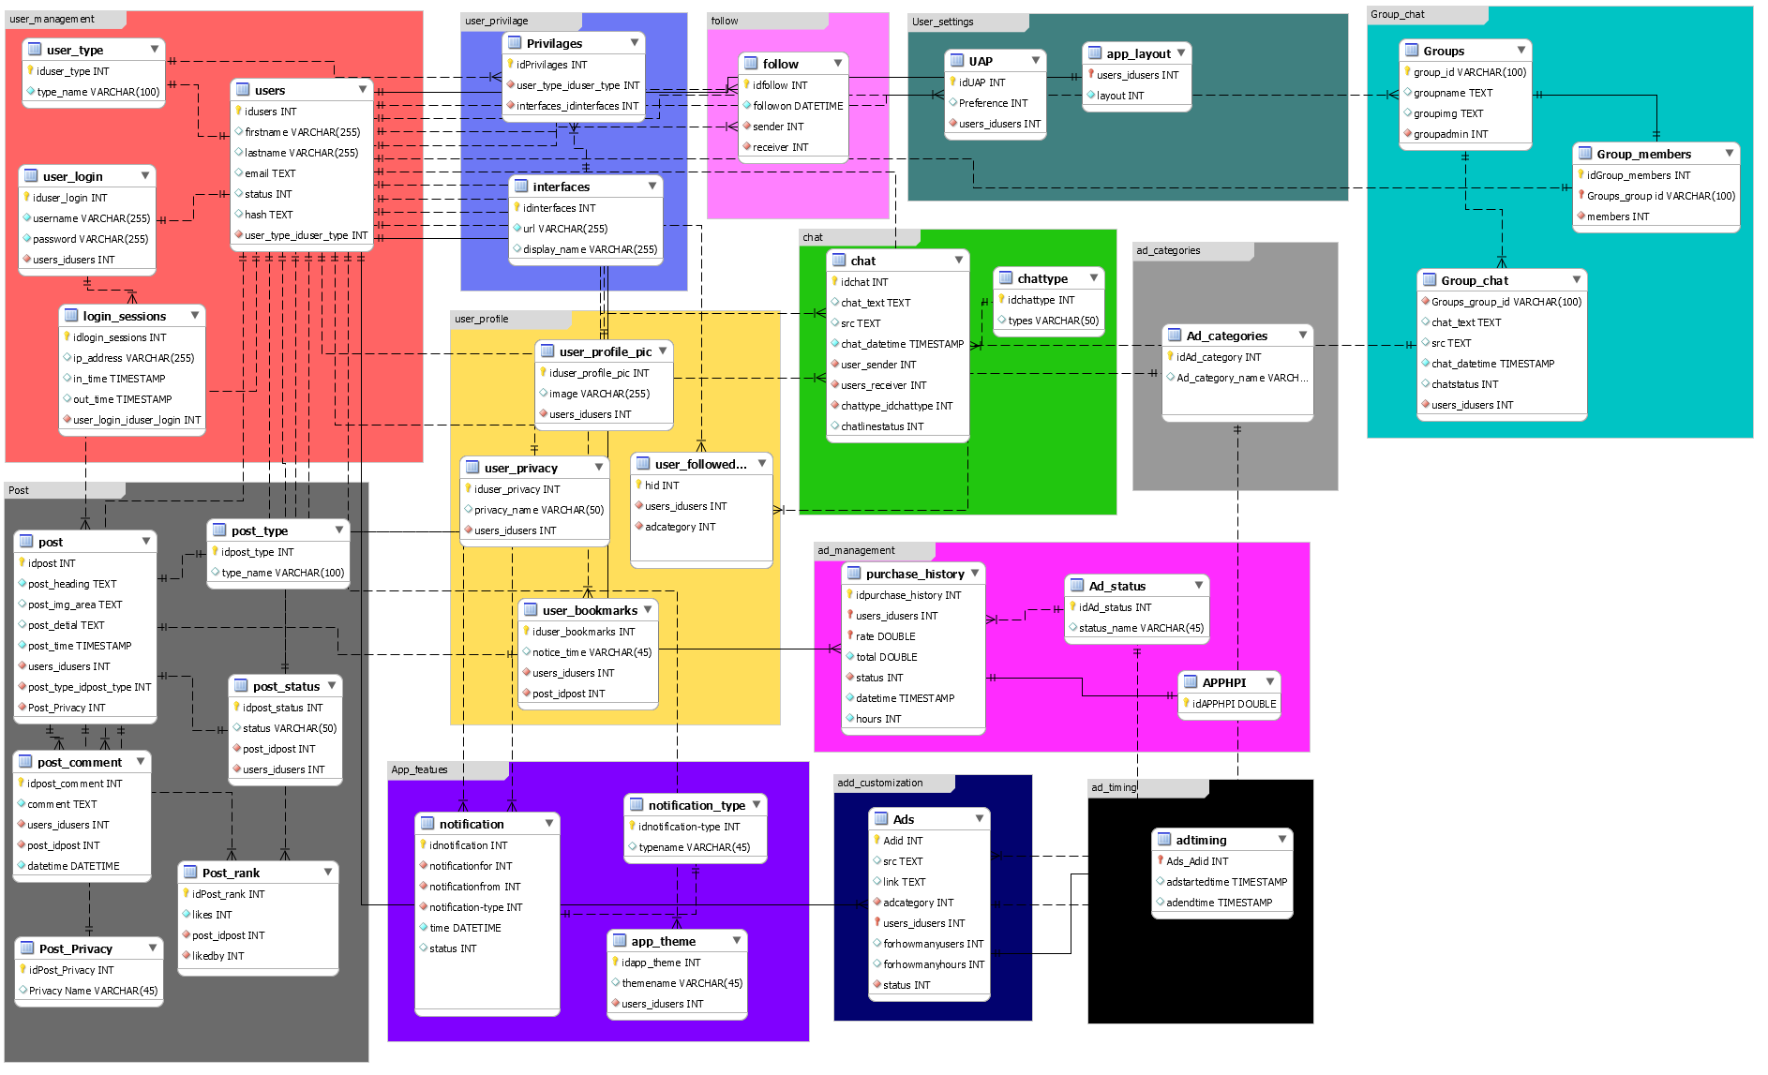

# Database Scope

## ads

|  |  |  |  |  |  |  |
| --- | --- | --- | --- | --- | --- | --- |
| **Column** | **Type** | **Null** | **Default** | **Links to** | **Comments** | **MIME** |
| Adid (Primary) | int(11) | No |  |  |  |  |
| src | text | Yes | *NULL* |  |  |  |
| link | text | Yes | *NULL* |  |  |  |
| adcategory | int(11) | No | 1 | ad_categories -> idAd_category |  |  |
| users_idusers (Primary) | int(11) | No |  | users -> idusers |  |  |
| forhowmanyusers | int(11) | Yes | *NULL* |  |  |  |
| forhowmanyhours | int(11) | Yes | *NULL* |  |  |  |
| status | int(11) | No |  | ad_status -> idAd_status |  |  |

### Indexes

| **Keyname** | **Type** | **Unique** | **Packed** | **Column** | **Cardinality** | **Collation** | **Null** | **Comment** |
| --- | --- | --- | --- | --- | --- | --- | --- | --- |
| PRIMARY | BTREE | Yes | No | Adid | 1 | A | No |  |
| users_idusers | 1 | A | No |
| fk_Ads_users1_idx | BTREE | No | No | users_idusers | 1 | A | No |  |
| fk_Ads_Ad_status1_idx | BTREE | No | No | status | 1 | A | No |  |
| fk_Ads_Ad_categories1_idx | BTREE | No | No | adcategory | 1 | A | No |  |

## adtiming

|  |  |  |  |  |  |  |
| --- | --- | --- | --- | --- | --- | --- |
| **Column** | **Type** | **Null** | **Default** | **Links to** | **Comments** | **MIME** |
| Ads_Adid (Primary) | int(11) | No |  | ads -> Adid |  |  |
| adstartedtime | timestamp | Yes | *NULL* |  |  |  |
| adendtime | timestamp | Yes | *NULL* |  |  |  |

### Indexes

| **Keyname** | **Type** | **Unique** | **Packed** | **Column** | **Cardinality** | **Collation** | **Null** | **Comment** |
| --- | --- | --- | --- | --- | --- | --- | --- | --- |
| PRIMARY | BTREE | Yes | No | Ads_Adid | 0 | A | No |  |

## ad_categories

|  |  |  |  |  |  |  |
| --- | --- | --- | --- | --- | --- | --- |
| **Column** | **Type** | **Null** | **Default** | **Links to** | **Comments** | **MIME** |
| idAd_category (Primary) | int(11) | No |  |  |  |  |
| Ad_category_name | varchar(45) | Yes | *NULL* |  |  |  |

### Indexes

| **Keyname** | **Type** | **Unique** | **Packed** | **Column** | **Cardinality** | **Collation** | **Null** | **Comment** |
| --- | --- | --- | --- | --- | --- | --- | --- | --- |
| PRIMARY | BTREE | Yes | No | idAd_category | 7 | A | No |  |

## ad_status

|  |  |  |  |  |  |  |
| --- | --- | --- | --- | --- | --- | --- |
| **Column** | **Type** | **Null** | **Default** | **Links to** | **Comments** | **MIME** |
| idAd_status (Primary) | int(11) | No |  |  |  |  |
| status_name | varchar(45) | Yes | *NULL* |  |  |  |

### Indexes

| **Keyname** | **Type** | **Unique** | **Packed** | **Column** | **Cardinality** | **Collation** | **Null** | **Comment** |
| --- | --- | --- | --- | --- | --- | --- | --- | --- |
| PRIMARY | BTREE | Yes | No | idAd_status | 6 | A | No |  |
| idAd_status_UNIQUE | BTREE | Yes | No | idAd_status | 6 | A | No |  |

## apphpi

|  |  |  |  |  |  |  |
| --- | --- | --- | --- | --- | --- | --- |
| **Column** | **Type** | **Null** | **Default** | **Links to** | **Comments** | **MIME** |
| idAPPHPI (Primary) | double | No |  |  |  |  |

### Indexes

| **Keyname** | **Type** | **Unique** | **Packed** | **Column** | **Cardinality** | **Collation** | **Null** | **Comment** |
| --- | --- | --- | --- | --- | --- | --- | --- | --- |
| PRIMARY | BTREE | Yes | No | idAPPHPI | 1 | A | No |  |

## app_layout

|  |  |  |  |  |  |  |
| --- | --- | --- | --- | --- | --- | --- |
| **Column** | **Type** | **Null** | **Default** | **Links to** | **Comments** | **MIME** |
| users_idusers (Primary) | int(11) | No |  | users -> idusers |  |  |
| layout | int(11) | No | 1 |  |  |  |

### Indexes

| **Keyname** | **Type** | **Unique** | **Packed** | **Column** | **Cardinality** | **Collation** | **Null** | **Comment** |
| --- | --- | --- | --- | --- | --- | --- | --- | --- |
| PRIMARY | BTREE | Yes | No | users_idusers | 13 | A | No |  |
| fk_app_layout_users1_idx | BTREE | No | No | users_idusers | 13 | A | No |  |

## app_theme

|  |  |  |  |  |  |  |
| --- | --- | --- | --- | --- | --- | --- |
| **Column** | **Type** | **Null** | **Default** | **Links to** | **Comments** | **MIME** |
| idapp_theme (Primary) | int(11) | No |  |  |  |  |
| themename | varchar(45) | Yes | *NULL* |  |  |  |
| users_idusers | int(11) | No |  | users -> idusers |  |  |

### Indexes

| **Keyname** | **Type** | **Unique** | **Packed** | **Column** | **Cardinality** | **Collation** | **Null** | **Comment** |
| --- | --- | --- | --- | --- | --- | --- | --- | --- |
| PRIMARY | BTREE | Yes | No | idapp_theme | 13 | A | No |  |
| fk_app_theme_users1_idx | BTREE | No | No | users_idusers | 13 | A | No |  |

## chat

|  |  |  |  |  |  |  |
| --- | --- | --- | --- | --- | --- | --- |
| **Column** | **Type** | **Null** | **Default** | **Links to** | **Comments** | **MIME** |
| idchat (Primary) | int(11) | No |  |  |  |  |
| chat_text | text | Yes | *NULL* |  |  |  |
| src | text | Yes | *NULL* |  |  |  |
| chat_datetime | timestamp | No | CURRENT_TIMESTAMP |  |  |  |
| user_sender | int(11) | No |  | users -> idusers |  |  |
| users_receiver | int(11) | No |  | users -> idusers |  |  |
| chattype_idchattype | int(11) | No |  | chattype -> idchattype |  |  |
| chatlinestatus | int(11) | Yes | 0 |  |  |  |

### Indexes

| **Keyname** | **Type** | **Unique** | **Packed** | **Column** | **Cardinality** | **Collation** | **Null** | **Comment** |
| --- | --- | --- | --- | --- | --- | --- | --- | --- |
| PRIMARY | BTREE | Yes | No | idchat | 16 | A | No |  |
| fk_chat_users1_idx | BTREE | No | No | user_sender | 8 | A | No |  |
| fk_chat_users2_idx | BTREE | No | No | users_receiver | 8 | A | No |  |
| fk_chat_chattype1_idx | BTREE | No | No | chattype_idchattype | 2 | A | No |  |

## chattype

|  |  |  |  |  |  |  |
| --- | --- | --- | --- | --- | --- | --- |
| **Column** | **Type** | **Null** | **Default** | **Links to** | **Comments** | **MIME** |
| idchattype (Primary) | int(11) | No |  |  |  |  |
| types | varchar(50) | Yes | *NULL* |  |  |  |

### Indexes

| **Keyname** | **Type** | **Unique** | **Packed** | **Column** | **Cardinality** | **Collation** | **Null** | **Comment** |
| --- | --- | --- | --- | --- | --- | --- | --- | --- |
| PRIMARY | BTREE | Yes | No | idchattype | 0 | A | No |  |

## follow

|  |  |  |  |  |  |  |
| --- | --- | --- | --- | --- | --- | --- |
| **Column** | **Type** | **Null** | **Default** | **Links to** | **Comments** | **MIME** |
| idfollow (Primary) | int(11) | No |  |  |  |  |
| followon | datetime | No | CURRENT_TIMESTAMP |  |  |  |
| sender | int(11) | No |  | users -> idusers |  |  |
| receiver | int(11) | No |  | users -> idusers |  |  |

### Indexes

| **Keyname** | **Type** | **Unique** | **Packed** | **Column** | **Cardinality** | **Collation** | **Null** | **Comment** |
| --- | --- | --- | --- | --- | --- | --- | --- | --- |
| PRIMARY | BTREE | Yes | No | idfollow | 32 | A | No |  |
| fk_follow_users1_idx | BTREE | No | No | sender | 32 | A | No |  |
| fk_follow_users2_idx | BTREE | No | No | receiver | 32 | A | No |  |

## groups

|  |  |  |  |  |  |  |
| --- | --- | --- | --- | --- | --- | --- |
| **Column** | **Type** | **Null** | **Default** | **Links to** | **Comments** | **MIME** |
| group_id (Primary) | varchar(100) | No |  |  |  |  |
| groupname | text | Yes | *NULL* |  |  |  |
| groupimg | text | Yes | *NULL* |  |  |  |
| groupadmin | int(11) | No |  | users -> idusers |  |  |

### Indexes

| **Keyname** | **Type** | **Unique** | **Packed** | **Column** | **Cardinality** | **Collation** | **Null** | **Comment** |
| --- | --- | --- | --- | --- | --- | --- | --- | --- |
| PRIMARY | BTREE | Yes | No | group_id | 0 | A | No |  |
| group id_UNIQUE | BTREE | Yes | No | group_id | 0 | A | No |  |
| fk_Groups_users1_idx | BTREE | No | No | groupadmin | 0 | A | No |  |

## group_chat

|  |  |  |  |  |  |  |
| --- | --- | --- | --- | --- | --- | --- |
| **Column** | **Type** | **Null** | **Default** | **Links to** | **Comments** | **MIME** |
| Groups_group_id | varchar(100) | No |  | groups -> group_id |  |  |
| chat_text | text | Yes | *NULL* |  |  |  |
| src | text | Yes | *NULL* |  |  |  |
| chat_datetime | timestamp | No | CURRENT_TIMESTAMP |  |  |  |
| chatstatus | int(11) | Yes | *NULL* |  |  |  |
| users_idusers | int(11) | No |  | users -> idusers |  |  |

### Indexes

| **Keyname** | **Type** | **Unique** | **Packed** | **Column** | **Cardinality** | **Collation** | **Null** | **Comment** |
| --- | --- | --- | --- | --- | --- | --- | --- | --- |
| fk_Group_chat_Groups1_idx | BTREE | No | No | Groups_group_id | 2 | A | No |  |
| fk_Group_chat_users1_idx | BTREE | No | No | users_idusers | 8 | A | No |  |

## group_members

|  |  |  |  |  |  |  |
| --- | --- | --- | --- | --- | --- | --- |
| **Column** | **Type** | **Null** | **Default** | **Links to** | **Comments** | **MIME** |
| idGroup_members (Primary) | int(11) | No |  |  |  |  |
| Groups_group_id (Primary) | varchar(100) | No |  | groups -> group_id |  |  |
| members | int(11) | No |  | users -> idusers |  |  |

### Indexes

| **Keyname** | **Type** | **Unique** | **Packed** | **Column** | **Cardinality** | **Collation** | **Null** | **Comment** |
| --- | --- | --- | --- | --- | --- | --- | --- | --- |
| PRIMARY | BTREE | Yes | No | idGroup_members | 6 | A | No |  |
| Groups_group_id | 6 | A | No |
| fk_Group_members_Groups1_idx | BTREE | No | No | Groups_group_id | 6 | A | No |  |
| fk_Group_members_users1_idx | BTREE | No | No | members | 6 | A | No |  |

## interfaces

|  |  |  |  |  |  |  |
| --- | --- | --- | --- | --- | --- | --- |
| **Column** | **Type** | **Null** | **Default** | **Links to** | **Comments** | **MIME** |
| idinterfaces (Primary) | int(11) | No |  |  |  |  |
| url | varchar(255) | No |  |  |  |  |
| display_name | varchar(255) | Yes | *NULL* |  |  |  |

### Indexes

| **Keyname** | **Type** | **Unique** | **Packed** | **Column** | **Cardinality** | **Collation** | **Null** | **Comment** |
| --- | --- | --- | --- | --- | --- | --- | --- | --- |
| PRIMARY | BTREE | Yes | No | idinterfaces | 0 | A | No |  |
| url_UNIQUE | BTREE | Yes | No | url | 0 | A | No |  |

## login_sessions

|  |  |  |  |  |  |  |
| --- | --- | --- | --- | --- | --- | --- |
| **Column** | **Type** | **Null** | **Default** | **Links to** | **Comments** | **MIME** |
| idlogin_sessions (Primary) | int(11) | No |  |  |  |  |
| ip_address | varchar(255) | Yes | *NULL* |  |  |  |
| in_time | timestamp | Yes | *NULL* |  |  |  |
| out_time | timestamp | Yes | *NULL* |  |  |  |
| user_login_iduser_login | int(11) | No |  | user_login -> iduser_login |  |  |

### Indexes

| **Keyname** | **Type** | **Unique** | **Packed** | **Column** | **Cardinality** | **Collation** | **Null** | **Comment** |
| --- | --- | --- | --- | --- | --- | --- | --- | --- |
| PRIMARY | BTREE | Yes | No | idlogin_sessions | 201 | A | No |  |
| fk_login_sessions_user_login1_idx | BTREE | No | No | user_login_iduser_login | 14 | A | No |  |

## notification

|  |  |  |  |  |  |  |
| --- | --- | --- | --- | --- | --- | --- |
| **Column** | **Type** | **Null** | **Default** | **Links to** | **Comments** | **MIME** |
| idnotification (Primary) | int(11) | No |  |  |  |  |
| notificationfor | int(11) | No |  | users -> idusers |  |  |
| notificationfrom | int(11) | No |  | users -> idusers |  |  |
| notification-type | int(11) | No |  | notification_type -> idnotification-type |  |  |
| time | datetime | No | CURRENT_TIMESTAMP |  |  |  |
| status | int(11) | Yes | 0 |  |  |  |
| target | int(11) | No |  |  |  |  |

### Indexes

| **Keyname** | **Type** | **Unique** | **Packed** | **Column** | **Cardinality** | **Collation** | **Null** | **Comment** |
| --- | --- | --- | --- | --- | --- | --- | --- | --- |
| PRIMARY | BTREE | Yes | No | idnotification | 19 | A | No |  |
| fk_notification_users1_idx | BTREE | No | No | notificationfor | 19 | A | No |  |
| fk_notification_users2_idx | BTREE | No | No | notificationfrom | 19 | A | No |  |
| fk_notification_notification-type1_idx | BTREE | No | No | notification-type | 4 | A | No |  |

## notification_type

|  |  |  |  |  |  |  |
| --- | --- | --- | --- | --- | --- | --- |
| **Column** | **Type** | **Null** | **Default** | **Links to** | **Comments** | **MIME** |
| idnotification-type (Primary) | int(11) | No |  |  |  |  |
| typename | varchar(45) | Yes | *NULL* |  |  |  |

### Indexes

| **Keyname** | **Type** | **Unique** | **Packed** | **Column** | **Cardinality** | **Collation** | **Null** | **Comment** |
| --- | --- | --- | --- | --- | --- | --- | --- | --- |
| PRIMARY | BTREE | Yes | No | idnotification-type | 2 | A | No |  |

## post

|  |  |  |  |  |  |  |
| --- | --- | --- | --- | --- | --- | --- |
| **Column** | **Type** | **Null** | **Default** | **Links to** | **Comments** | **MIME** |
| idpost (Primary) | int(11) | No |  |  |  |  |
| post_heading | text | No |  |  |  |  |
| post_img_area | text | Yes | *NULL* |  |  |  |
| post_detial | text | Yes | *NULL* |  |  |  |
| post_time | timestamp | No | CURRENT_TIMESTAMP |  |  |  |
| users_idusers | int(11) | No |  | users -> idusers |  |  |
| post_type_idpost_type | int(11) | No |  | post_type -> idpost_type |  |  |
| Post_Privacy | int(11) | No |  | post_privacy -> idPost_Privacy |  |  |

### Indexes

| **Keyname** | **Type** | **Unique** | **Packed** | **Column** | **Cardinality** | **Collation** | **Null** | **Comment** |
| --- | --- | --- | --- | --- | --- | --- | --- | --- |
| PRIMARY | BTREE | Yes | No | idpost | 13 | A | No |  |
| fk_post_users1_idx | BTREE | No | No | users_idusers | 13 | A | No |  |
| fk_post_post_type1_idx | BTREE | No | No | post_type_idpost_type | 4 | A | No |  |
| fk_post_Post_Privacy1_idx | BTREE | No | No | Post_Privacy | 2 | A | No |  |

## post_comment

|  |  |  |  |  |  |  |
| --- | --- | --- | --- | --- | --- | --- |
| **Column** | **Type** | **Null** | **Default** | **Links to** | **Comments** | **MIME** |
| idpost_comment (Primary) | int(11) | No |  |  |  |  |
| comment | text | No |  |  |  |  |
| users_idusers | int(11) | No |  | users -> idusers |  |  |
| post_idpost | int(11) | No |  | post -> idpost |  |  |
| datetime | datetime | No | CURRENT_TIMESTAMP |  |  |  |

### Indexes

| **Keyname** | **Type** | **Unique** | **Packed** | **Column** | **Cardinality** | **Collation** | **Null** | **Comment** |
| --- | --- | --- | --- | --- | --- | --- | --- | --- |
| PRIMARY | BTREE | Yes | No | idpost_comment | 6 | A | No |  |
| fk_post_comment_users1_idx | BTREE | No | No | users_idusers | 6 | A | No |  |
| fk_post_comment_post1_idx | BTREE | No | No | post_idpost | 6 | A | No |  |

## post_privacy

|  |  |  |  |  |  |  |
| --- | --- | --- | --- | --- | --- | --- |
| **Column** | **Type** | **Null** | **Default** | **Links to** | **Comments** | **MIME** |
| idPost_Privacy (Primary) | int(11) | No |  |  |  |  |
| Privacy Name | varchar(45) | Yes | *NULL* |  |  |  |

### Indexes

| **Keyname** | **Type** | **Unique** | **Packed** | **Column** | **Cardinality** | **Collation** | **Null** | **Comment** |
| --- | --- | --- | --- | --- | --- | --- | --- | --- |
| PRIMARY | BTREE | Yes | No | idPost_Privacy | 2 | A | No |  |

## post_rank

|  |  |  |  |  |  |  |
| --- | --- | --- | --- | --- | --- | --- |
| **Column** | **Type** | **Null** | **Default** | **Links to** | **Comments** | **MIME** |
| idPost_rank (Primary) | int(11) | No |  |  |  |  |
| likes | int(11) | No | 0 |  |  |  |
| post_idpost | int(11) | No |  | post -> idpost |  |  |
| likedby | int(11) | No |  | users -> idusers |  |  |

### Indexes

| **Keyname** | **Type** | **Unique** | **Packed** | **Column** | **Cardinality** | **Collation** | **Null** | **Comment** |
| --- | --- | --- | --- | --- | --- | --- | --- | --- |
| PRIMARY | BTREE | Yes | No | idPost_rank | 4 | A | No |  |
| fk_Post_rank_post1_idx | BTREE | No | No | post_idpost | 4 | A | No |  |
| fk_Post_rank_users1_idx | BTREE | No | No | likedby | 4 | A | No |  |

## post_status

|  |  |  |  |  |  |  |
| --- | --- | --- | --- | --- | --- | --- |
| **Column** | **Type** | **Null** | **Default** | **Links to** | **Comments** | **MIME** |
| idpost_status (Primary) | int(11) | No |  |  |  |  |
| status | varchar(50) | Yes | *NULL* |  |  |  |
| post_idpost | int(11) | No |  | post -> idpost |  |  |
| users_idusers | int(11) | No |  | users -> idusers |  |  |

### Indexes

| **Keyname** | **Type** | **Unique** | **Packed** | **Column** | **Cardinality** | **Collation** | **Null** | **Comment** |
| --- | --- | --- | --- | --- | --- | --- | --- | --- |
| PRIMARY | BTREE | Yes | No | idpost_status | 0 | A | No |  |
| fk_post_status_post1_idx | BTREE | No | No | post_idpost | 0 | A | No |  |
| fk_post_status_users1_idx | BTREE | No | No | users_idusers | 0 | A | No |  |

## post_type

|  |  |  |  |  |  |  |
| --- | --- | --- | --- | --- | --- | --- |
| **Column** | **Type** | **Null** | **Default** | **Links to** | **Comments** | **MIME** |
| idpost_type (Primary) | int(11) | No |  |  |  |  |
| type_name | varchar(100) | Yes | *NULL* |  |  |  |

### Indexes

| **Keyname** | **Type** | **Unique** | **Packed** | **Column** | **Cardinality** | **Collation** | **Null** | **Comment** |
| --- | --- | --- | --- | --- | --- | --- | --- | --- |
| PRIMARY | BTREE | Yes | No | idpost_type | 2 | A | No |  |
| type_name_UNIQUE | BTREE | Yes | No | type_name | 2 | A | Yes |  |

## privilages

|  |  |  |  |  |  |  |
| --- | --- | --- | --- | --- | --- | --- |
| **Column** | **Type** | **Null** | **Default** | **Links to** | **Comments** | **MIME** |
| idPrivilages (Primary) | int(11) | No |  |  |  |  |
| user_type_iduser_type | int(11) | No |  | user_type -> iduser_type |  |  |
| interfaces_idinterfaces | int(11) | No |  | interfaces -> idinterfaces |  |  |

### Indexes

| **Keyname** | **Type** | **Unique** | **Packed** | **Column** | **Cardinality** | **Collation** | **Null** | **Comment** |
| --- | --- | --- | --- | --- | --- | --- | --- | --- |
| PRIMARY | BTREE | Yes | No | idPrivilages | 0 | A | No |  |
| fk_Privilages_user_type1_idx | BTREE | No | No | user_type_iduser_type | 0 | A | No |  |
| fk_Privilages_interfaces1_idx | BTREE | No | No | interfaces_idinterfaces | 0 | A | No |  |

## purchase_history

|  |  |  |  |  |  |  |
| --- | --- | --- | --- | --- | --- | --- |
| **Column** | **Type** | **Null** | **Default** | **Links to** | **Comments** | **MIME** |
| idpurchase_history (Primary) | int(11) | No |  |  |  |  |
| users_idusers (Primary) | int(11) | No |  | users -> idusers |  |  |
| rate | double | Yes | *NULL* |  |  |  |
| total | double | No |  |  |  |  |
| status | int(11) | No |  | ad_status -> idAd_status |  |  |
| datetime | timestamp | No | CURRENT_TIMESTAMP |  |  |  |
| hours | int(11) | No |  |  |  |  |

### Indexes

| **Keyname** | **Type** | **Unique** | **Packed** | **Column** | **Cardinality** | **Collation** | **Null** | **Comment** |
| --- | --- | --- | --- | --- | --- | --- | --- | --- |
| PRIMARY | BTREE | Yes | No | idpurchase_history | 0 | A | No |  |
| users_idusers | 0 | A | No |
| fk_purchase_history_users1_idx | BTREE | No | No | users_idusers | 0 | A | No |  |
| fk_purchase_history_Ad_status1_idx | BTREE | No | No | status | 0 | A | No |  |

## tailzconfig

|  |  |  |  |  |  |  |
| --- | --- | --- | --- | --- | --- | --- |
| **Column** | **Type** | **Null** | **Default** | **Links to** | **Comments** | **MIME** |
| id (Primary) | int(11) | No |  |  |  |  |
| name | text | No |  |  |  |  |
| state | tinyint(1) | No |  |  |  |  |

### Indexes

| **Keyname** | **Type** | **Unique** | **Packed** | **Column** | **Cardinality** | **Collation** | **Null** | **Comment** |
| --- | --- | --- | --- | --- | --- | --- | --- | --- |
| PRIMARY | BTREE | Yes | No | id | 3 | A | No |  |

## uap

|  |  |  |  |  |  |  |
| --- | --- | --- | --- | --- | --- | --- |
| **Column** | **Type** | **Null** | **Default** | **Links to** | **Comments** | **MIME** |
| idUAP (Primary) | int(11) | No |  |  |  |  |
| Preference | int(11) | Yes | 1 |  |  |  |
| users_idusers | int(11) | No |  | users -> idusers |  |  |

### Indexes

| **Keyname** | **Type** | **Unique** | **Packed** | **Column** | **Cardinality** | **Collation** | **Null** | **Comment** |
| --- | --- | --- | --- | --- | --- | --- | --- | --- |
| PRIMARY | BTREE | Yes | No | idUAP | 13 | A | No |  |
| fk_User_location_users1_idx | BTREE | No | No | users_idusers | 13 | A | No |  |

## users

|  |  |  |  |  |  |  |
| --- | --- | --- | --- | --- | --- | --- |
| **Column** | **Type** | **Null** | **Default** | **Links to** | **Comments** | **MIME** |
| idusers (Primary) | int(11) | No |  |  |  |  |
| firstname | varchar(255) | Yes | *NULL* |  |  |  |
| lastname | varchar(255) | Yes | *NULL* |  |  |  |
| email | text | Yes | *NULL* |  |  |  |
| status | int(11) | Yes | 0 |  |  |  |
| hash | text | Yes | *NULL* |  |  |  |
| user_type_iduser_type | int(11) | No |  | user_type -> iduser_type |  |  |

### Indexes

| **Keyname** | **Type** | **Unique** | **Packed** | **Column** | **Cardinality** | **Collation** | **Null** | **Comment** |
| --- | --- | --- | --- | --- | --- | --- | --- | --- |
| PRIMARY | BTREE | Yes | No | idusers | 14 | A | No |  |
| fk_users_user_type_idx | BTREE | No | No | user_type_iduser_type | 7 | A | No |  |

## user_bookmarks

|  |  |  |  |  |  |  |
| --- | --- | --- | --- | --- | --- | --- |
| **Column** | **Type** | **Null** | **Default** | **Links to** | **Comments** | **MIME** |
| iduser_bookmarks (Primary) | int(11) | No |  |  |  |  |
| notice_time | varchar(45) | Yes | *NULL* |  |  |  |
| users_idusers | int(11) | No |  | users -> idusers |  |  |
| post_idpost | int(11) | No |  | post -> idpost |  |  |

### Indexes

| **Keyname** | **Type** | **Unique** | **Packed** | **Column** | **Cardinality** | **Collation** | **Null** | **Comment** |
| --- | --- | --- | --- | --- | --- | --- | --- | --- |
| PRIMARY | BTREE | Yes | No | iduser_bookmarks | 2 | A | No |  |
| fk_user_notice_users1_idx | BTREE | No | No | users_idusers | 2 | A | No |  |
| fk_user_bookmarks_post1_idx | BTREE | No | No | post_idpost | 2 | A | No |  |

## user_followed_ad_catergories

|  |  |  |  |  |  |  |
| --- | --- | --- | --- | --- | --- | --- |
| **Column** | **Type** | **Null** | **Default** | **Links to** | **Comments** | **MIME** |
| hid (Primary) | int(11) | No |  |  |  |  |
| users_idusers | int(11) | No |  | users -> idusers |  |  |
| adcategory | int(11) | No | 1 | ad_categories -> idAd_category |  |  |

### Indexes

| **Keyname** | **Type** | **Unique** | **Packed** | **Column** | **Cardinality** | **Collation** | **Null** | **Comment** |
| --- | --- | --- | --- | --- | --- | --- | --- | --- |
| PRIMARY | BTREE | Yes | No | hid | 6 | A | No |  |
| fk_user_warning_users1_idx | BTREE | No | No | users_idusers | 6 | A | No |  |
| fk_user_followed_ad_catergories_Ad_categories1_idx | BTREE | No | No | adcategory | 6 | A | No |  |

## user_login

|  |  |  |  |  |  |  |
| --- | --- | --- | --- | --- | --- | --- |
| **Column** | **Type** | **Null** | **Default** | **Links to** | **Comments** | **MIME** |
| iduser_login (Primary) | int(11) | No |  |  |  |  |
| username | varchar(255) | No |  |  |  |  |
| password | varchar(255) | No |  |  |  |  |
| users_idusers | int(11) | No |  | users -> idusers |  |  |

### Indexes

| **Keyname** | **Type** | **Unique** | **Packed** | **Column** | **Cardinality** | **Collation** | **Null** | **Comment** |
| --- | --- | --- | --- | --- | --- | --- | --- | --- |
| PRIMARY | BTREE | Yes | No | iduser_login | 10 | A | No |  |
| username_UNIQUE | BTREE | Yes | No | username | 10 | A | No |  |
| fk_user_login_users1_idx | BTREE | No | No | users_idusers | 10 | A | No |  |

## user_privacy

|  |  |  |  |  |  |  |
| --- | --- | --- | --- | --- | --- | --- |
| **Column** | **Type** | **Null** | **Default** | **Links to** | **Comments** | **MIME** |
| iduser_privacy (Primary) | int(11) | No |  |  |  |  |
| privacy_name | varchar(50) | Yes | *NULL* |  |  |  |
| users_idusers | int(11) | No |  | users -> idusers |  |  |

### Indexes

| **Keyname** | **Type** | **Unique** | **Packed** | **Column** | **Cardinality** | **Collation** | **Null** | **Comment** |
| --- | --- | --- | --- | --- | --- | --- | --- | --- |
| PRIMARY | BTREE | Yes | No | iduser_privacy | 13 | A | No |  |
| fk_user_status_users1_idx | BTREE | No | No | users_idusers | 13 | A | No |  |

## user_profile_pic

|  |  |  |  |  |  |  |
| --- | --- | --- | --- | --- | --- | --- |
| **Column** | **Type** | **Null** | **Default** | **Links to** | **Comments** | **MIME** |
| iduser_profile_pic (Primary) | int(11) | No |  |  |  |  |
| image | varchar(255) | Yes | *NULL* |  |  |  |
| users_idusers | int(11) | No |  | users -> idusers |  |  |

### Indexes

| **Keyname** | **Type** | **Unique** | **Packed** | **Column** | **Cardinality** | **Collation** | **Null** | **Comment** |
| --- | --- | --- | --- | --- | --- | --- | --- | --- |
| PRIMARY | BTREE | Yes | No | iduser_profile_pic | 13 | A | No |  |
| fk_user_profile_pic_users1_idx | BTREE | No | No | users_idusers | 13 | A | No |  |

## user_type

|  |  |  |  |  |  |  |
| --- | --- | --- | --- | --- | --- | --- |
| **Column** | **Type** | **Null** | **Default** | **Links to** | **Comments** | **MIME** |
| iduser_type (Primary) | int(11) | No |  |  |  |  |
| type_name | varchar(100) | No |  |  |  |  |

### Indexes

| **Keyname** | **Type** | **Unique** | **Packed** | **Column** | **Cardinality** | **Collation** | **Null** | **Comment** |
| --- | --- | --- | --- | --- | --- | --- | --- | --- |
| PRIMARY | BTREE | Yes | No | iduser_type | 3 | A | No |  |
| type_name_UNIQUE | BTREE | Yes | No | type_name | 3 | A | No |  |

# User Interfaces Gallery

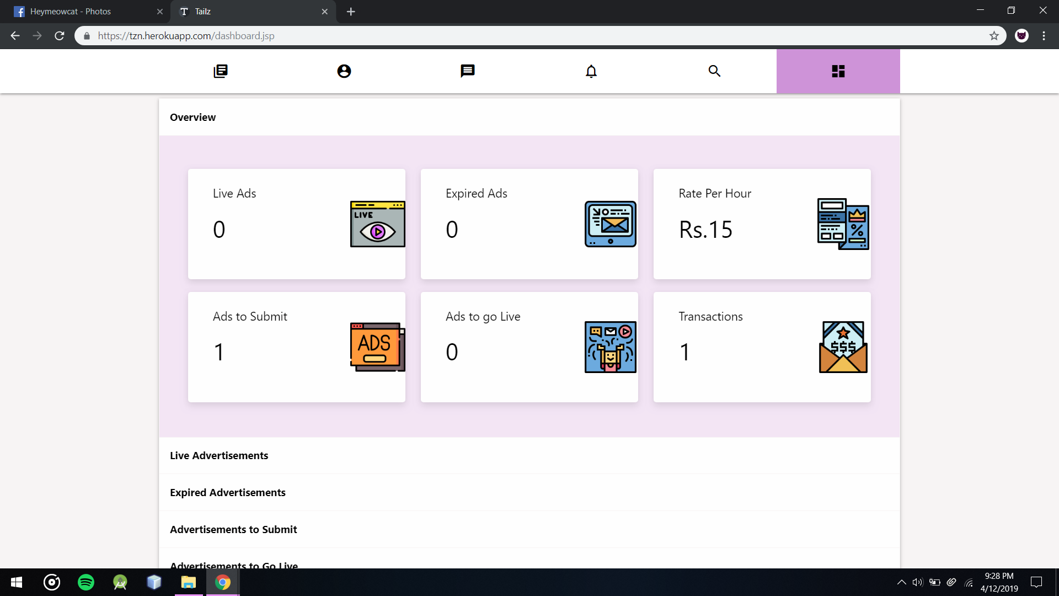

Customer’s All In one Advertisement Managing dashboard

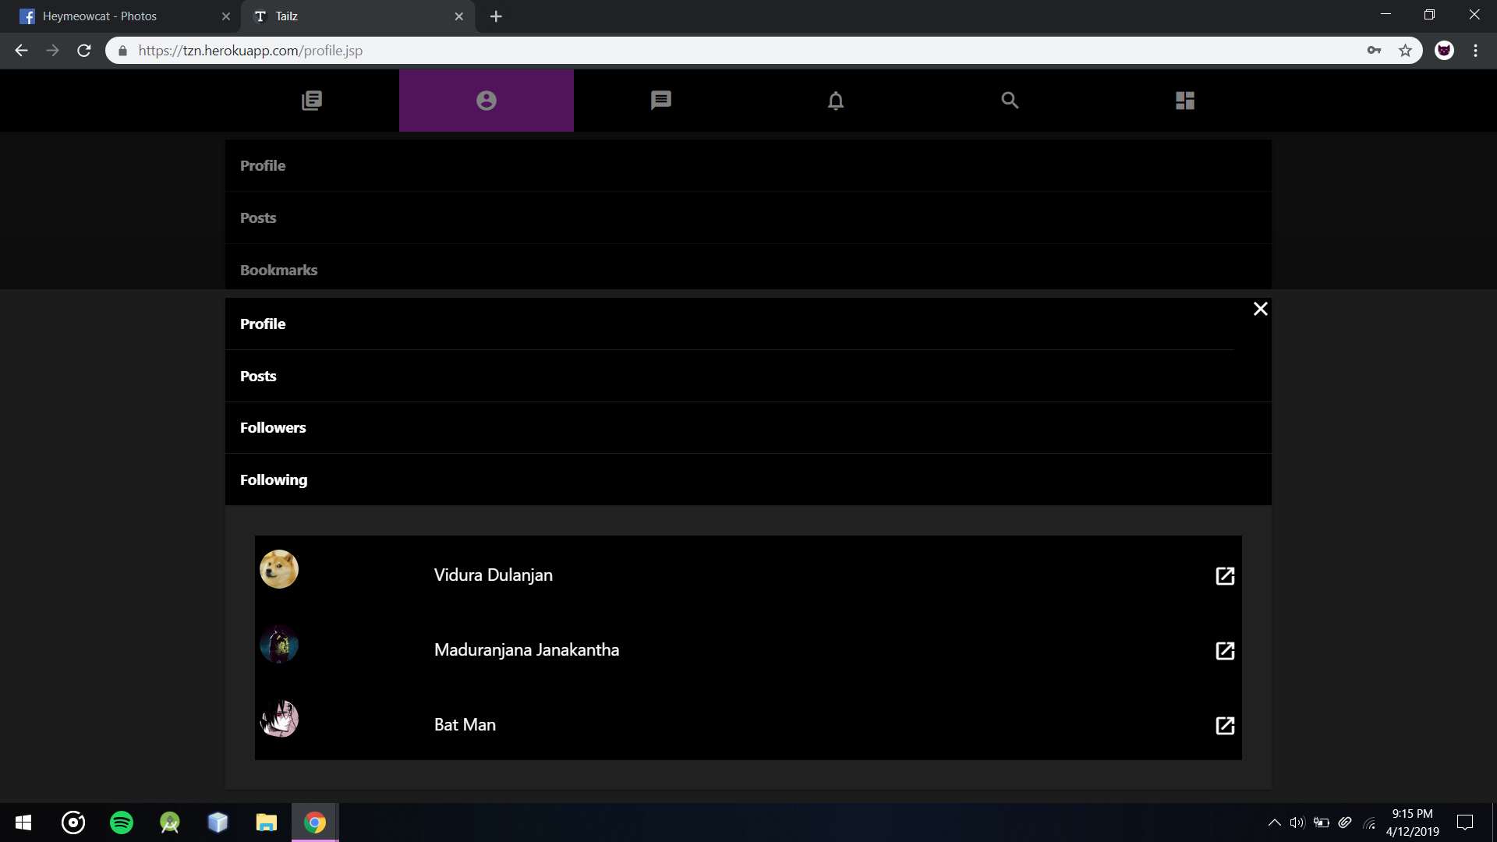

Users Following list

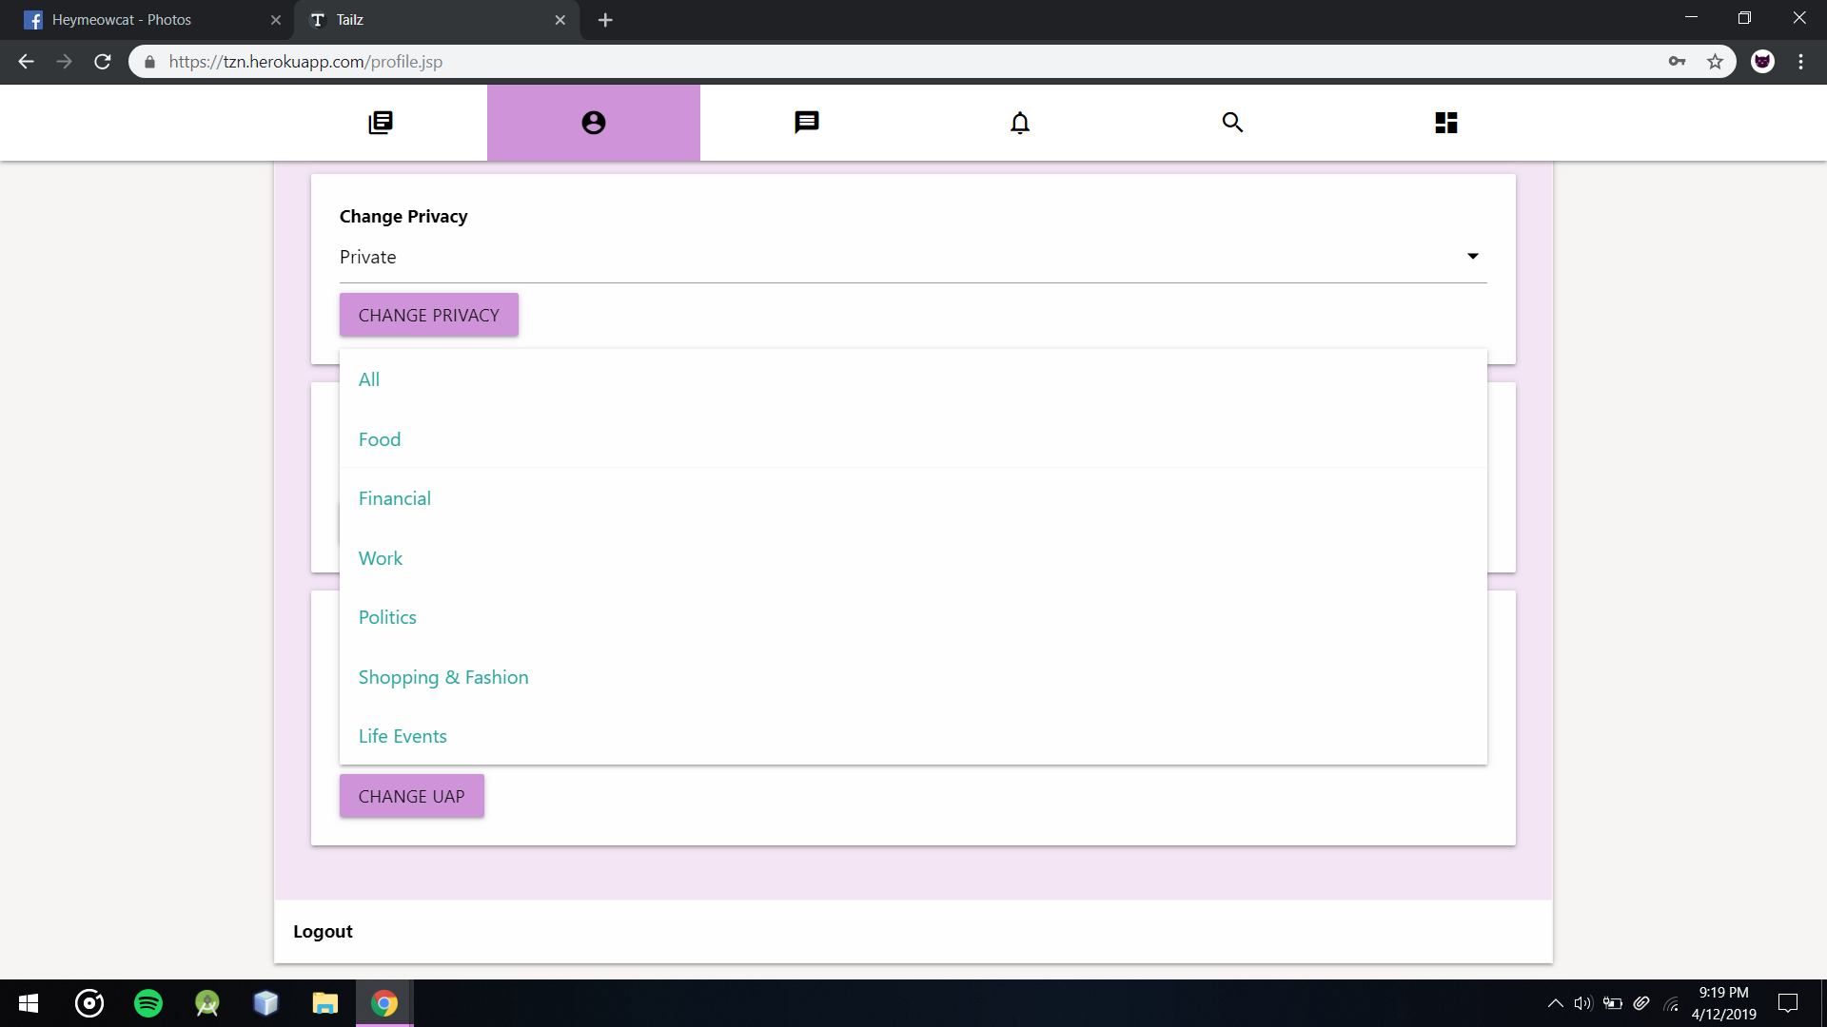

User can Set Advertisement Preferences if Advertisements are turned On

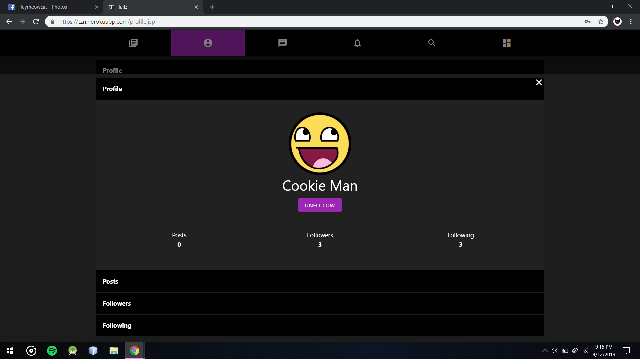

Users Profile, Here User Can View and Manage All User Related Settings including themes and layout preferences

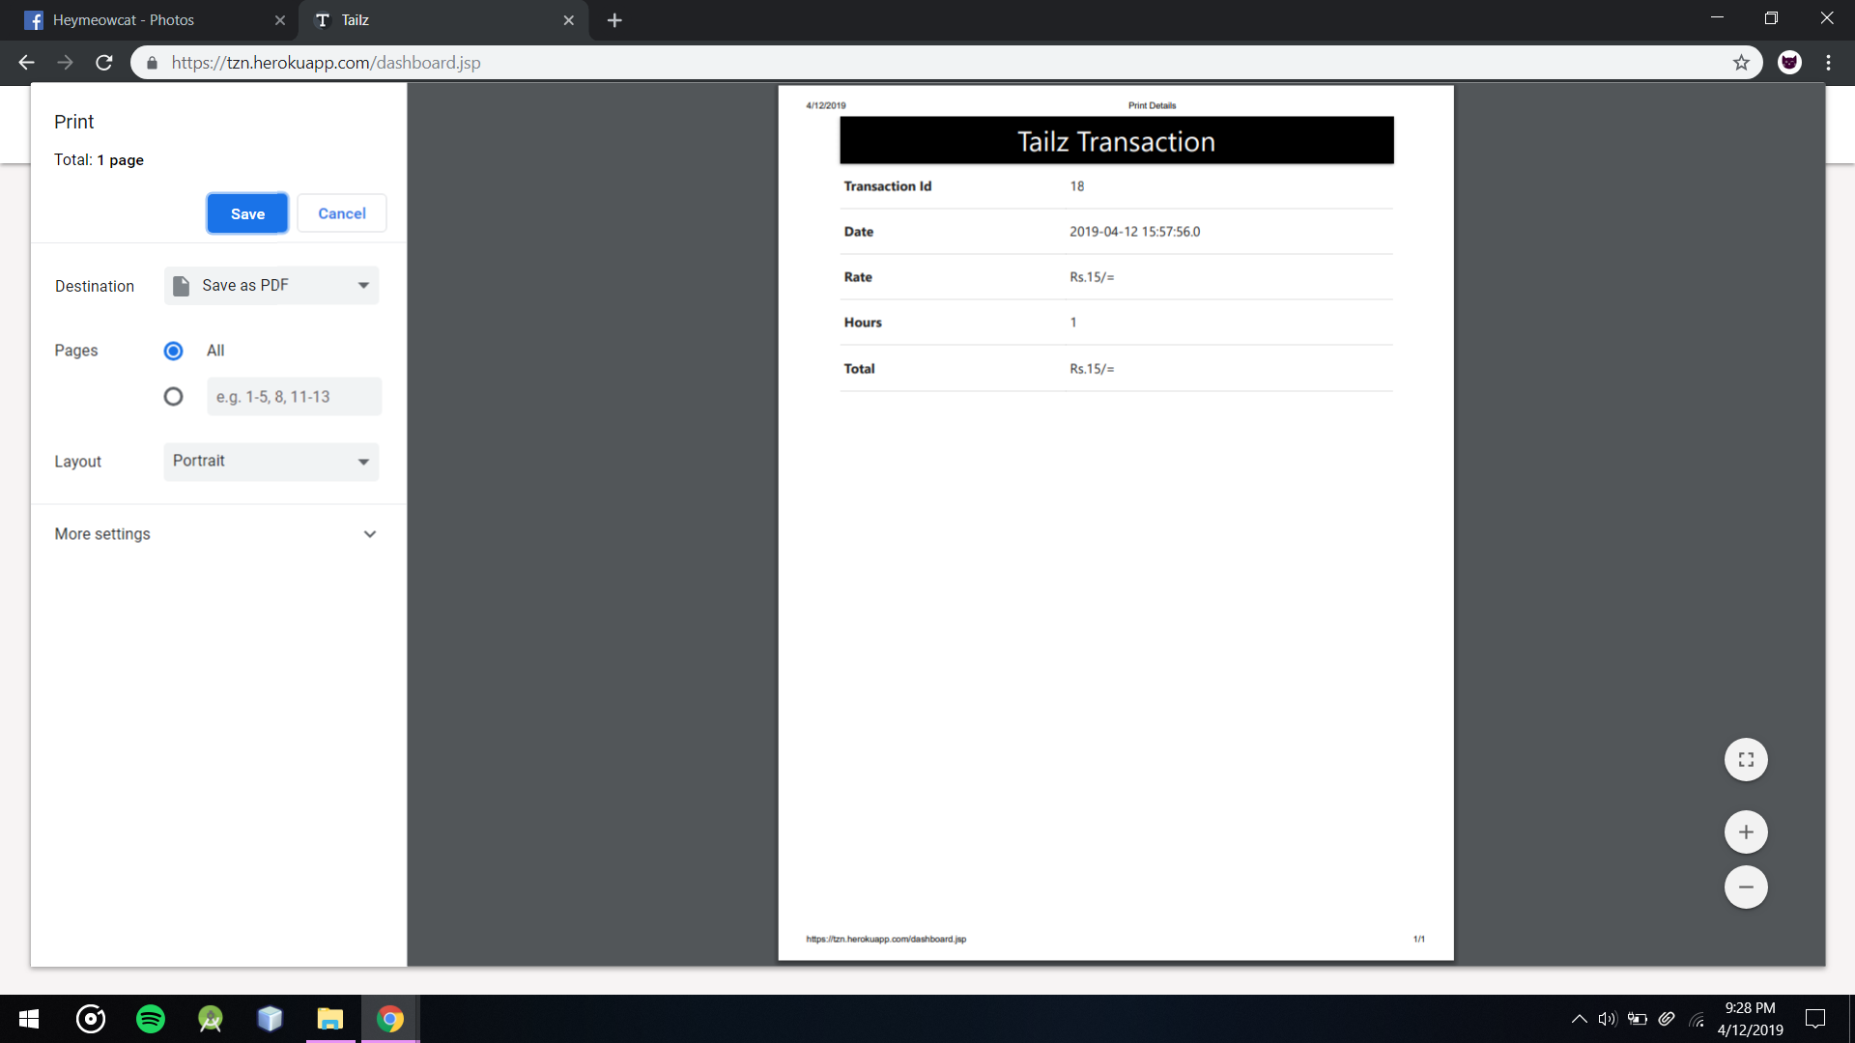

Customer Can View and Print each Transaction Receipts from Transactions Table

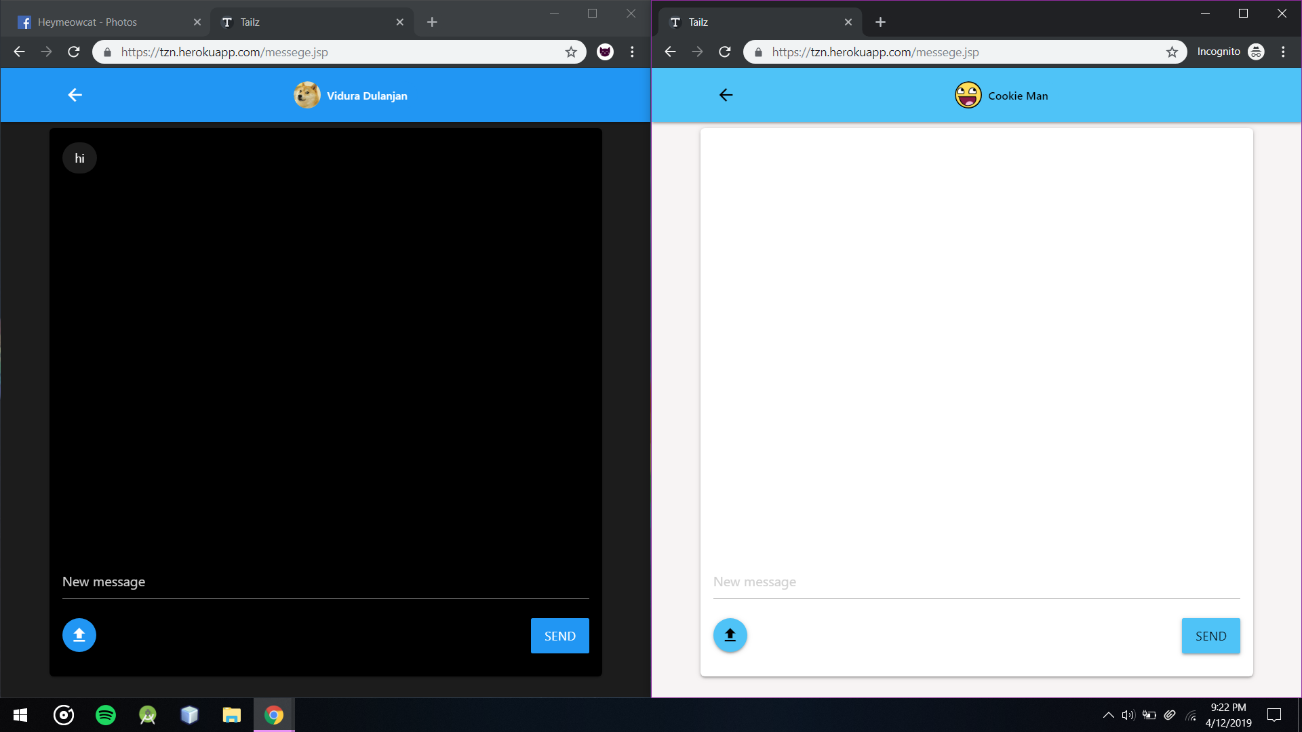

In Messaging section user can send messages images to follow backed followers or can create a group messaging inboxes

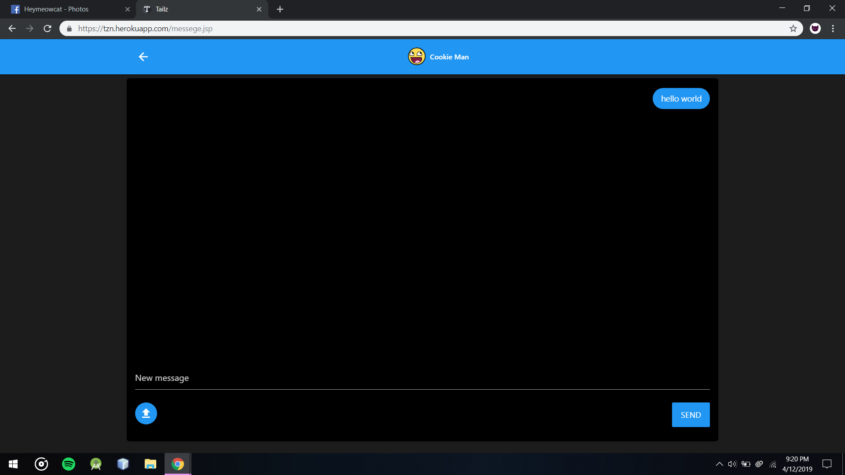

Messages and User Posts and other User Data are encrypted and stored in databases

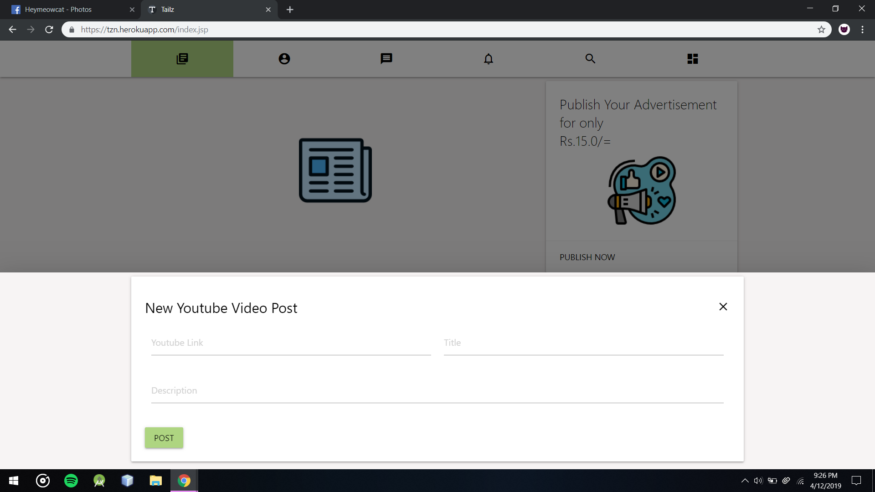

Users Can Post Youtube Posts Directly from link to here

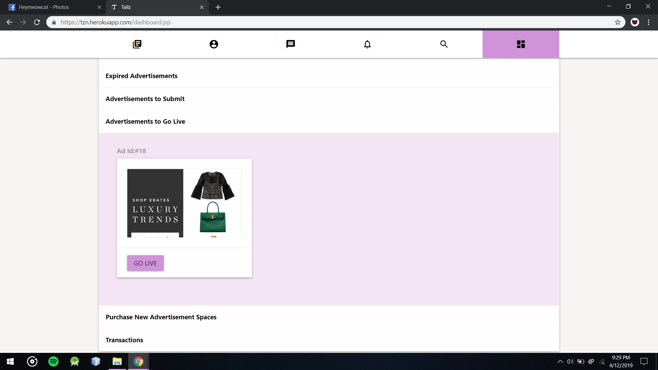  
Customers Dashboard’s Advertisements to Go Live Section here they can preset an Advertisement and set Live at anytime

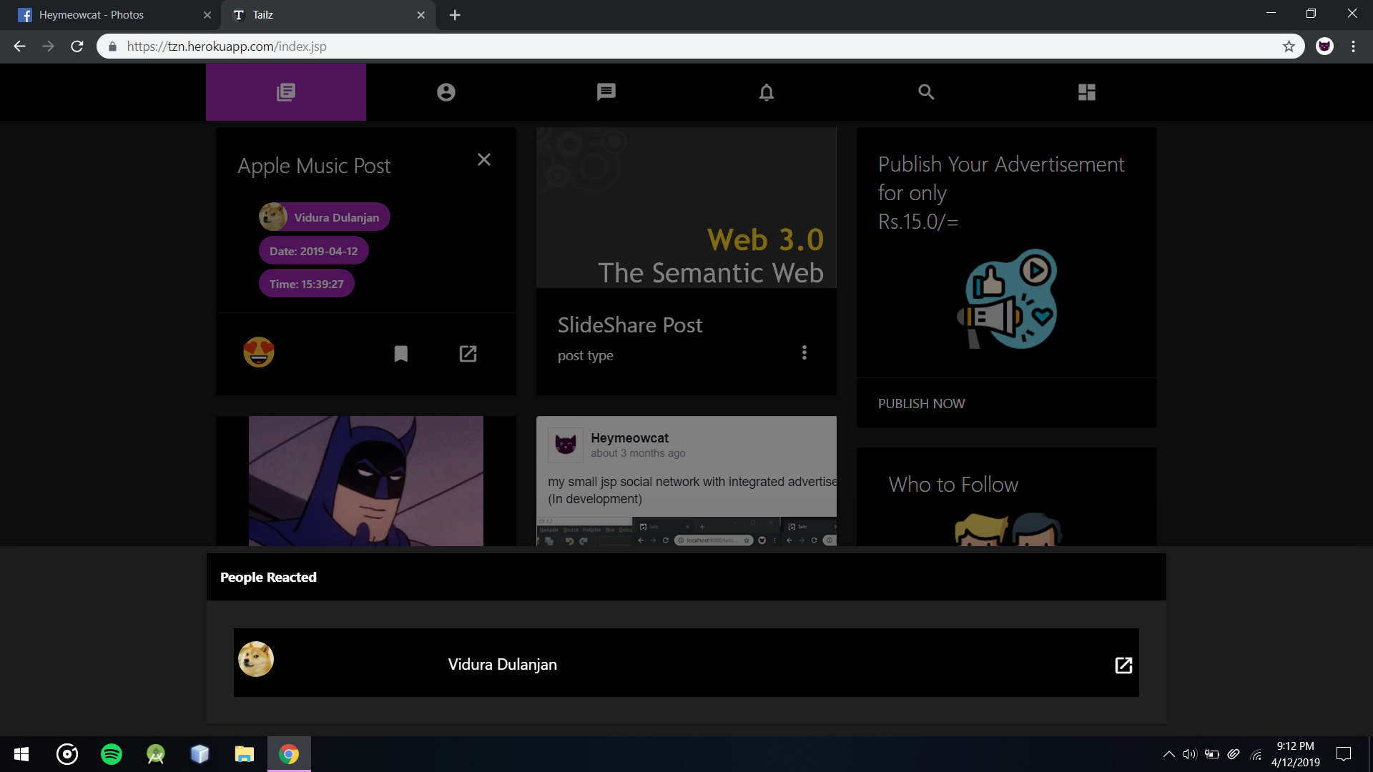

Users Can View who liked a post and their profiles if not their privacy settings are private

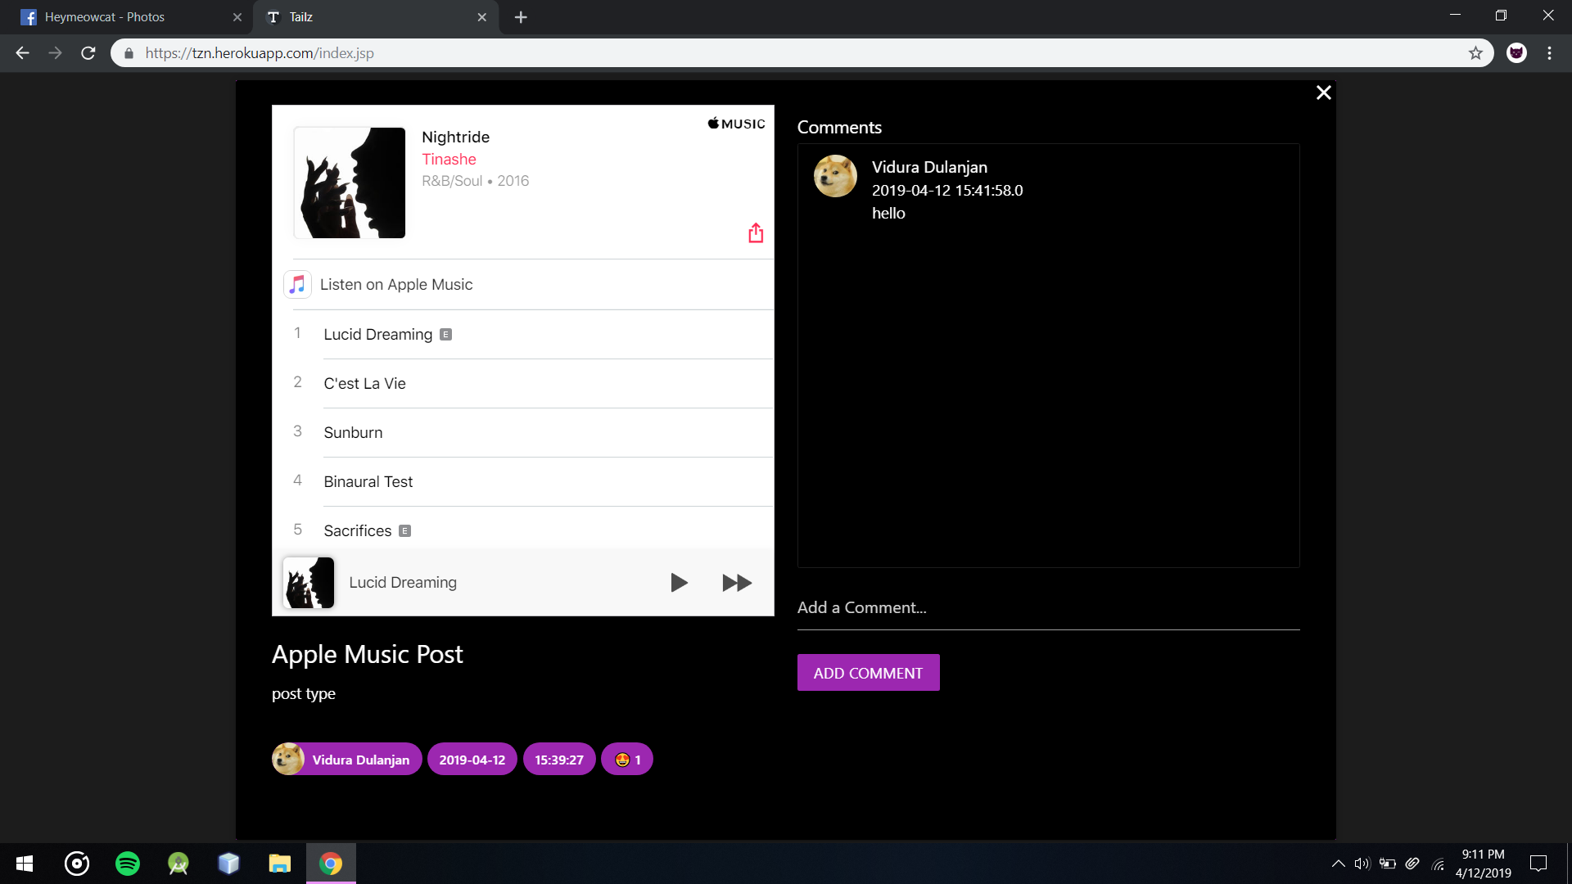

Users Can Comment on any public post in the system

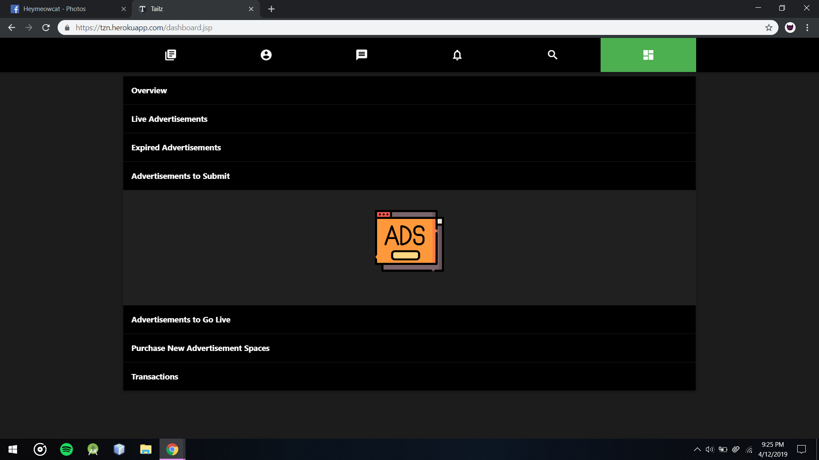

Customers Dashboard’s Advertisements to submit section without any Ads to submit

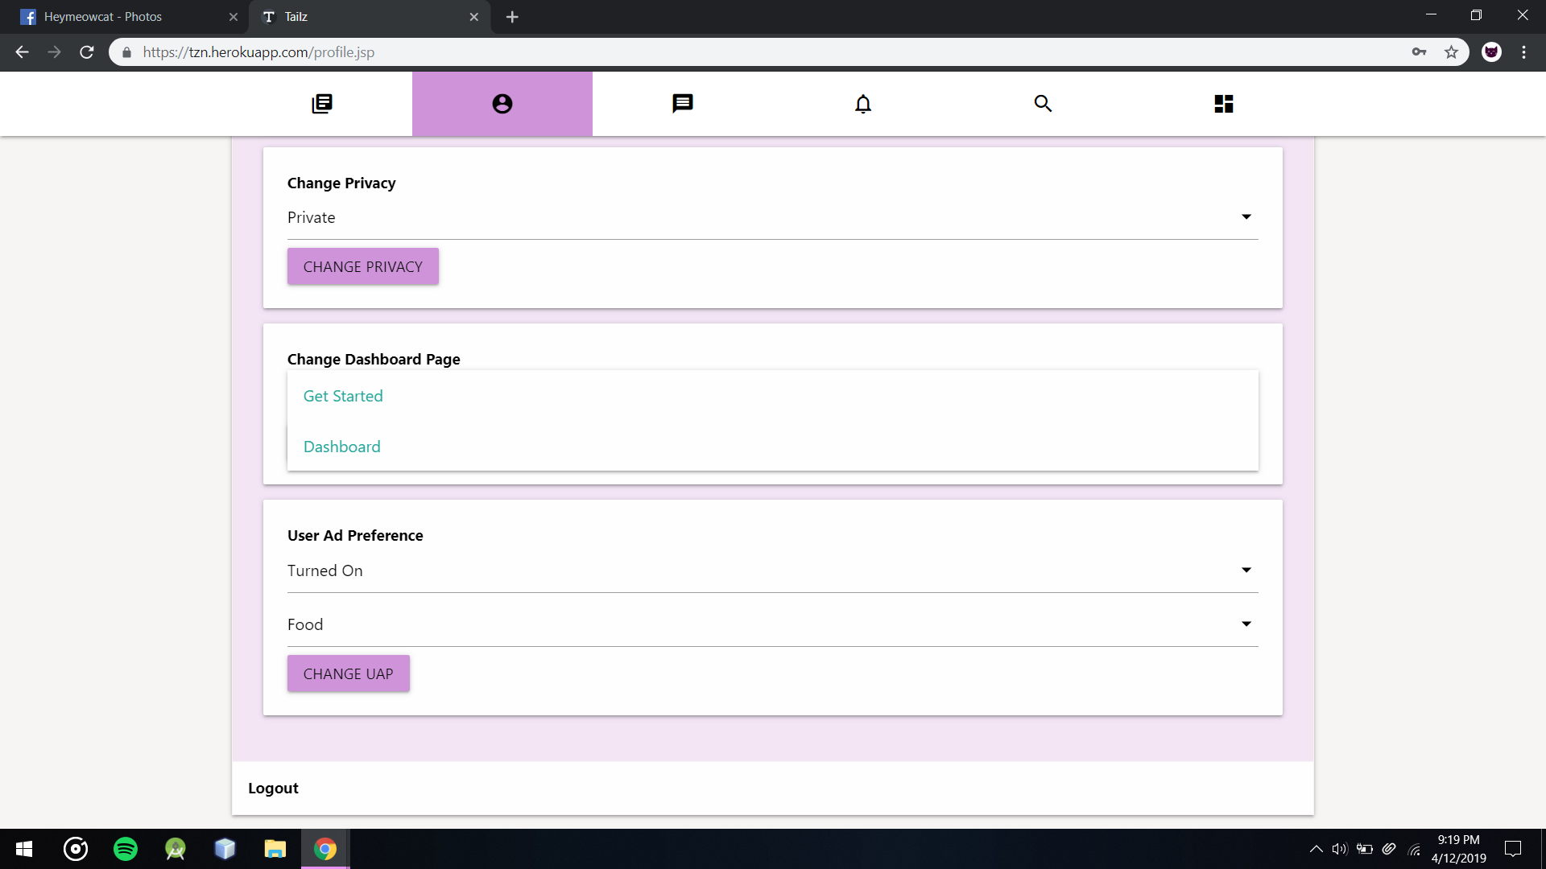

User Can change Dashboard page if User don’t want to Use Dashboard Option

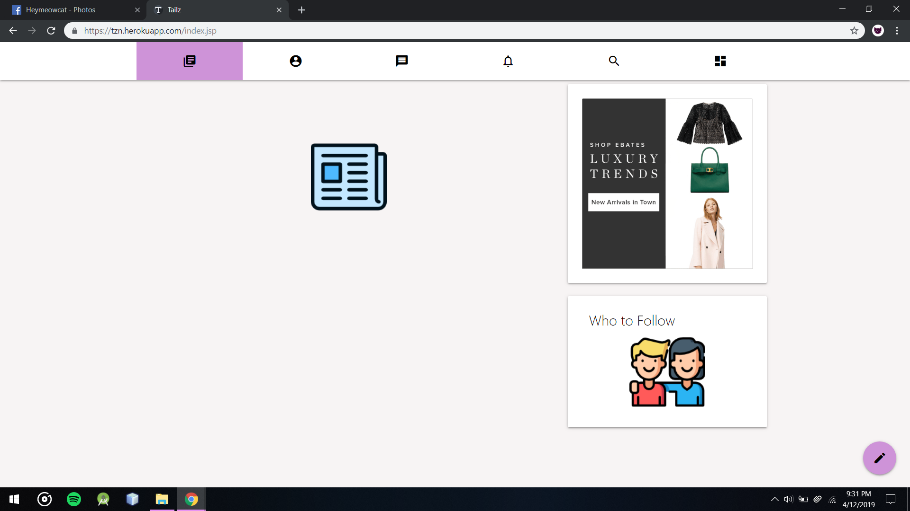

All Ads in the system at that time can be found on right side of the page in pc view or on bottom on mobile view

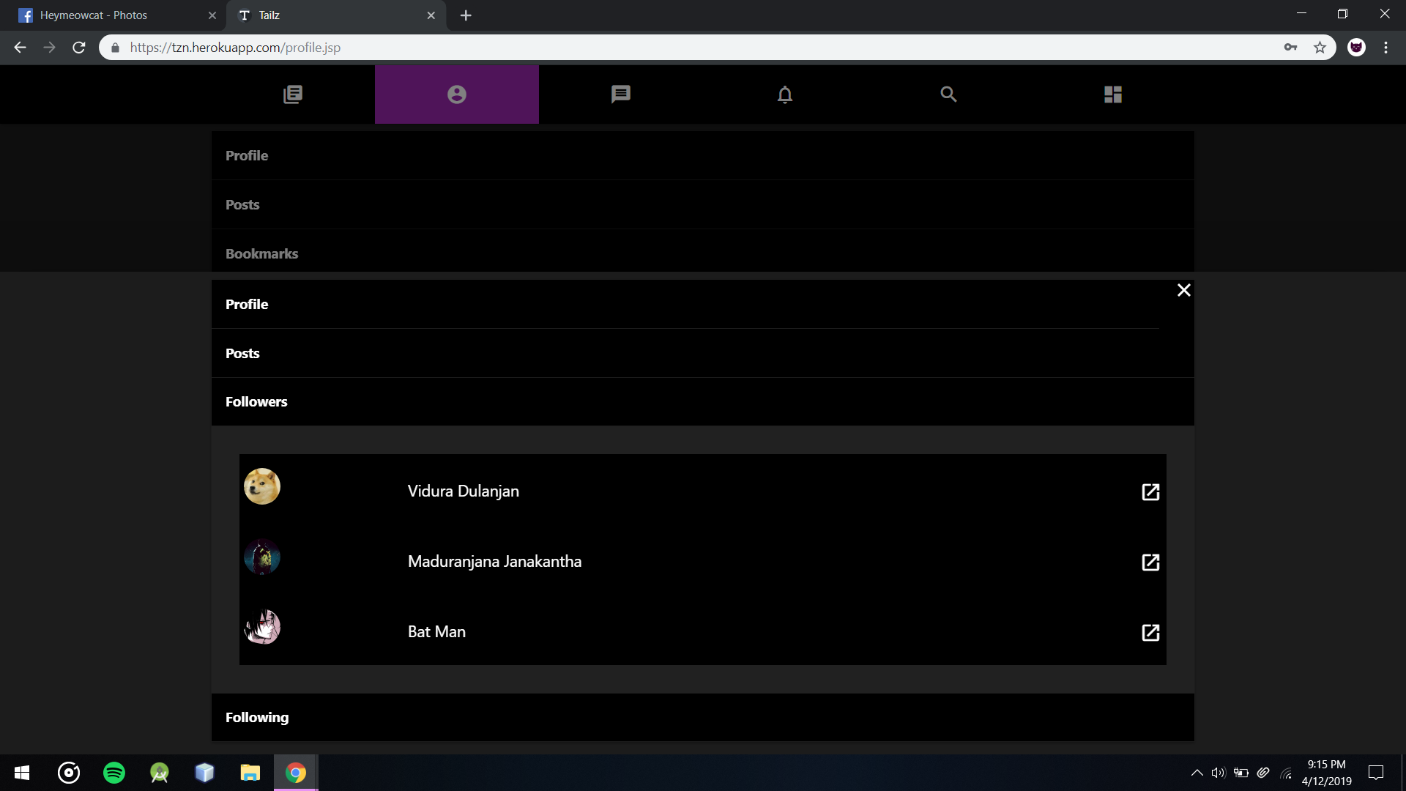

Users Profile Following list can view the followers that users have

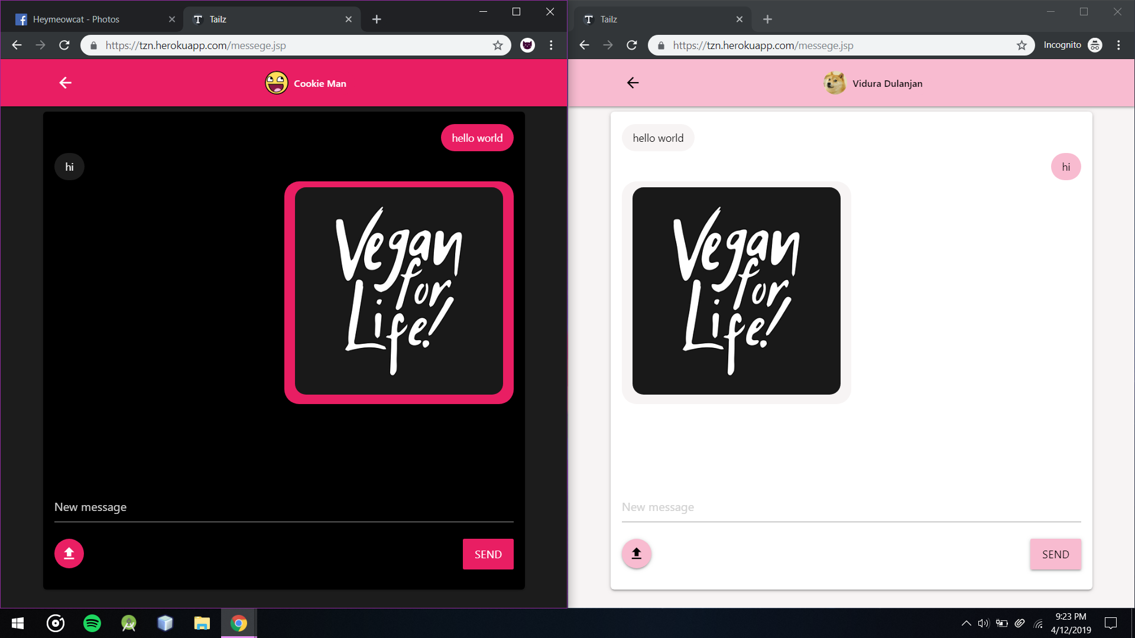

Users Can send images from messaging Area these images will store in imgur.

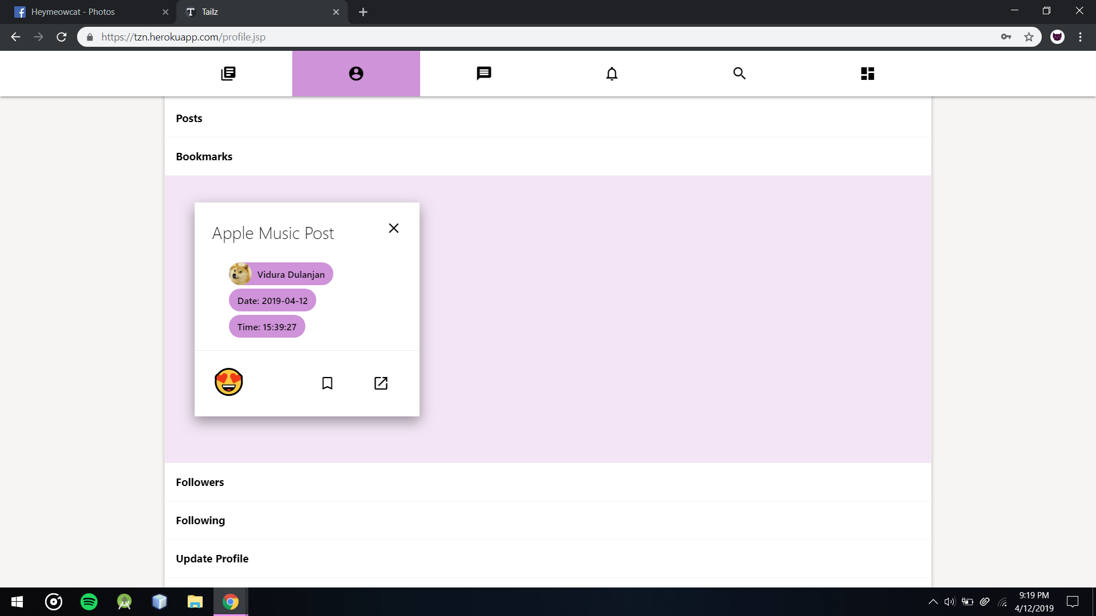

Users can remove book marks from Profile’s bookmark section

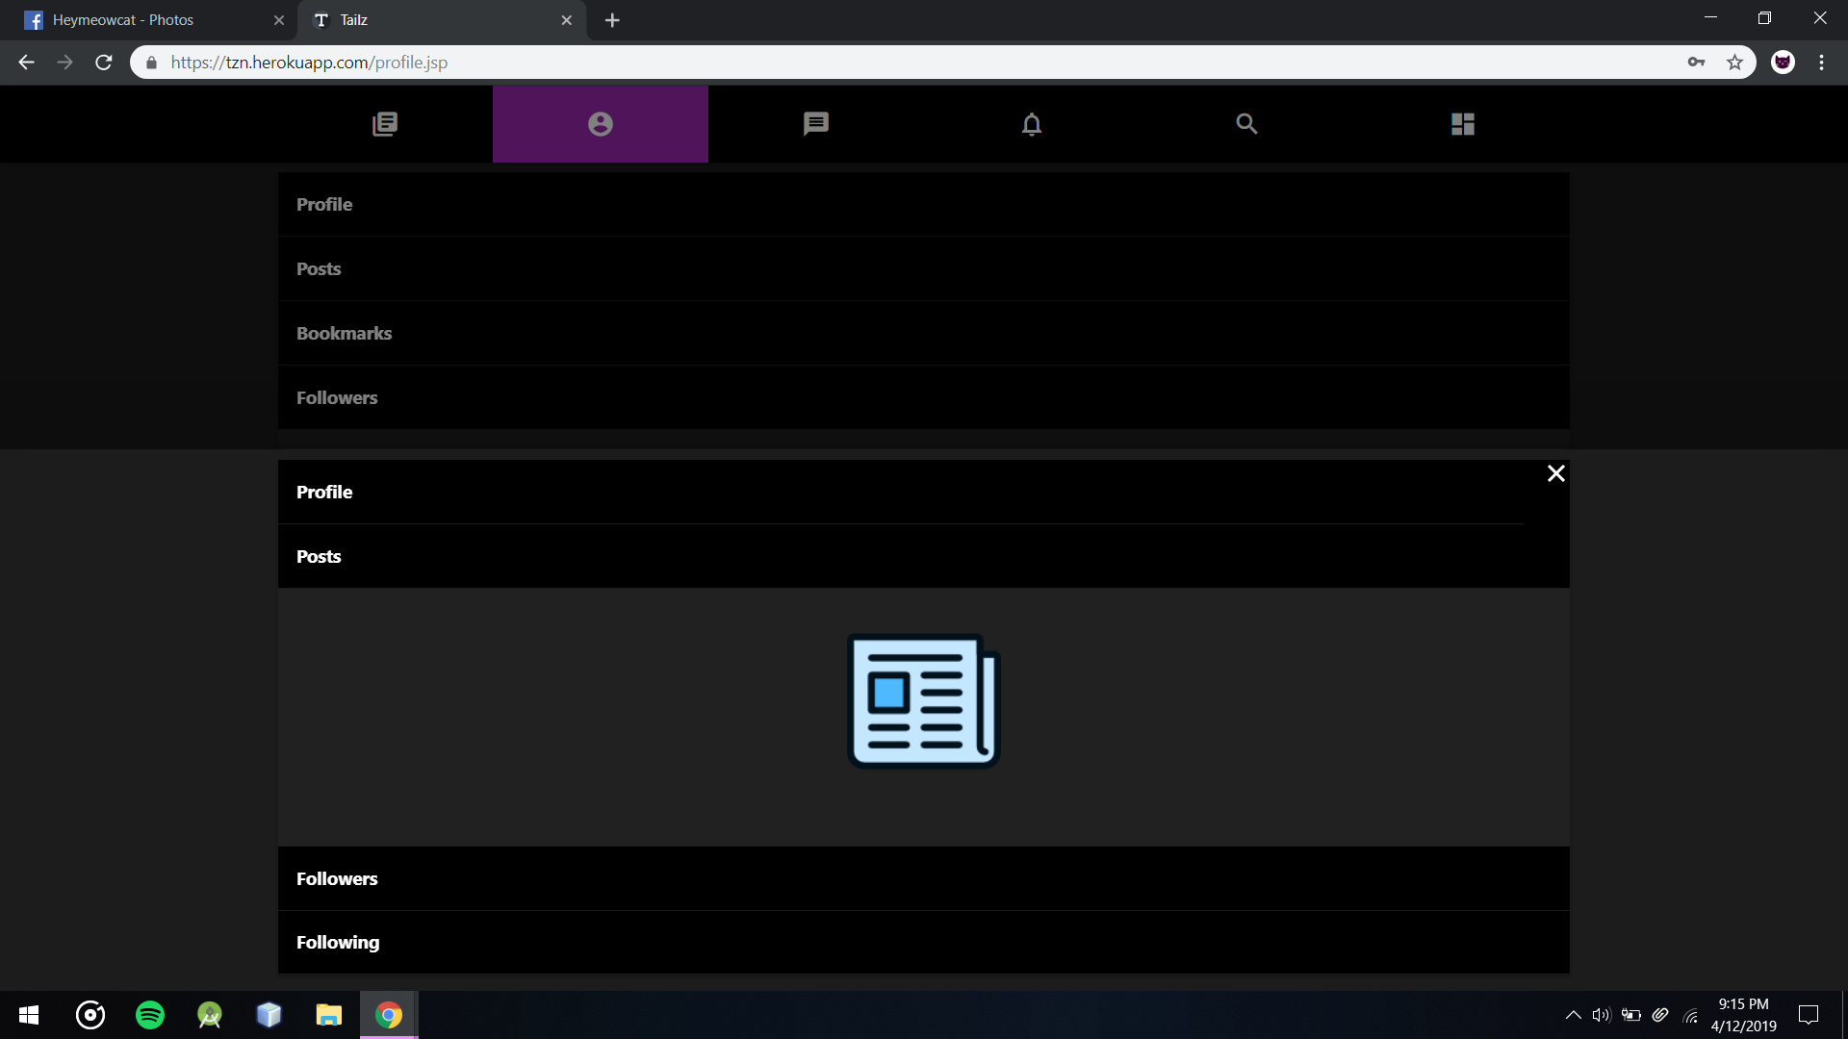

Users can view specific posts from users that their privacy option is set to public

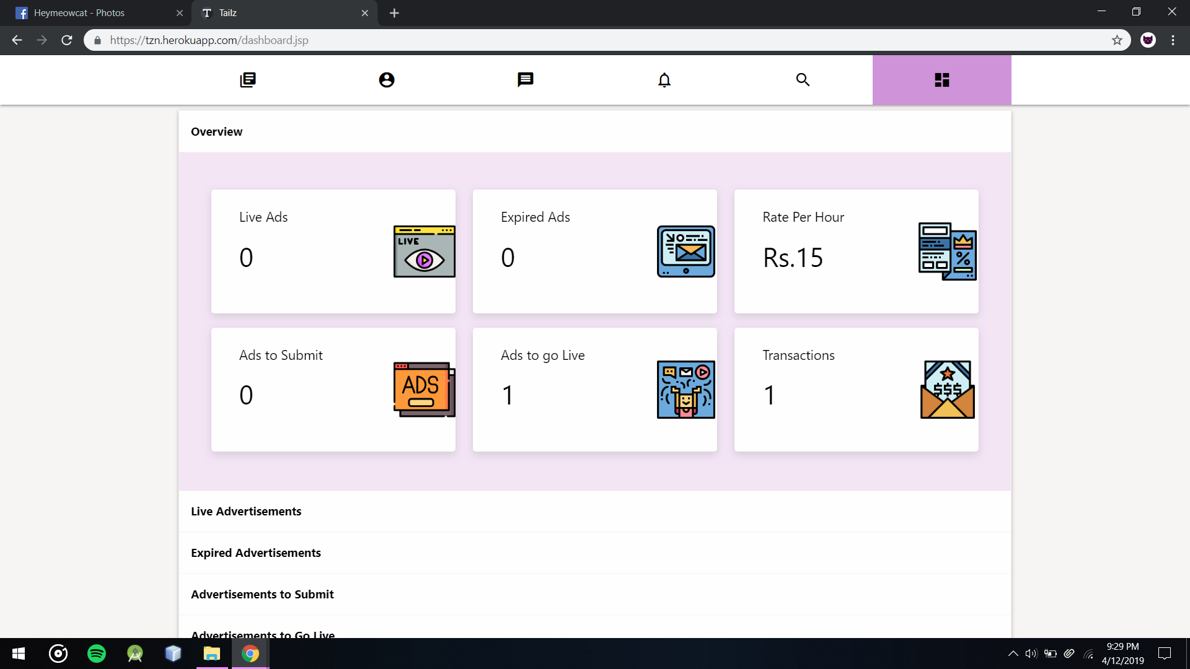

After Completing A Transaction Customer can view them quickly from Dashboard

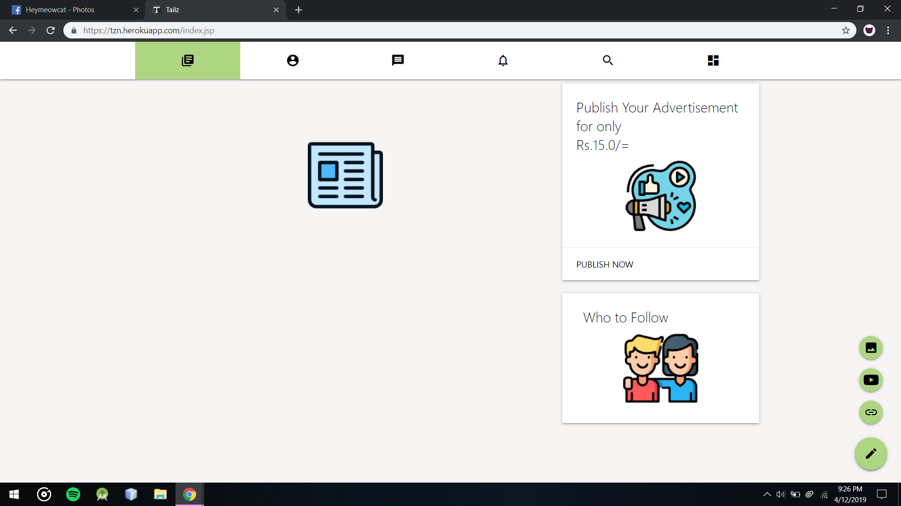

Users can create post on Tailz by 3 categories image posts, youtube posts and embed posts

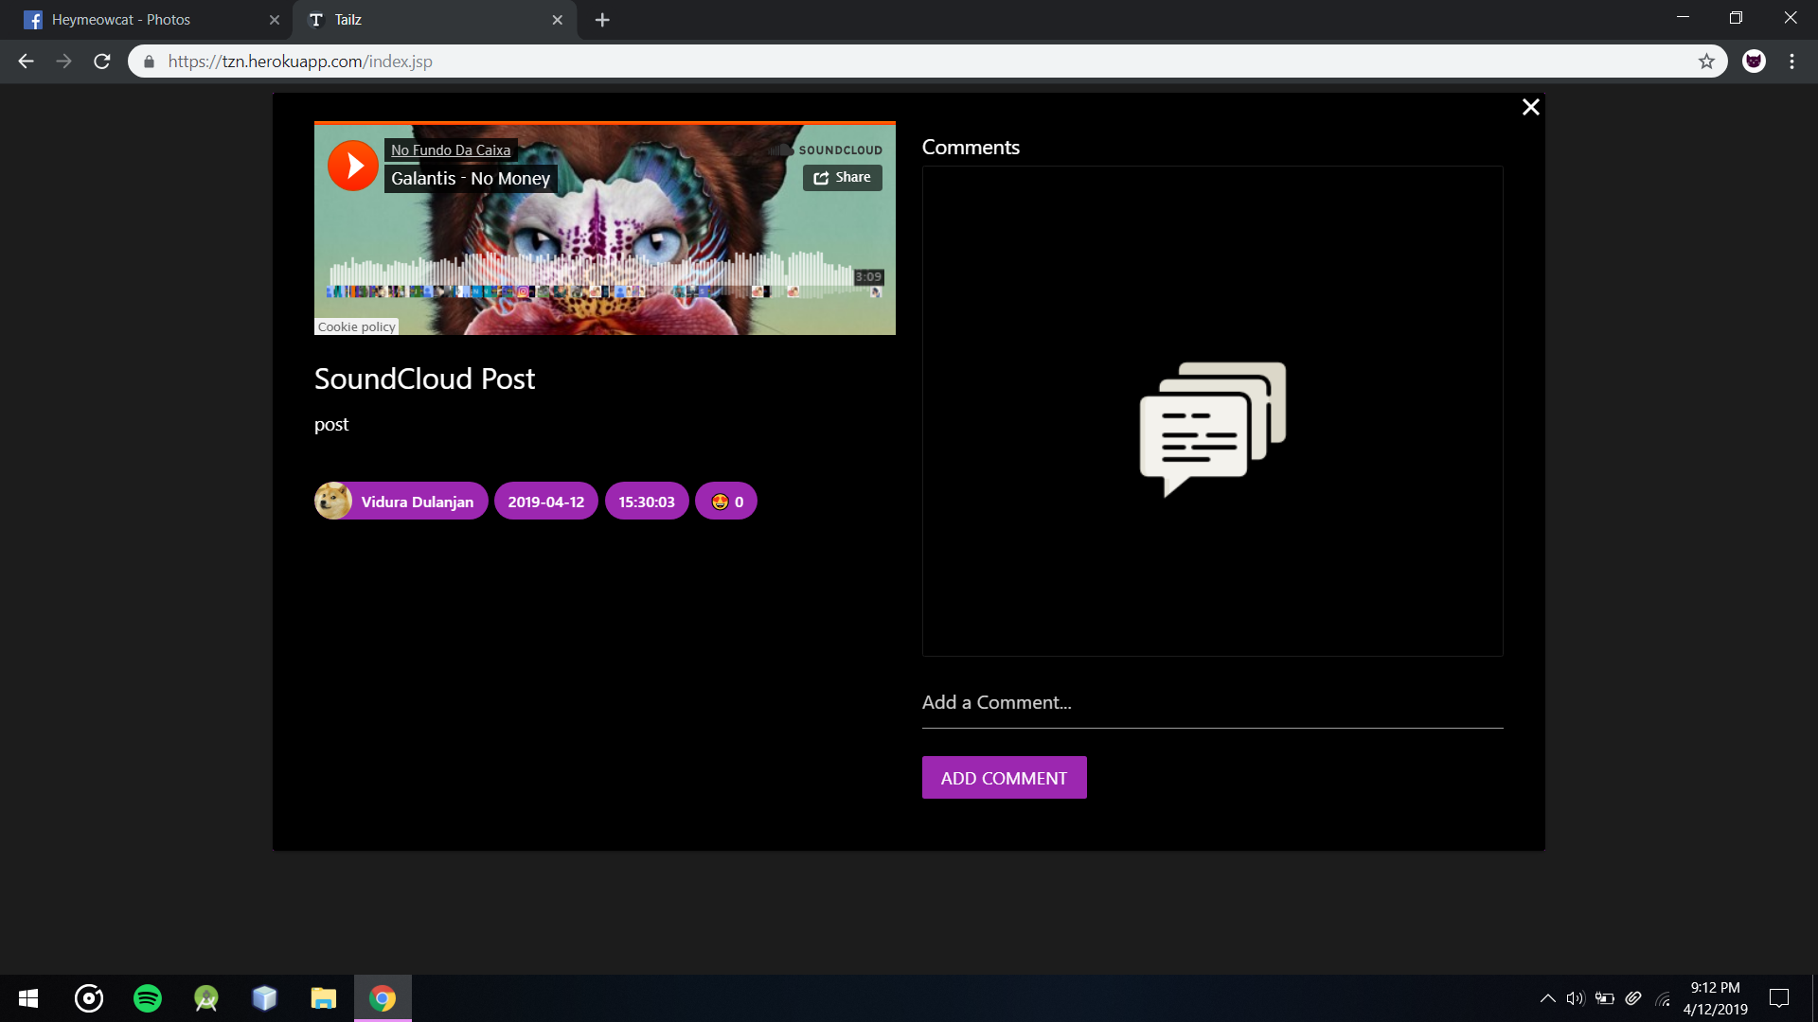

Embed SoundCloud post’s Comment Section without any comments

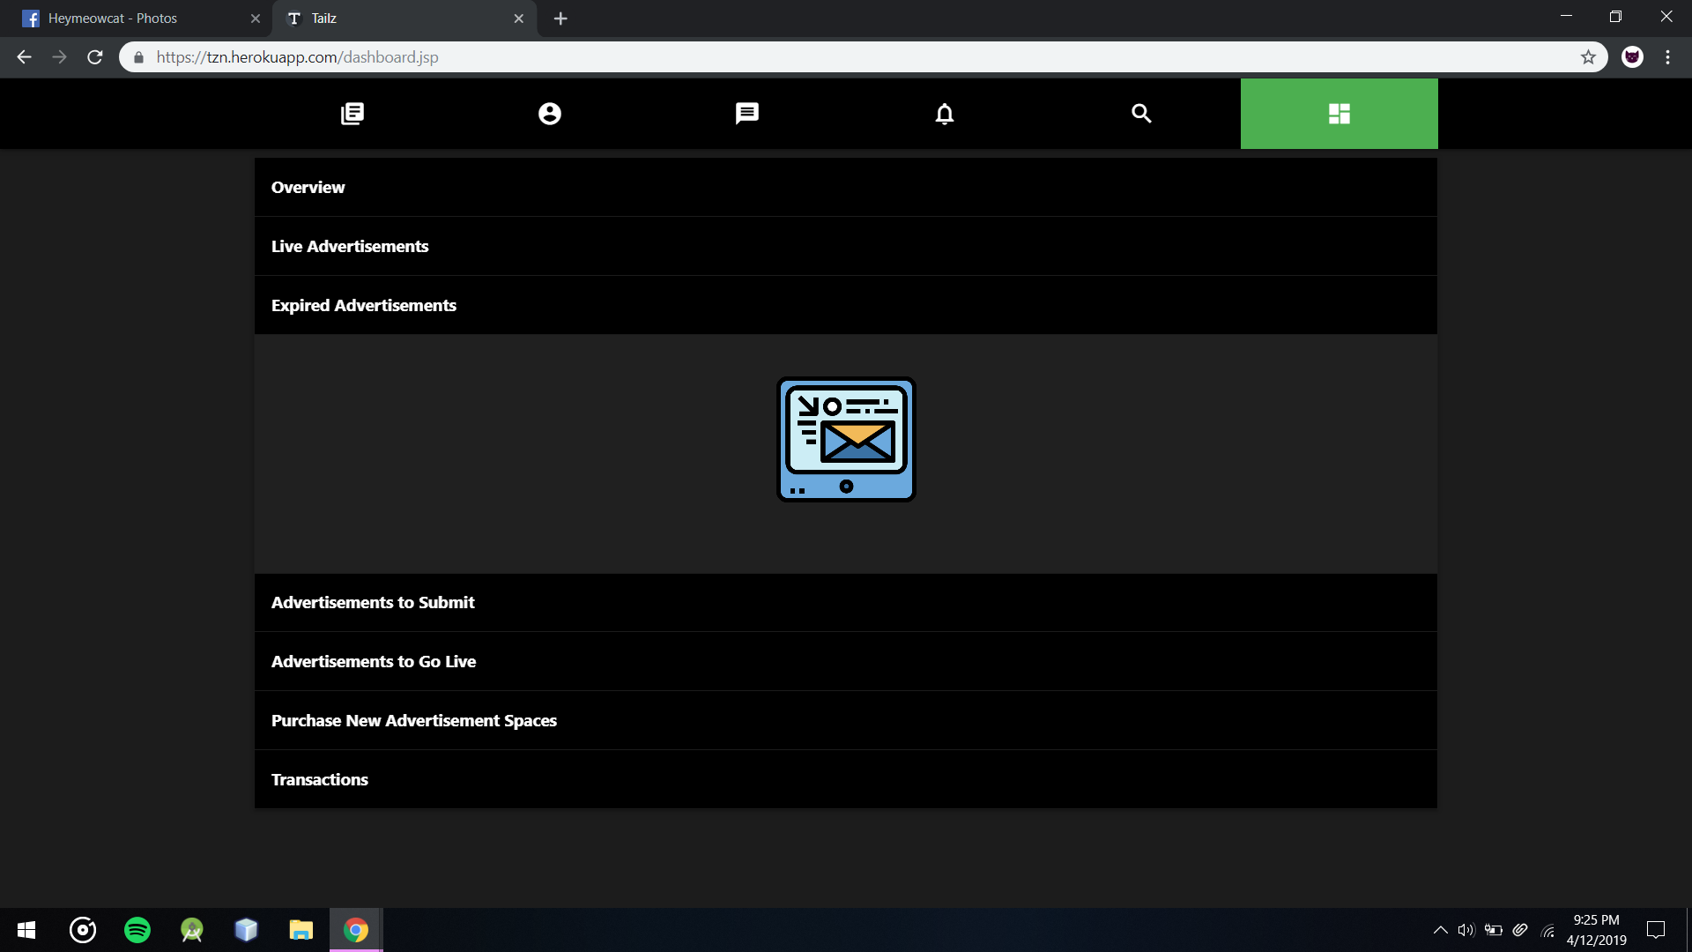

Dashboard’s Expired Advertisement Section without any Expired Ads

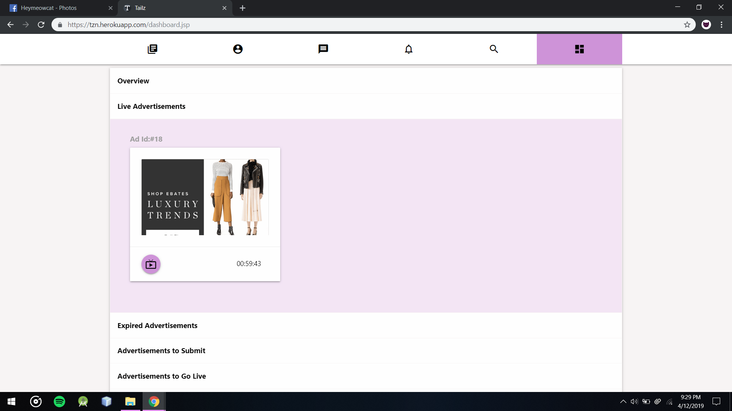  
Customers Can View Dashboard’s Live Advertisements section to view time left for each live advertisement that customer puchased

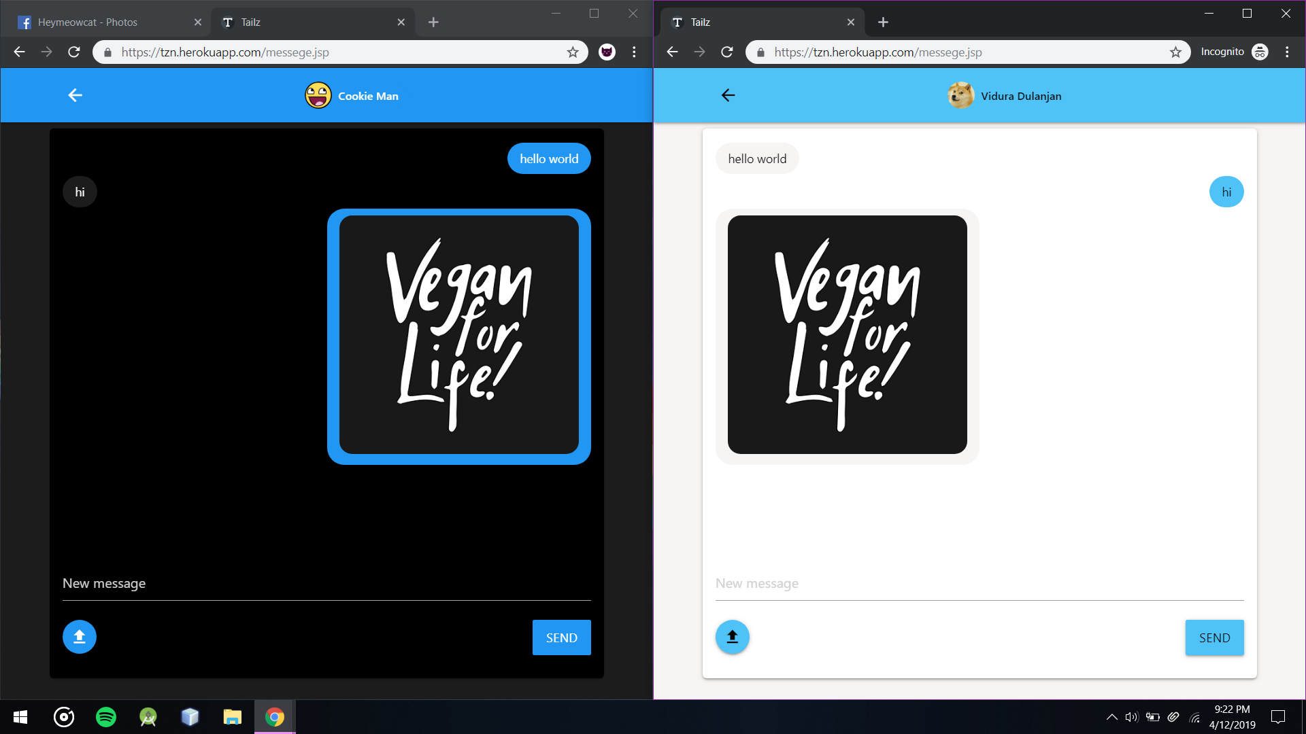

Users Can use 10 different themes which are 5 colors and 2 modes dark and light

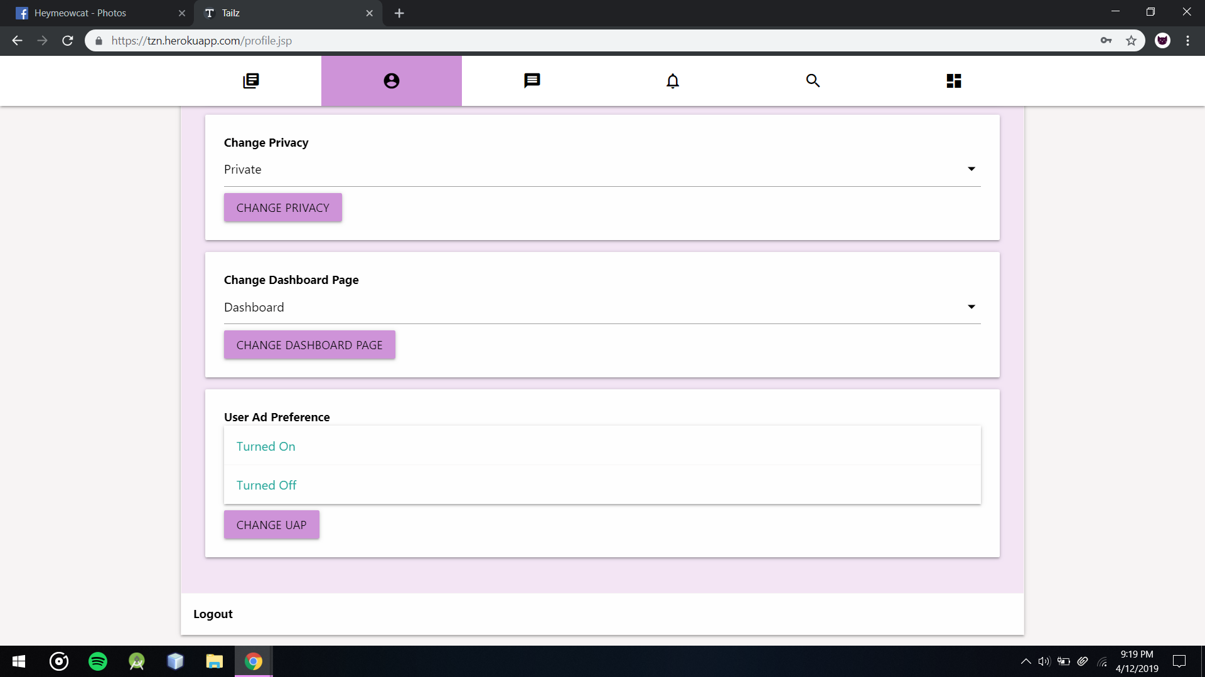

Users can turn on off Advertisements from Settings Section in Profile

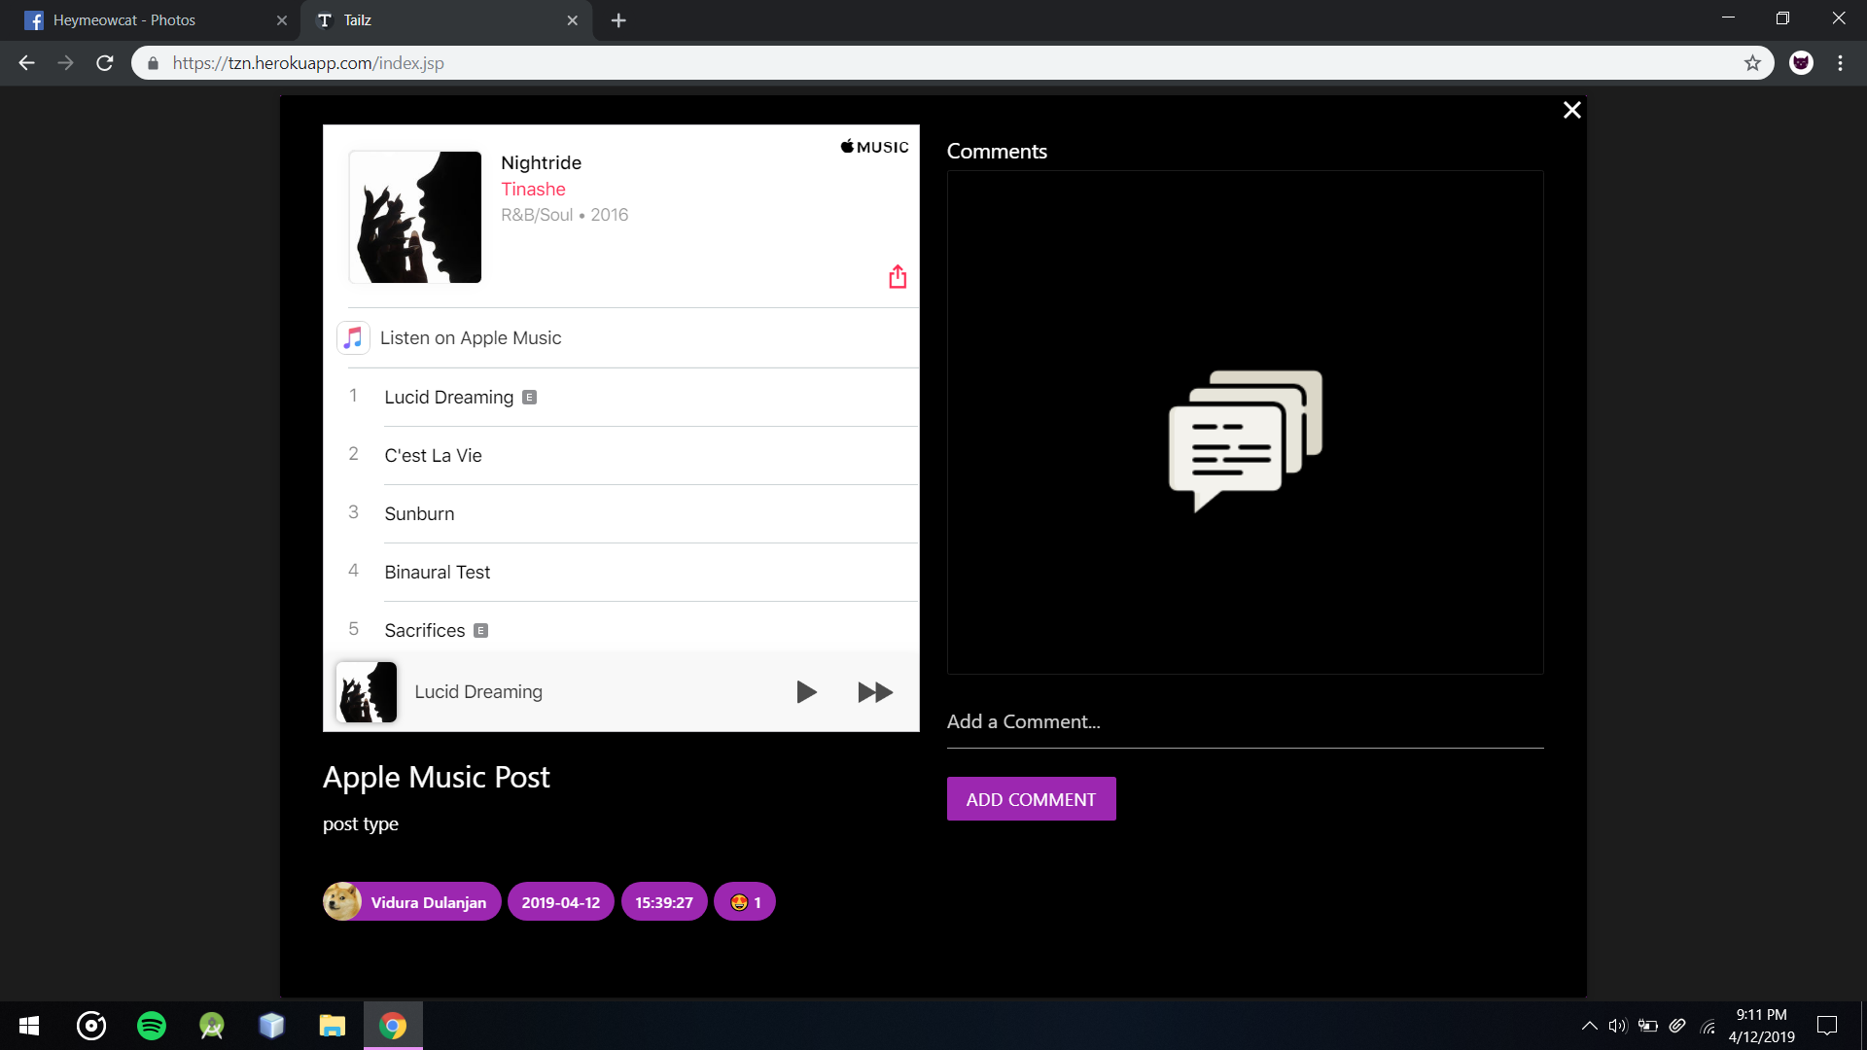

Users Can post any embed posts from creating new embed post from home

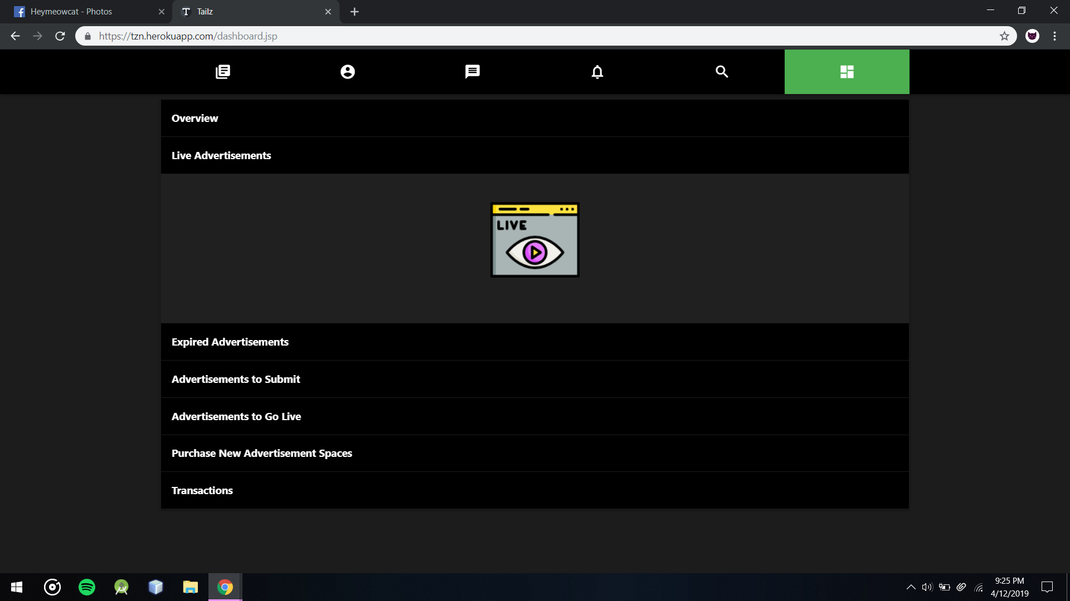

Customers Live Advertisements Section without any Ads

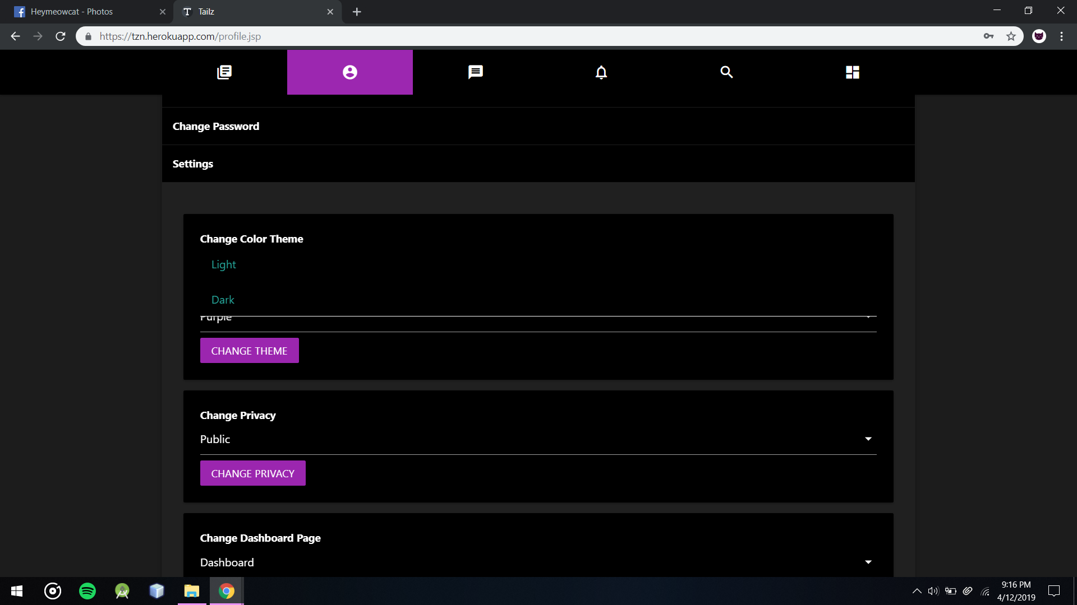

User Can Set Color theme mode to Light or Dark from settings section in Profile

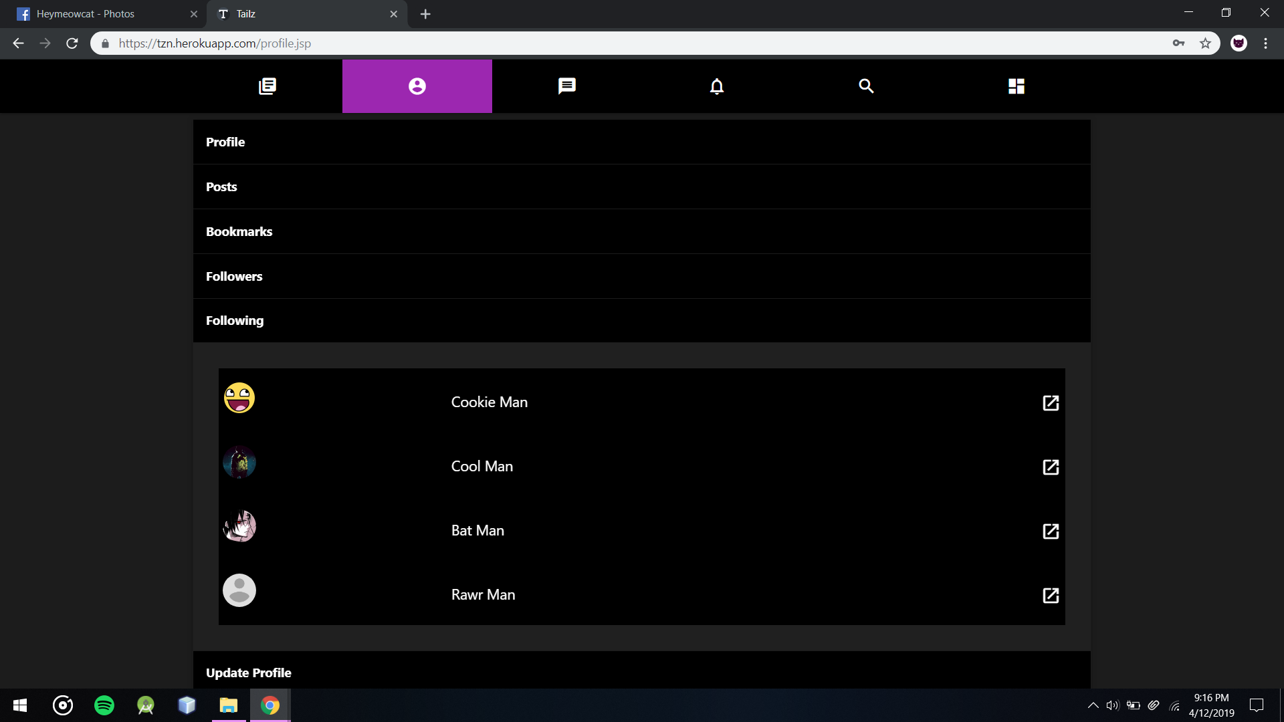

User Profile’s Following Section

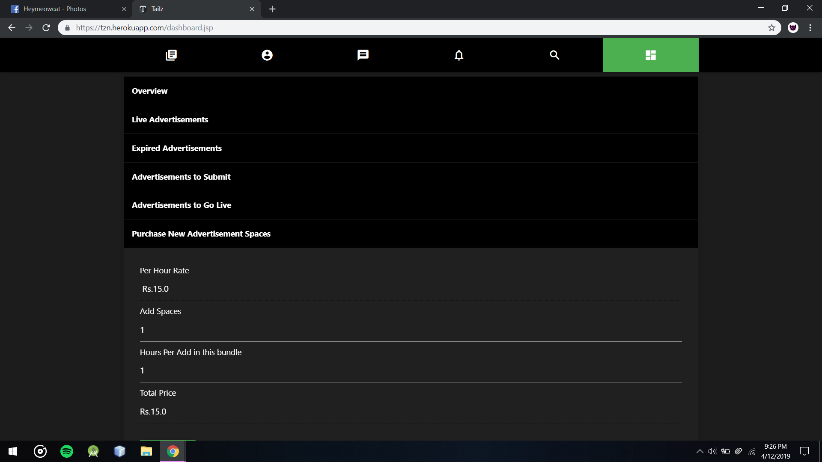

Customer Dashboard’s Purchase New Advertisement Spaces section which Customers can purchase Advertisements in bundles and customize the order

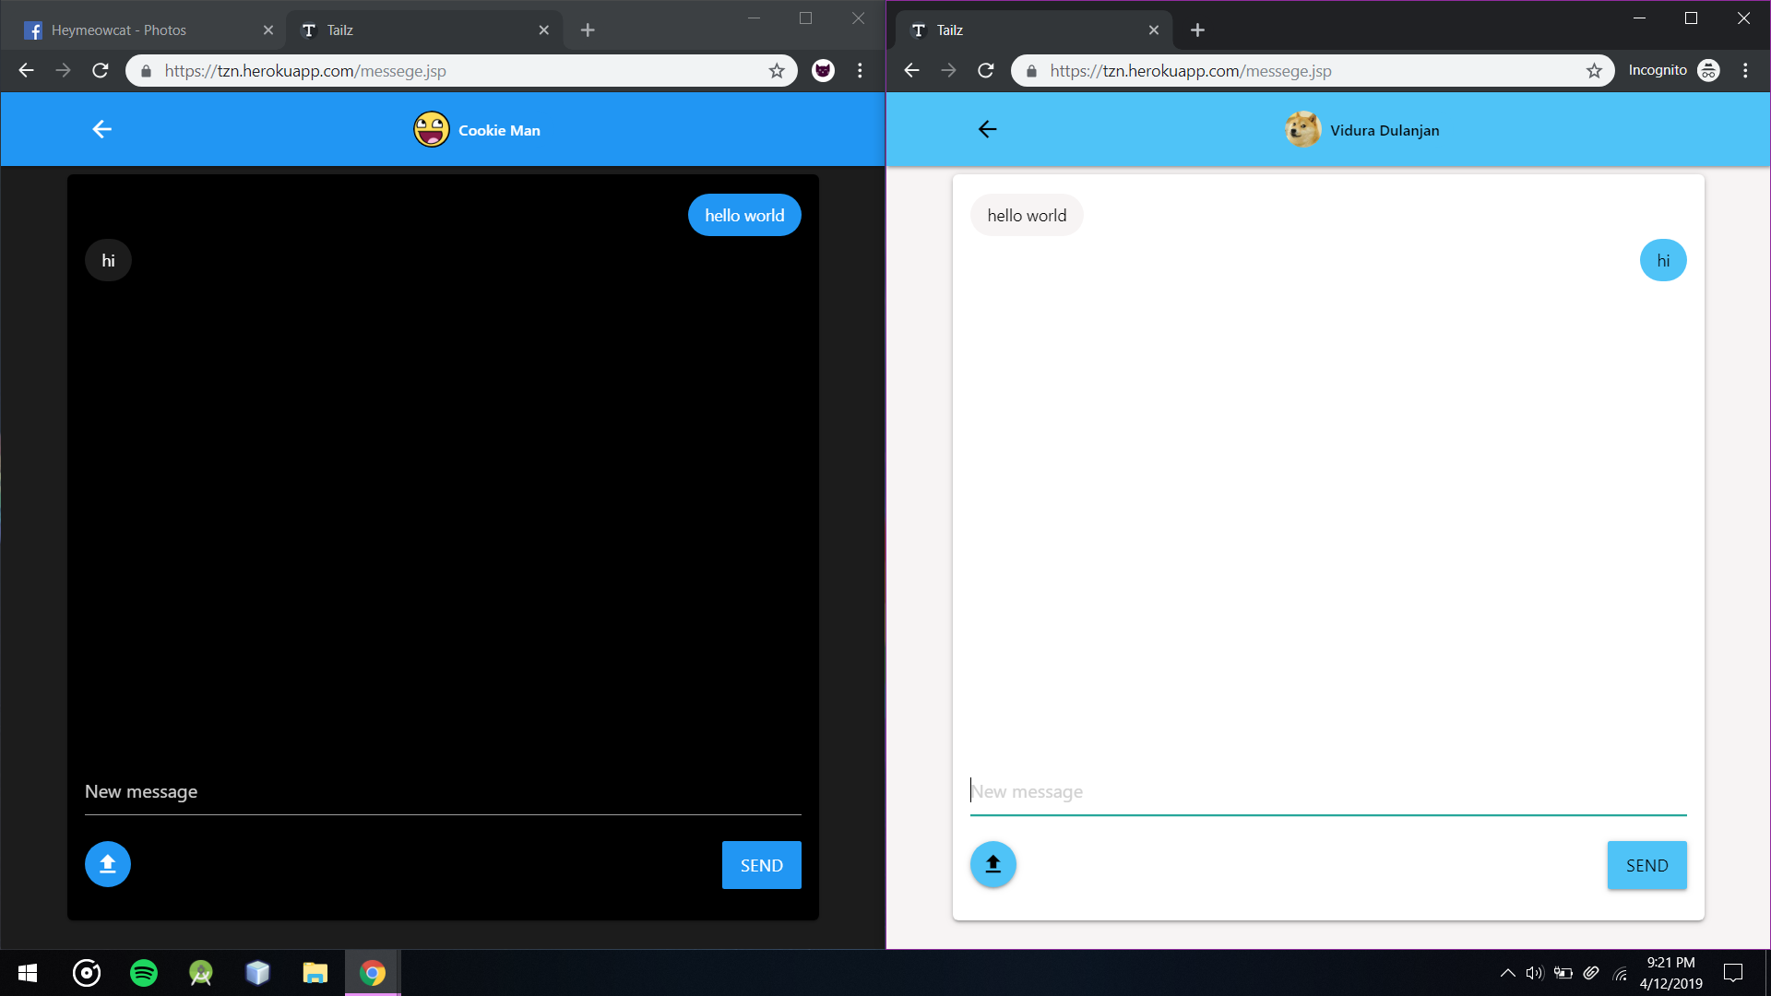

Messaging section after opens chat boxes

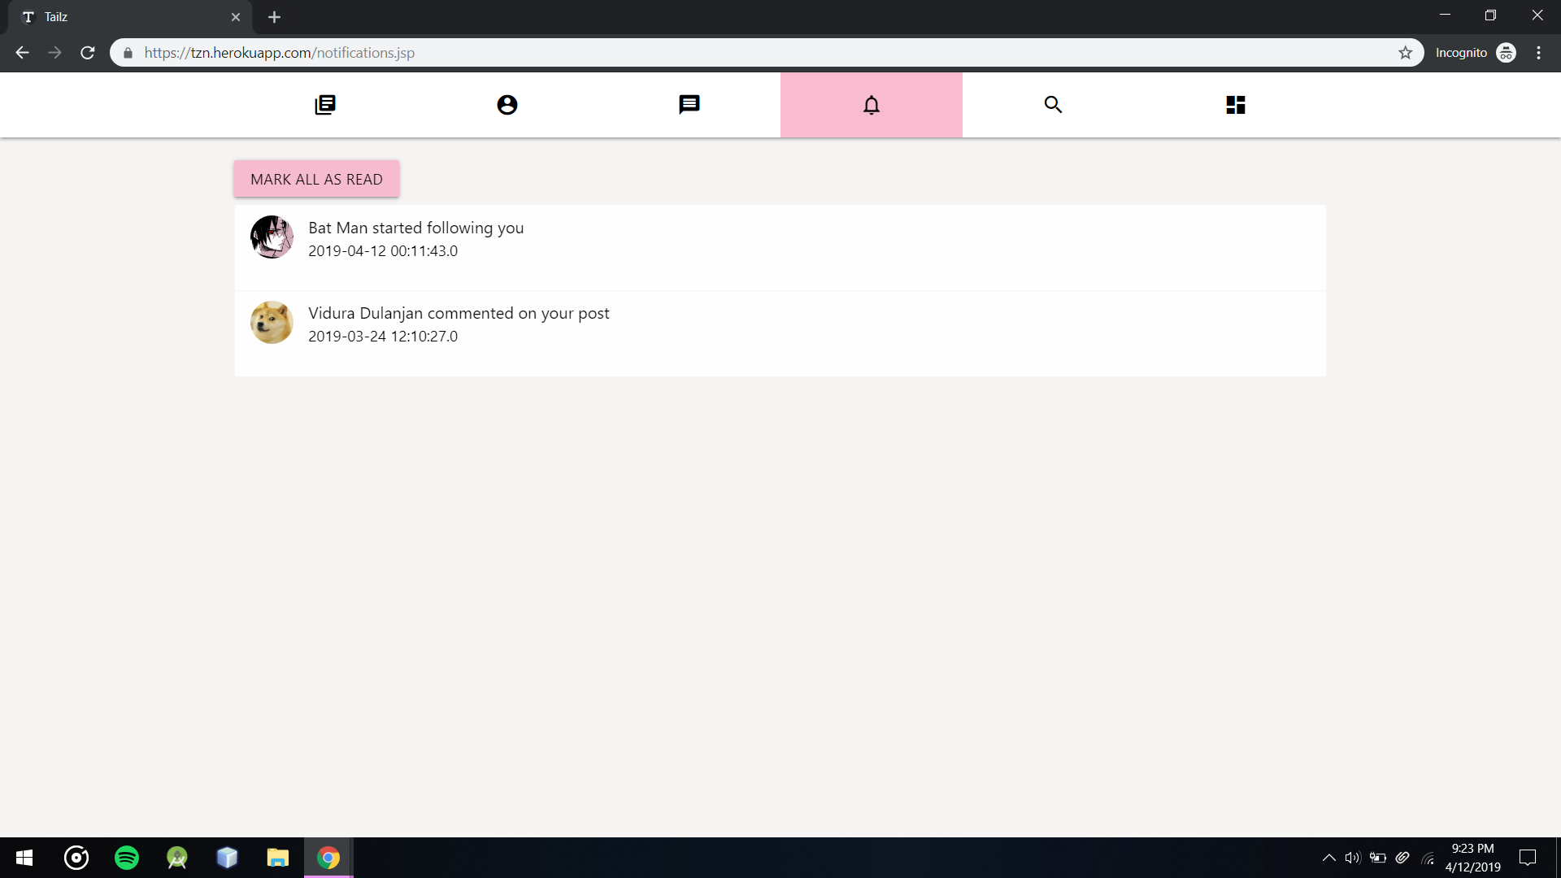

Users Notification Section

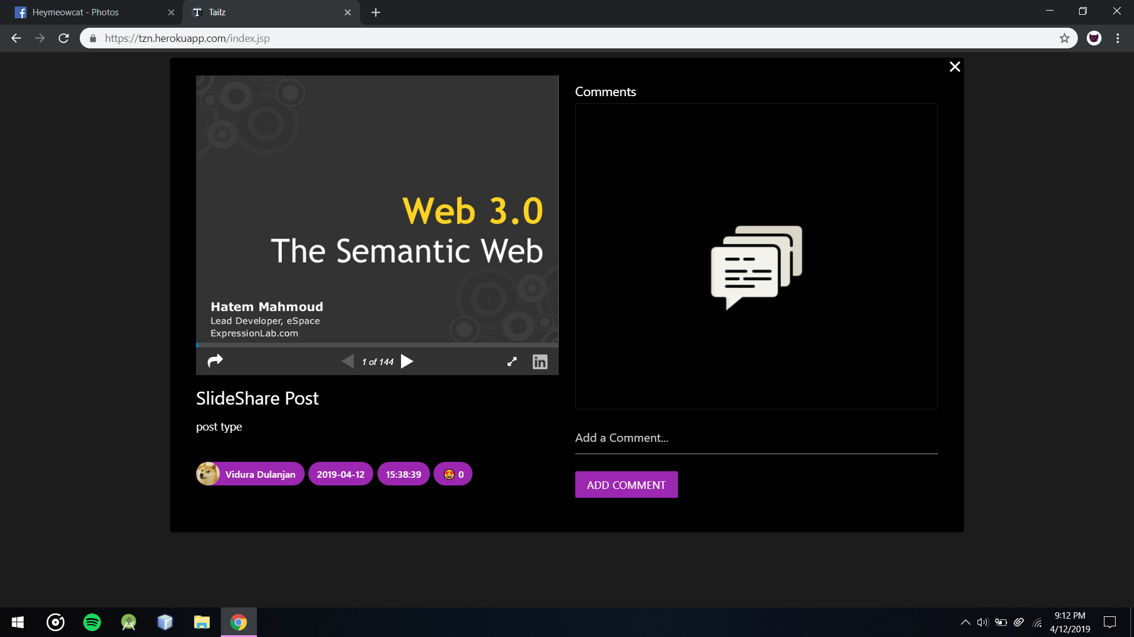

Embed SlideShare Post opened

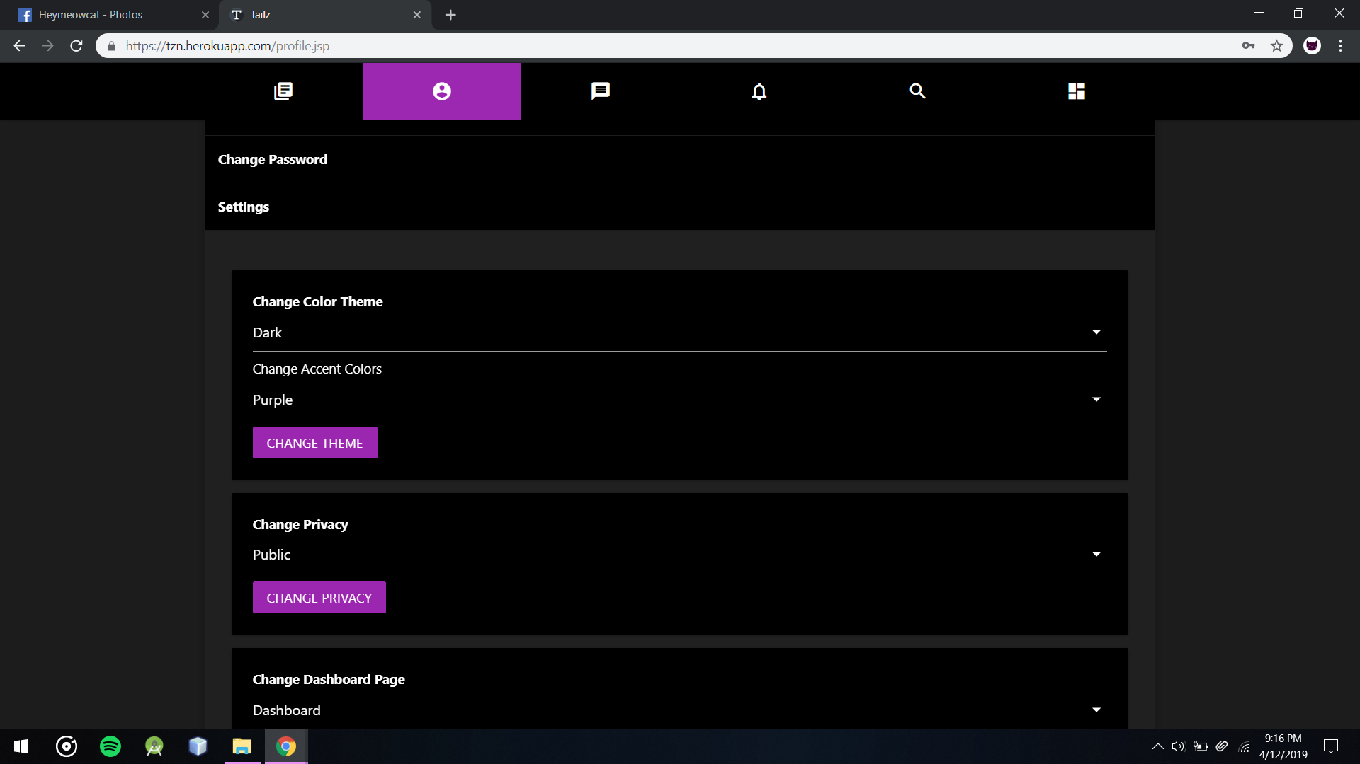

Users Settings Section in Profile

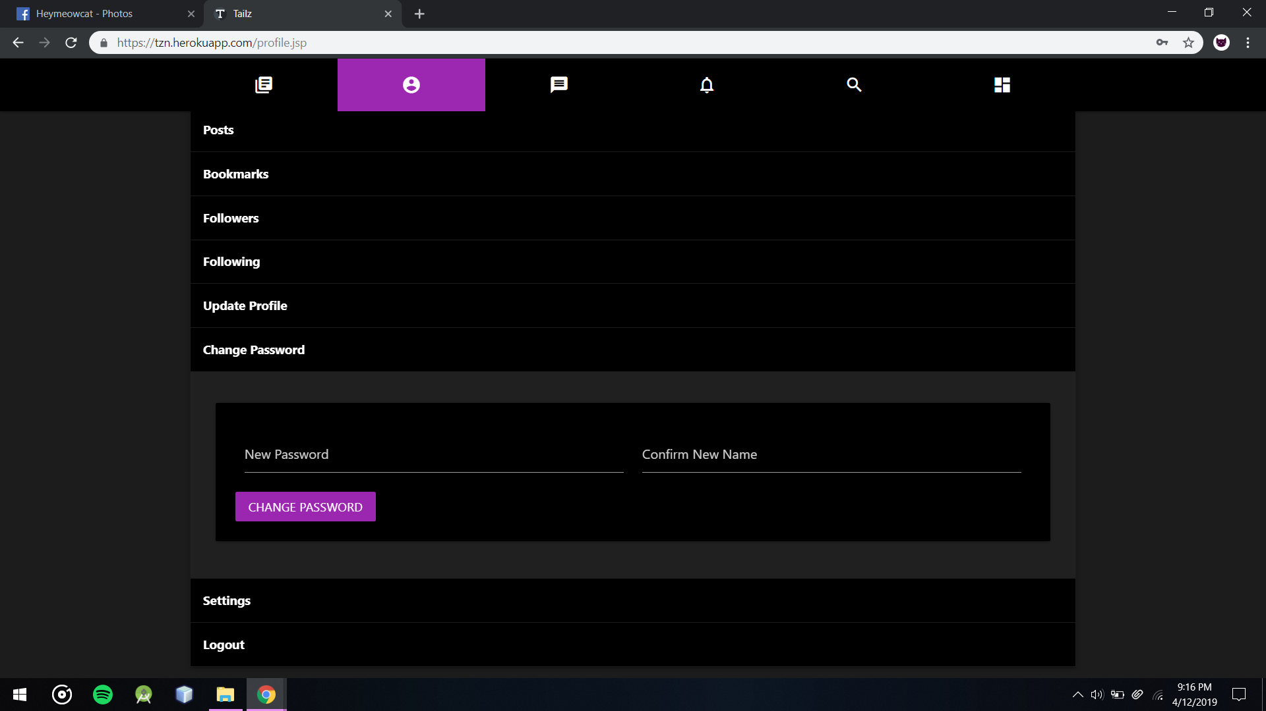

Users Can change password from Change Password section in Profile

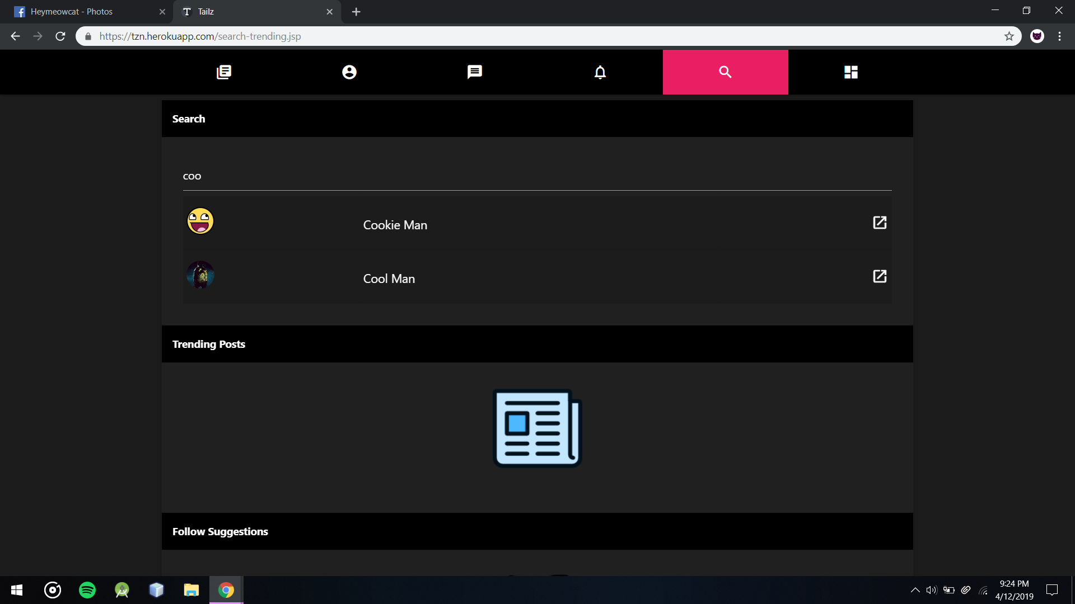

Search and Trending Section with Search system to file people ordered by mutual followings

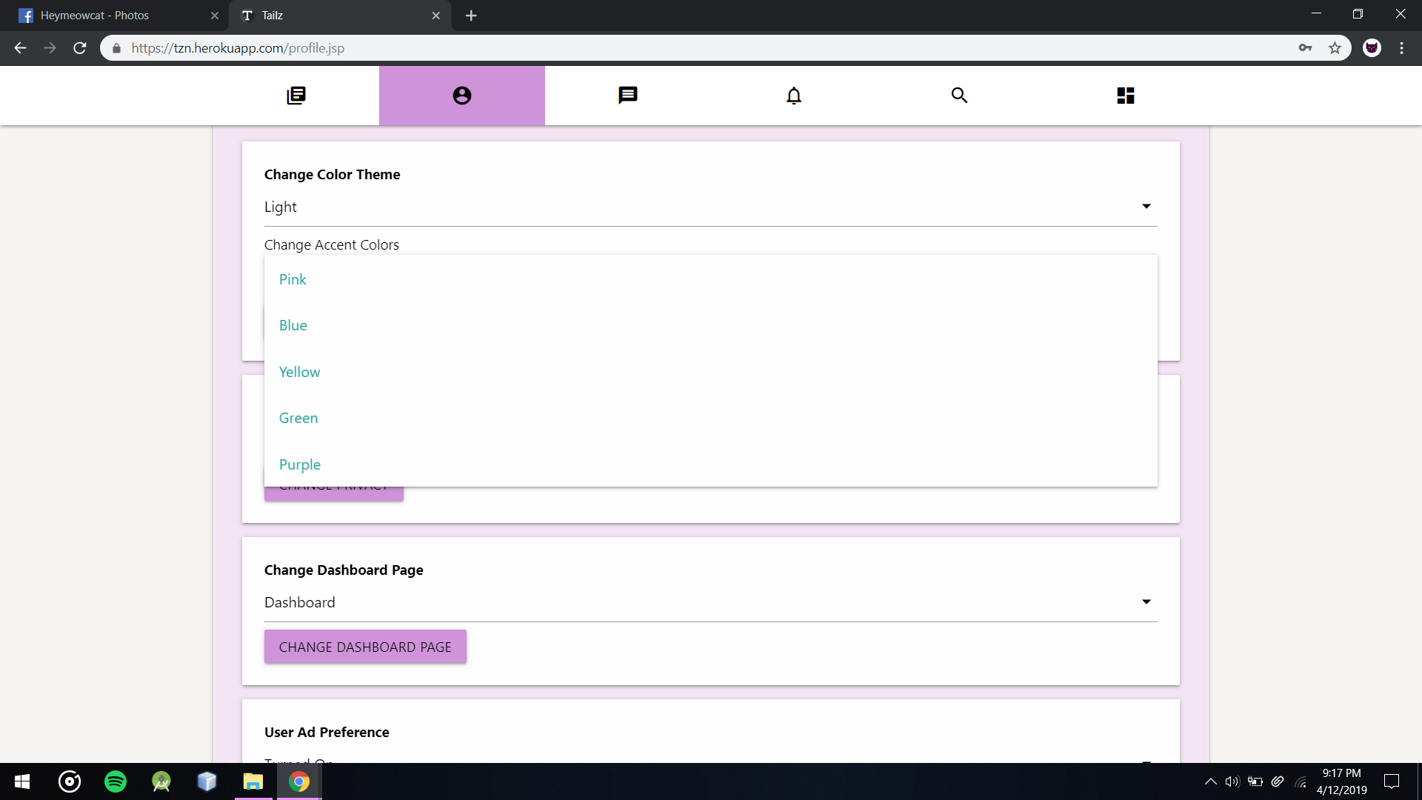

Users Can Chose 5 different accent colors

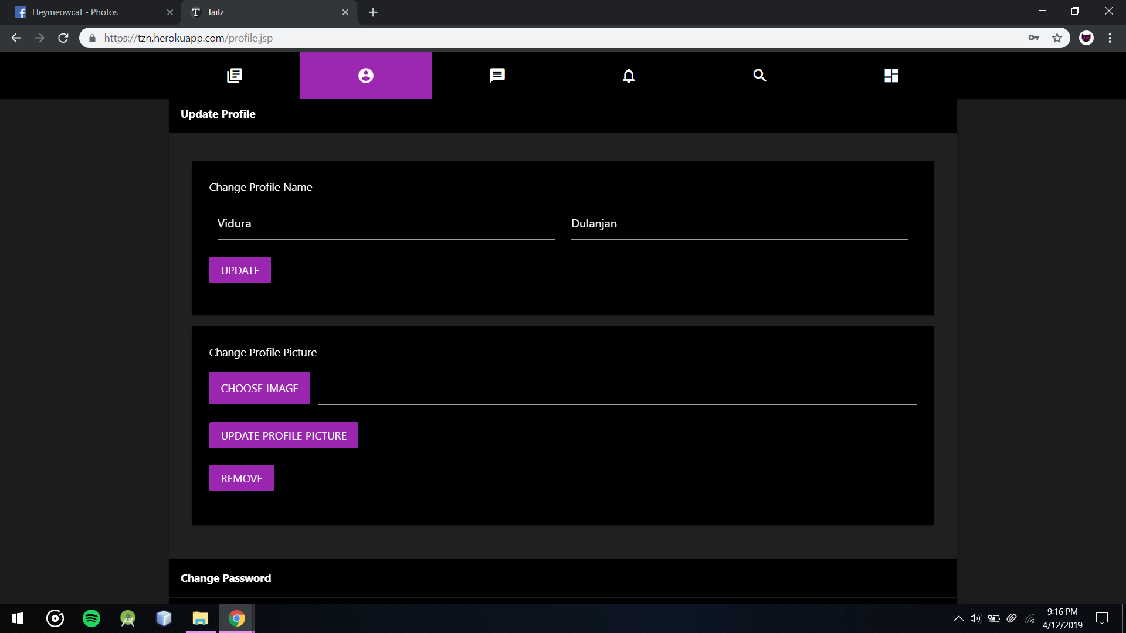

Users Update Profile Section

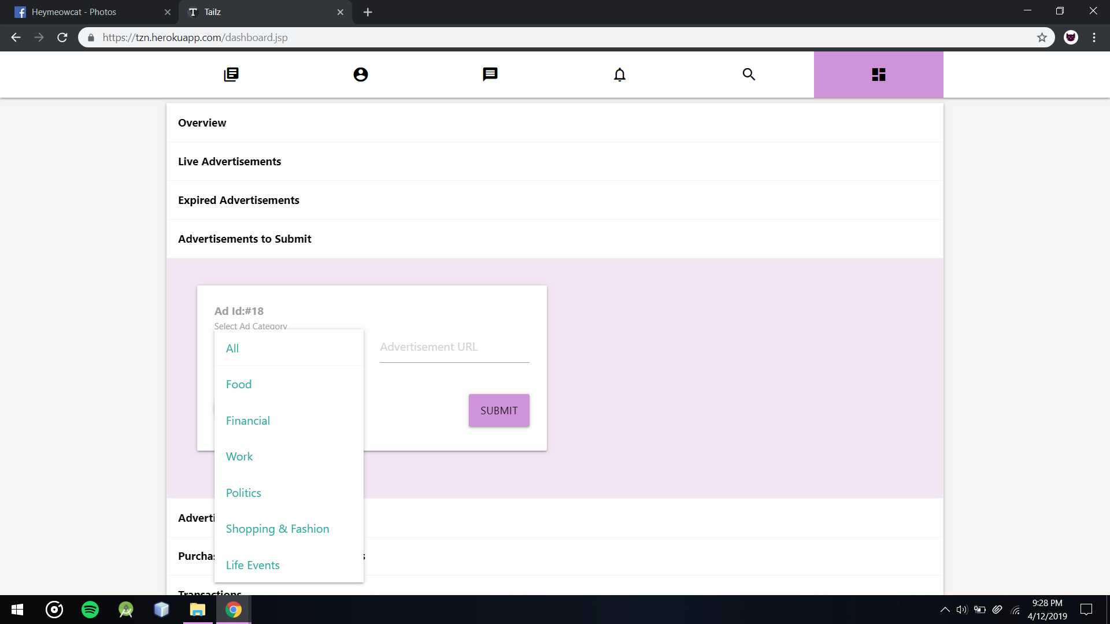

Customers Can chose different types of Categories when Completing Advertisement

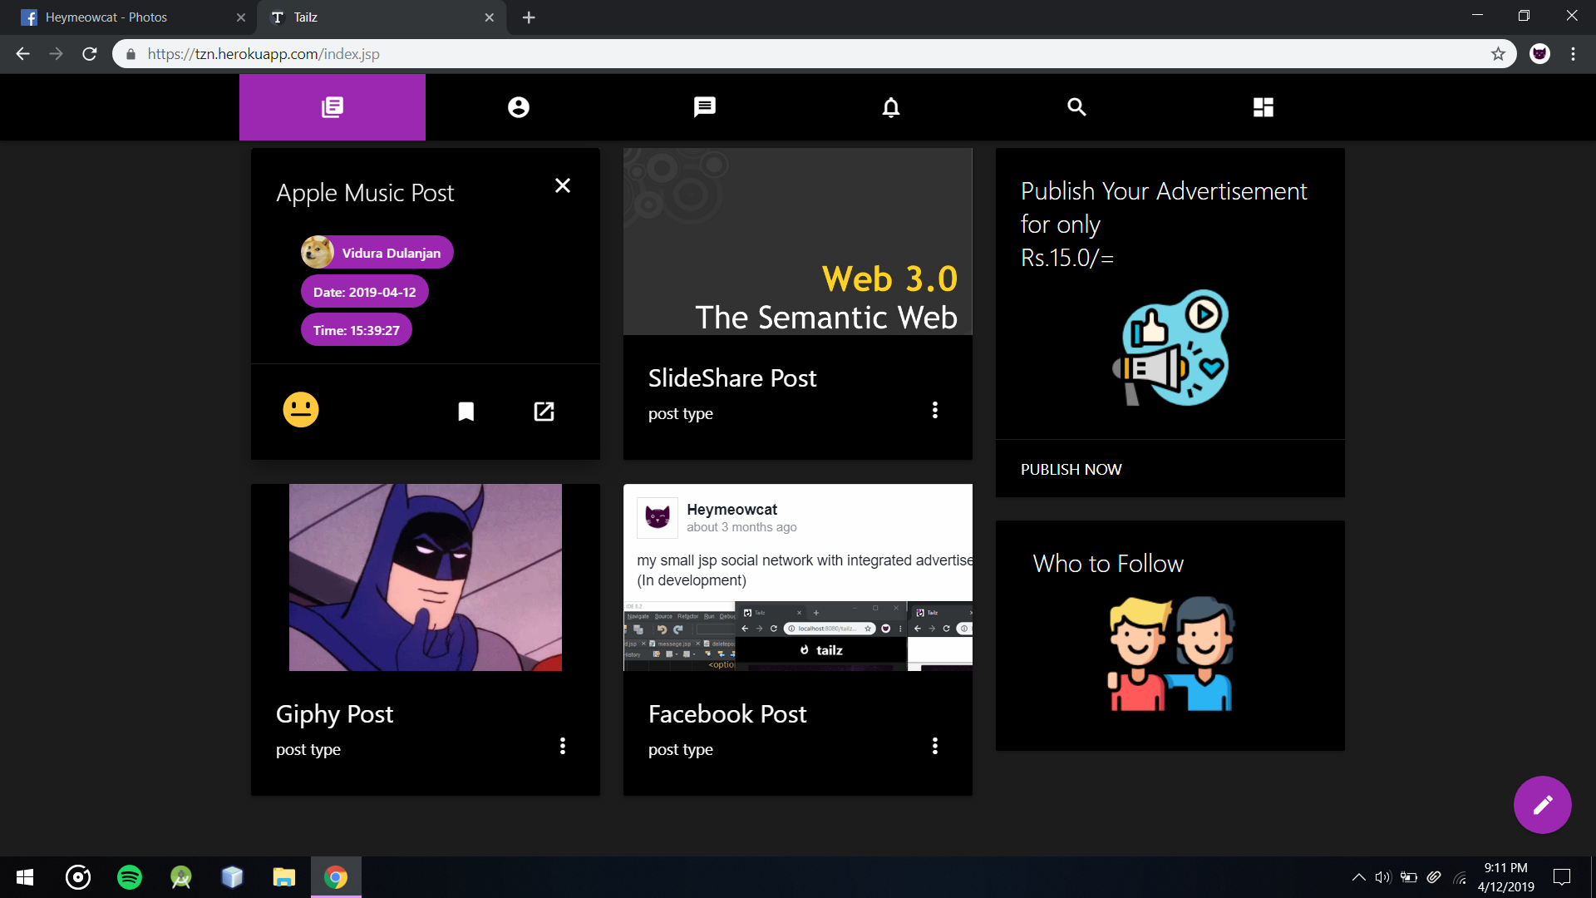

Post’s Details and actions can be found on clicking on menu icon below the post

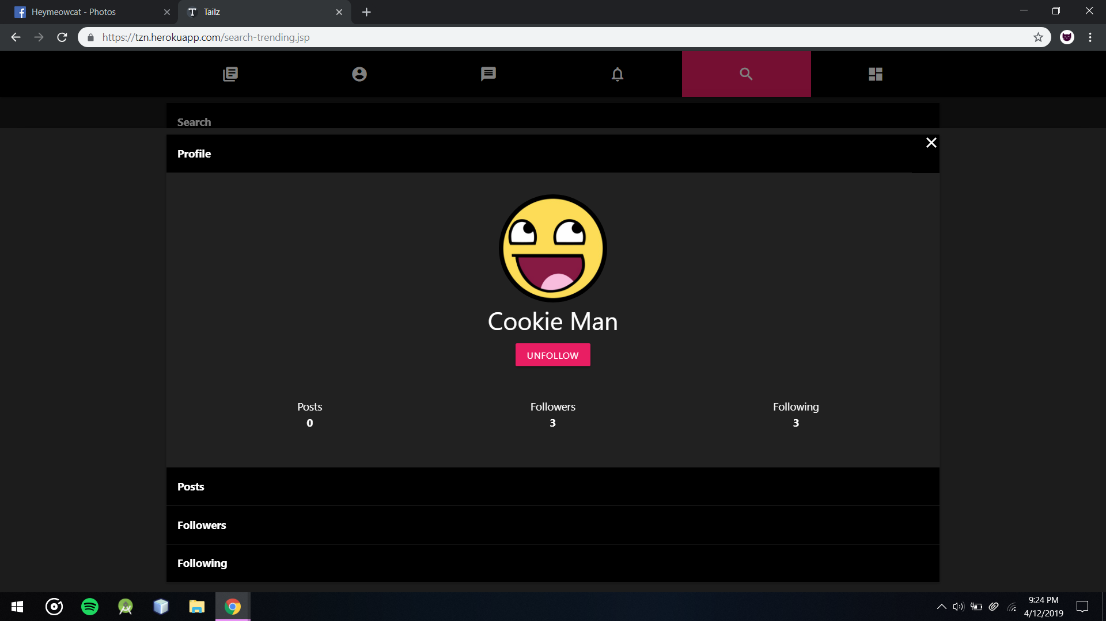

Users Can View the profile of Users after searching them to unfollow/follow or view posts of that user

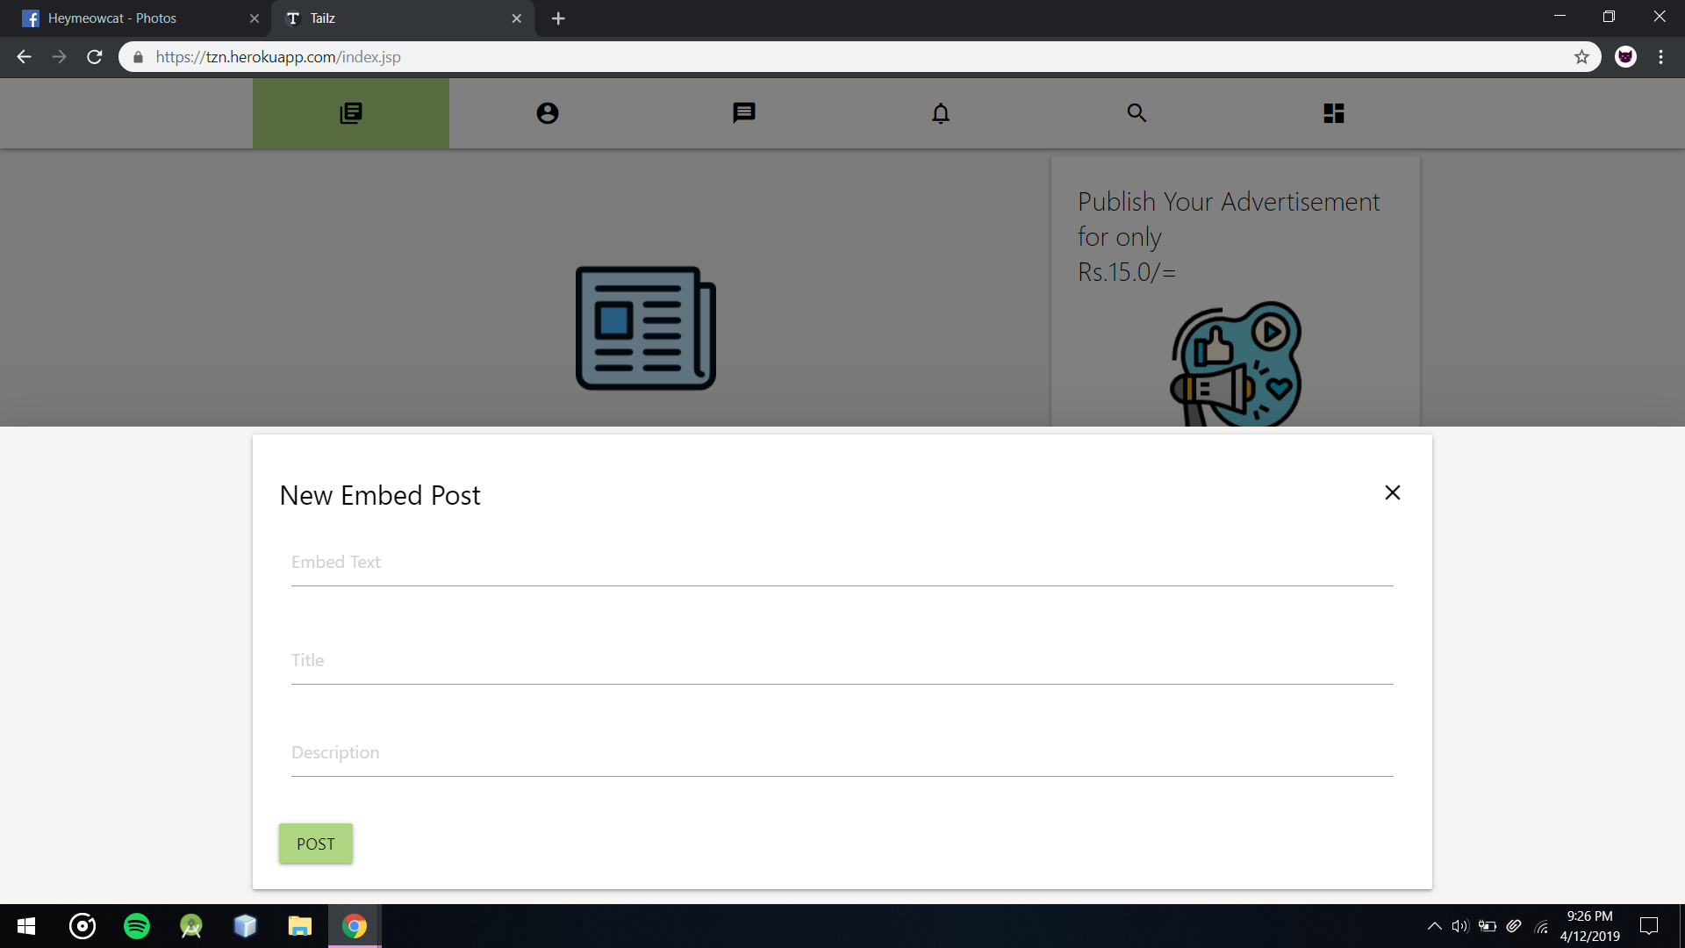

New Embed Post form

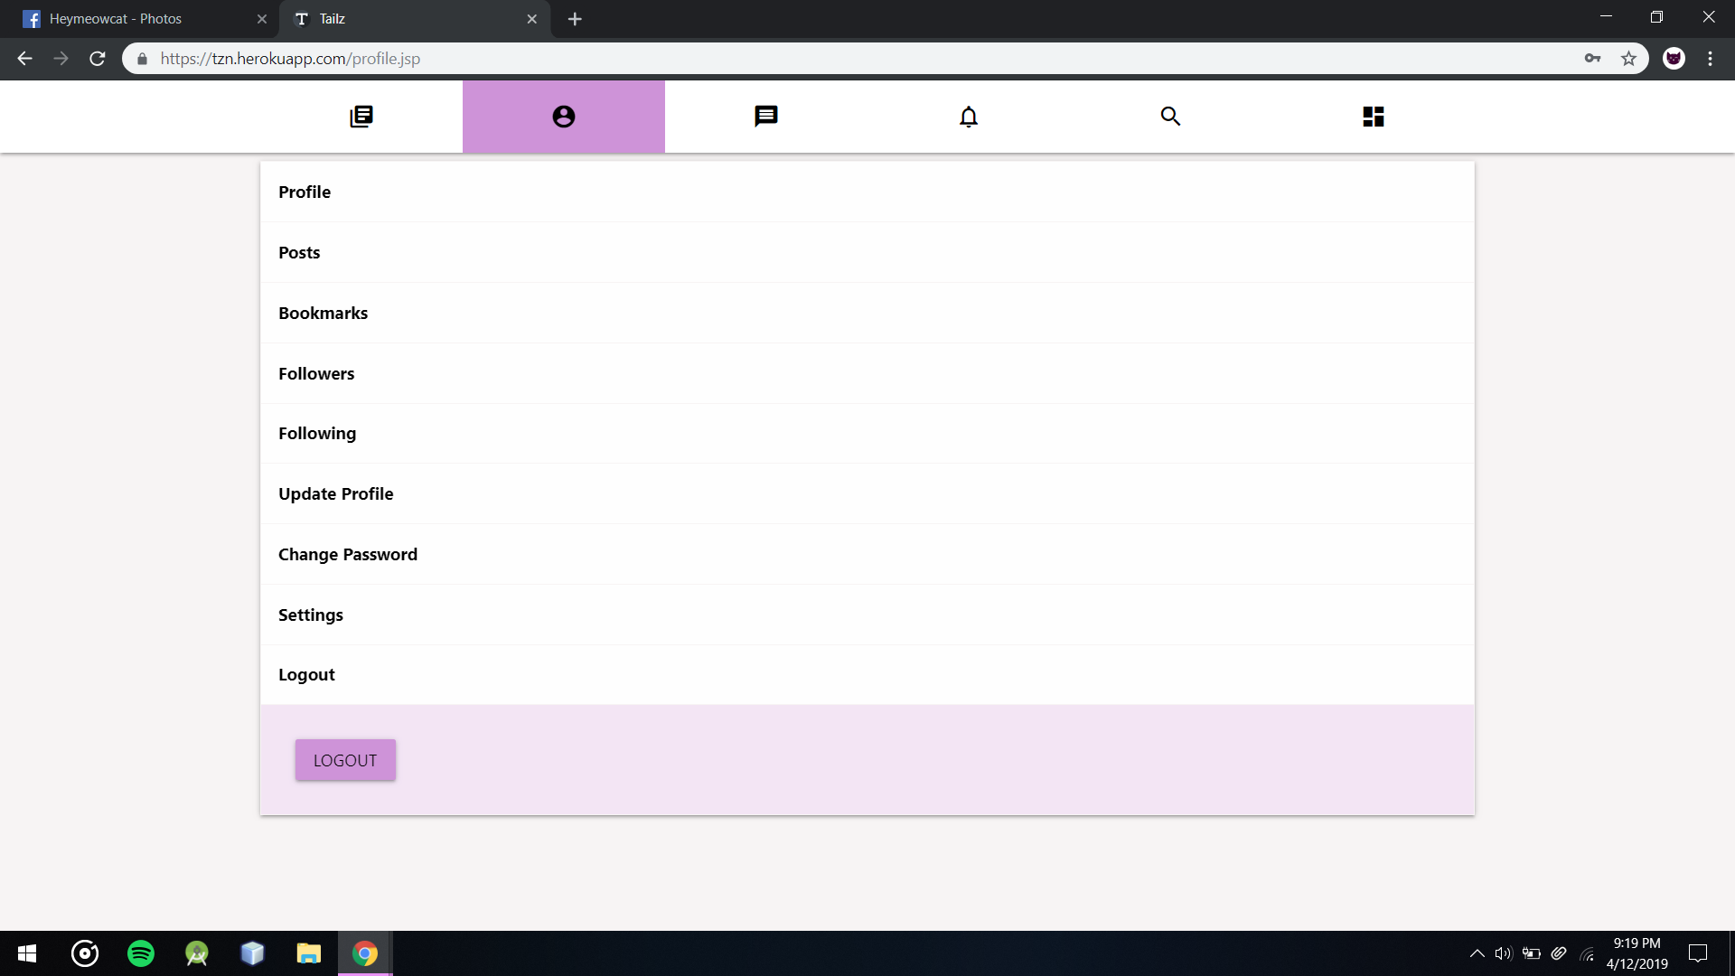

Users can logout from Logout button in Logout section in Profile

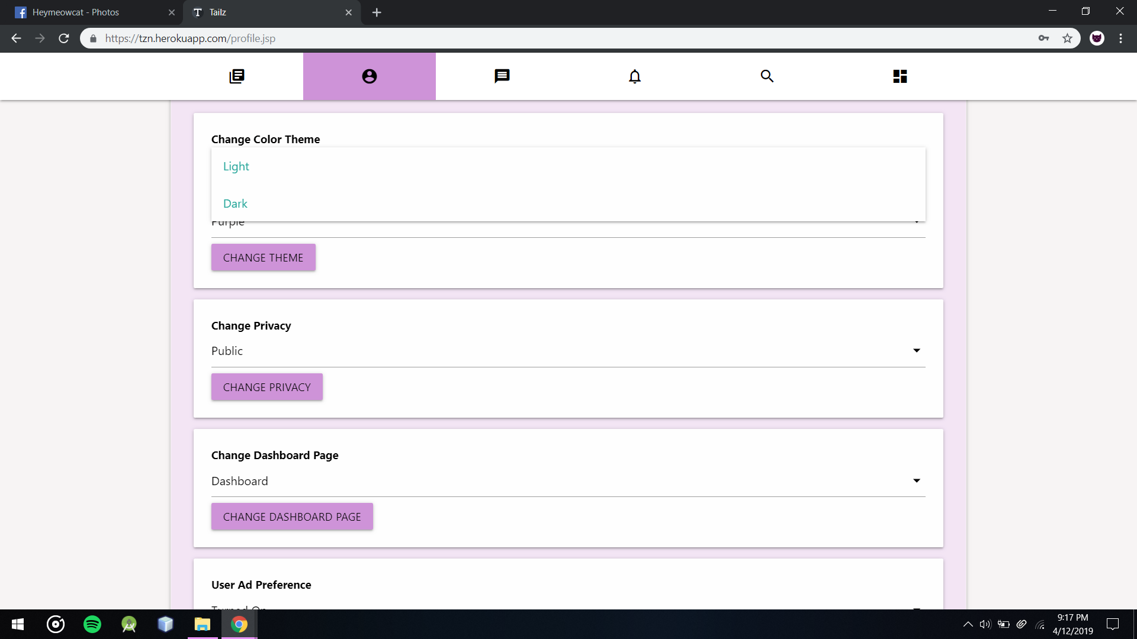

User Can select 2 color modes Dark and Light

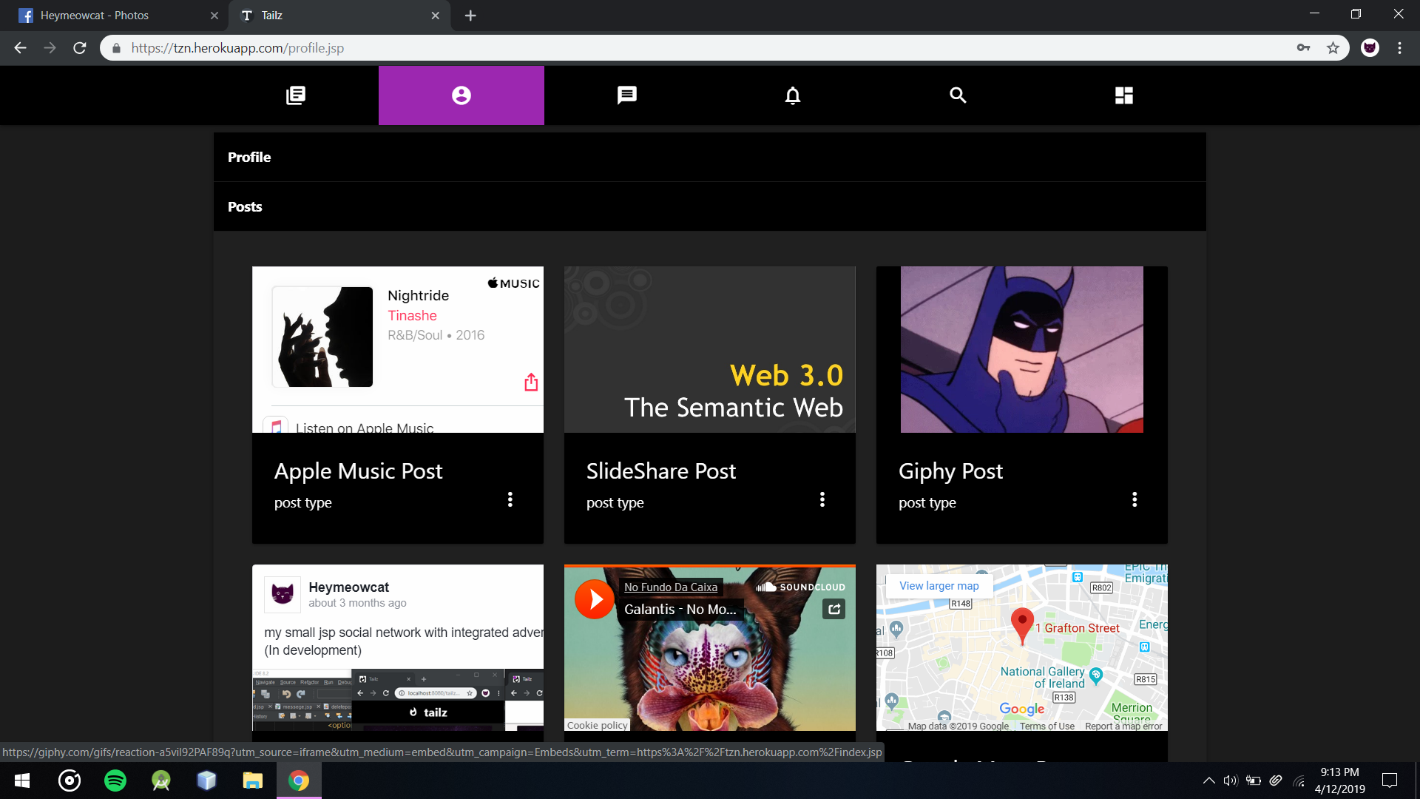

User Can View and Delete Posts that user posted from Profile Section

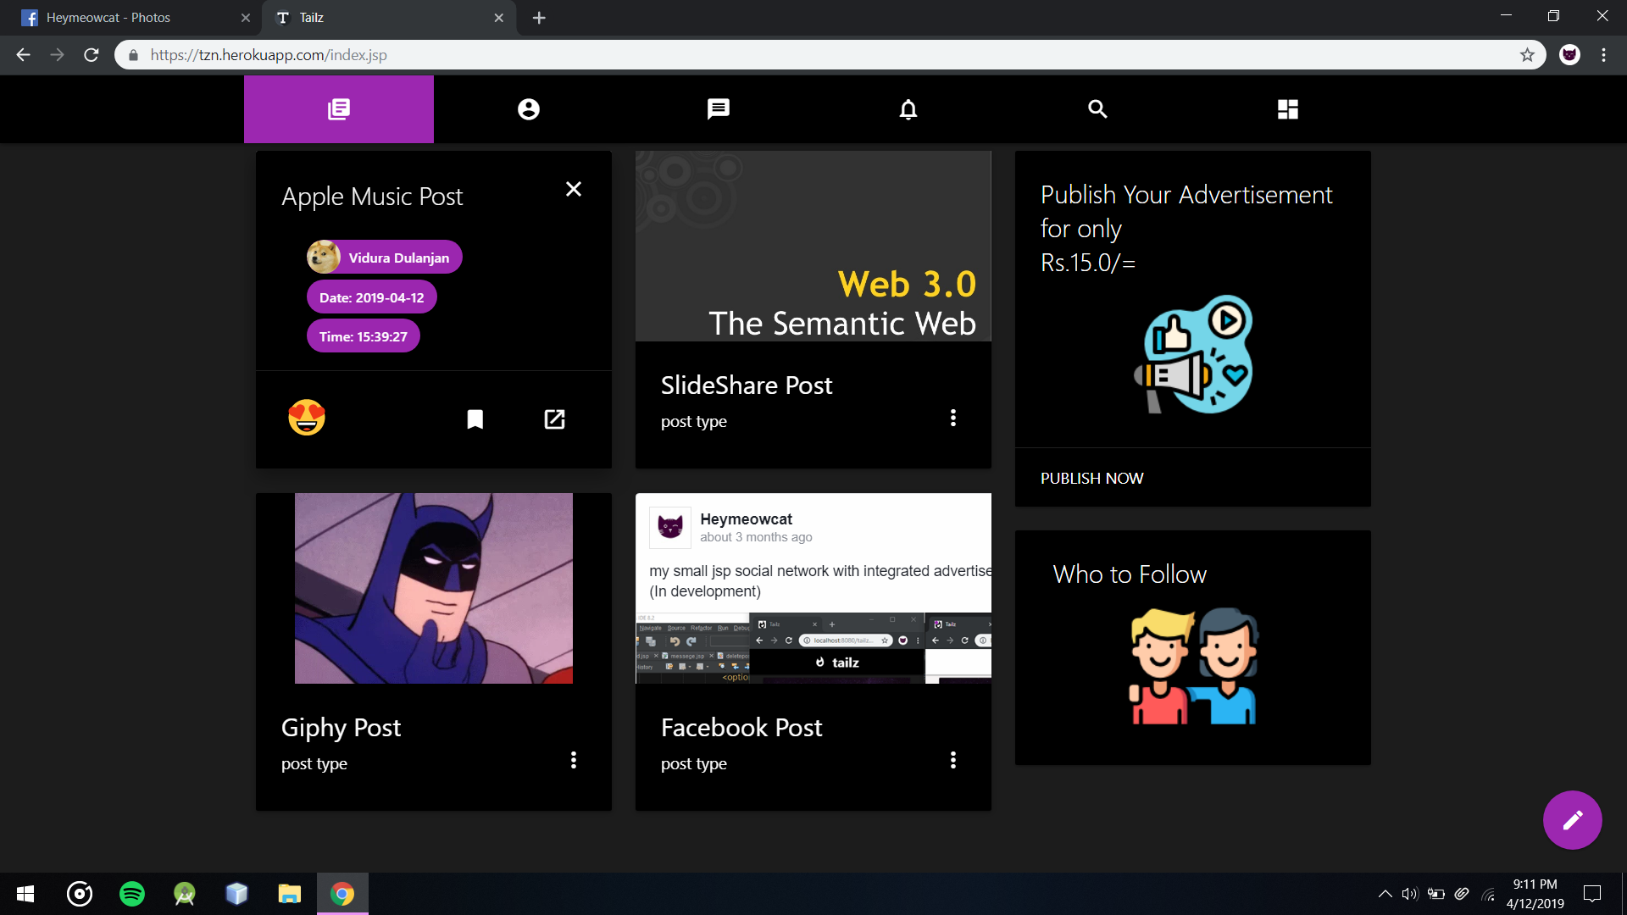

Users Can React to Posts and Bookmark them from Home Feed or Search and Trending Page

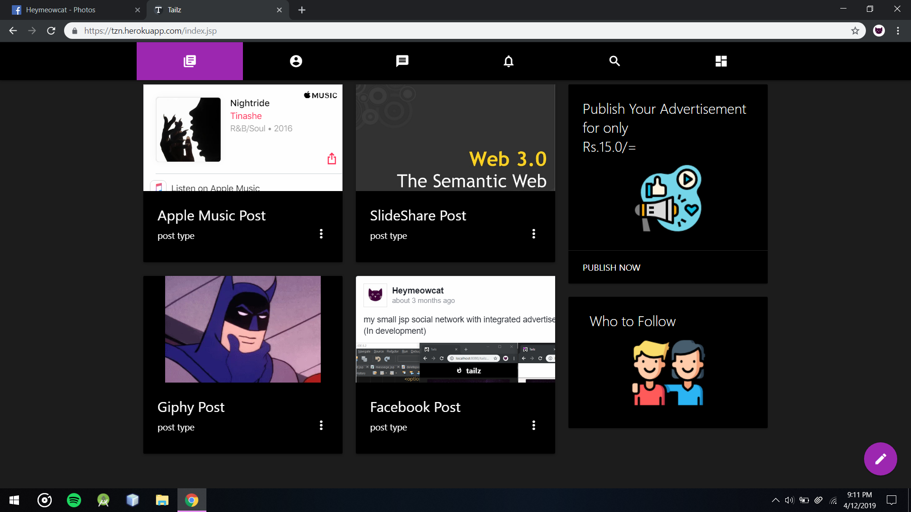

Home Feed with Different types of Content and there are not Live advertisements at this moment

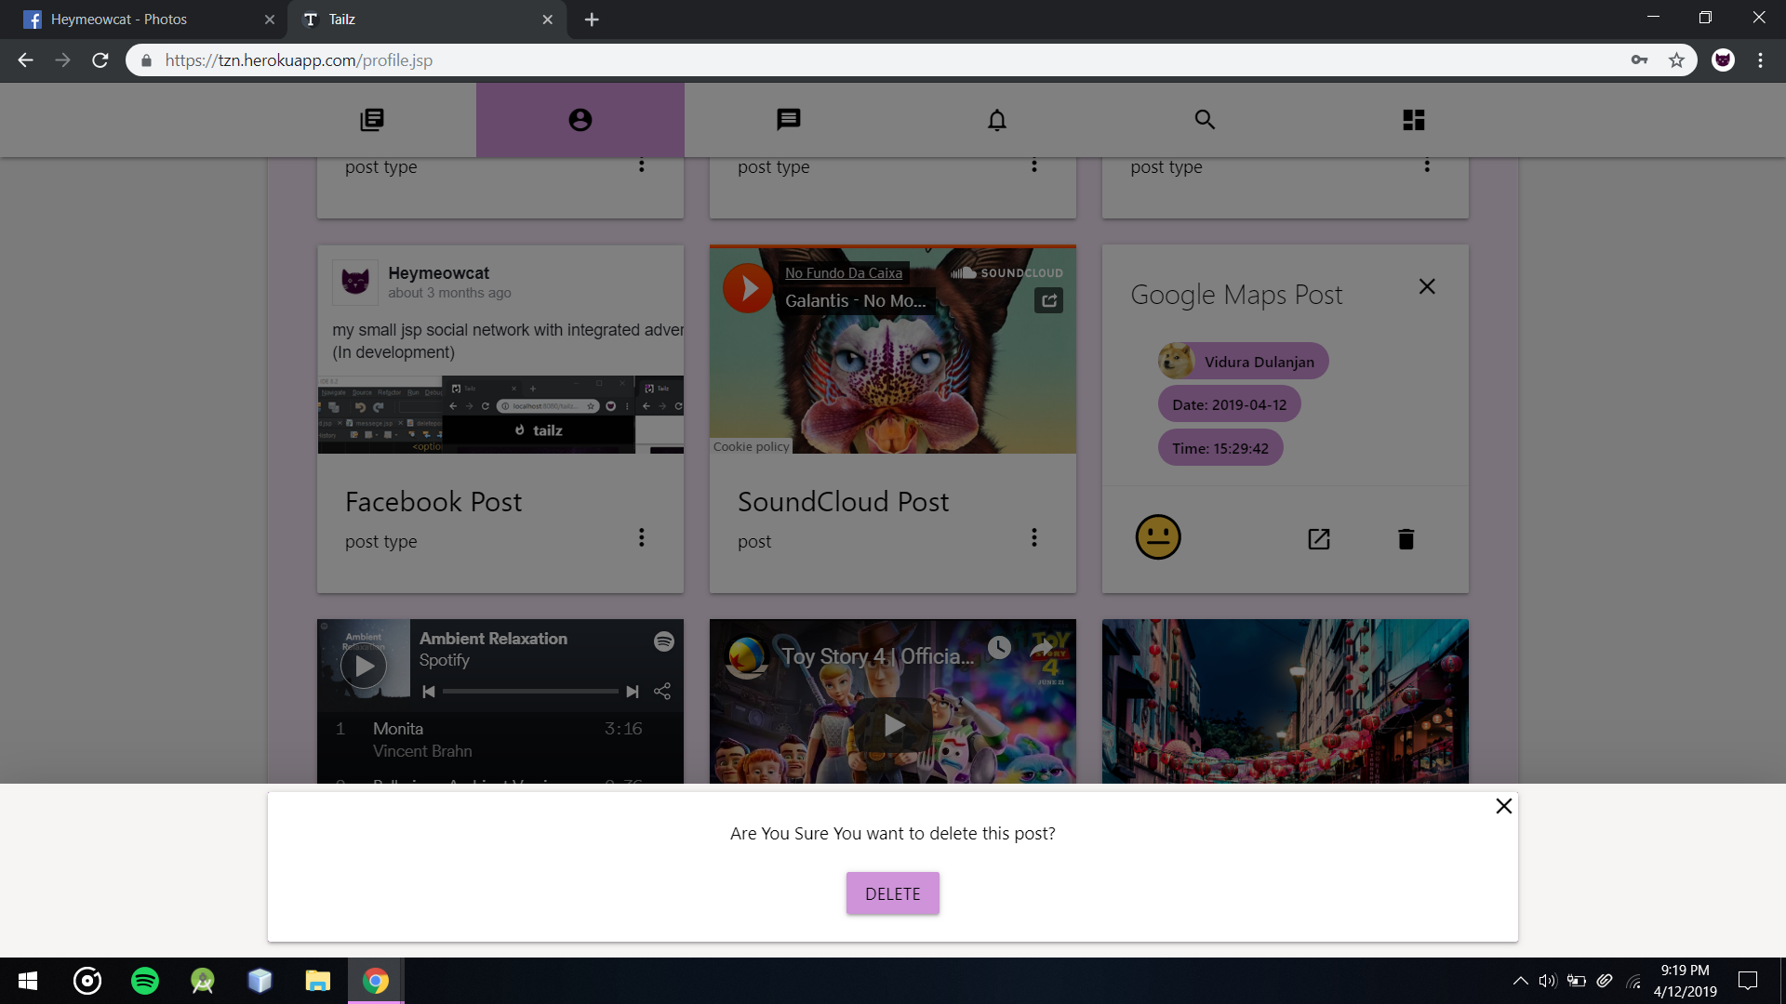

Delete prompt before deleting a Post

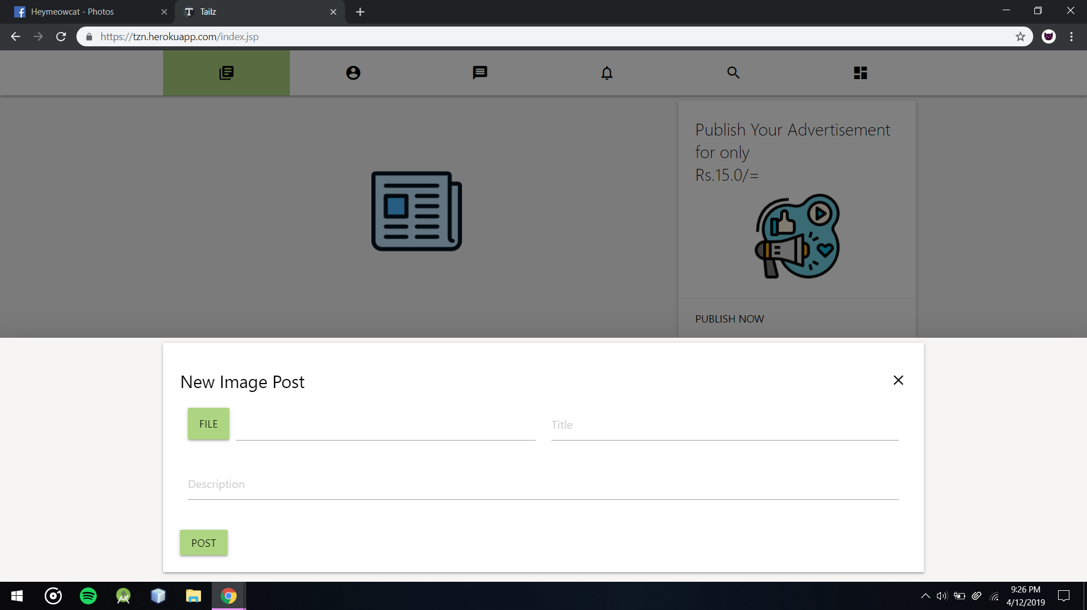

Image Post Form

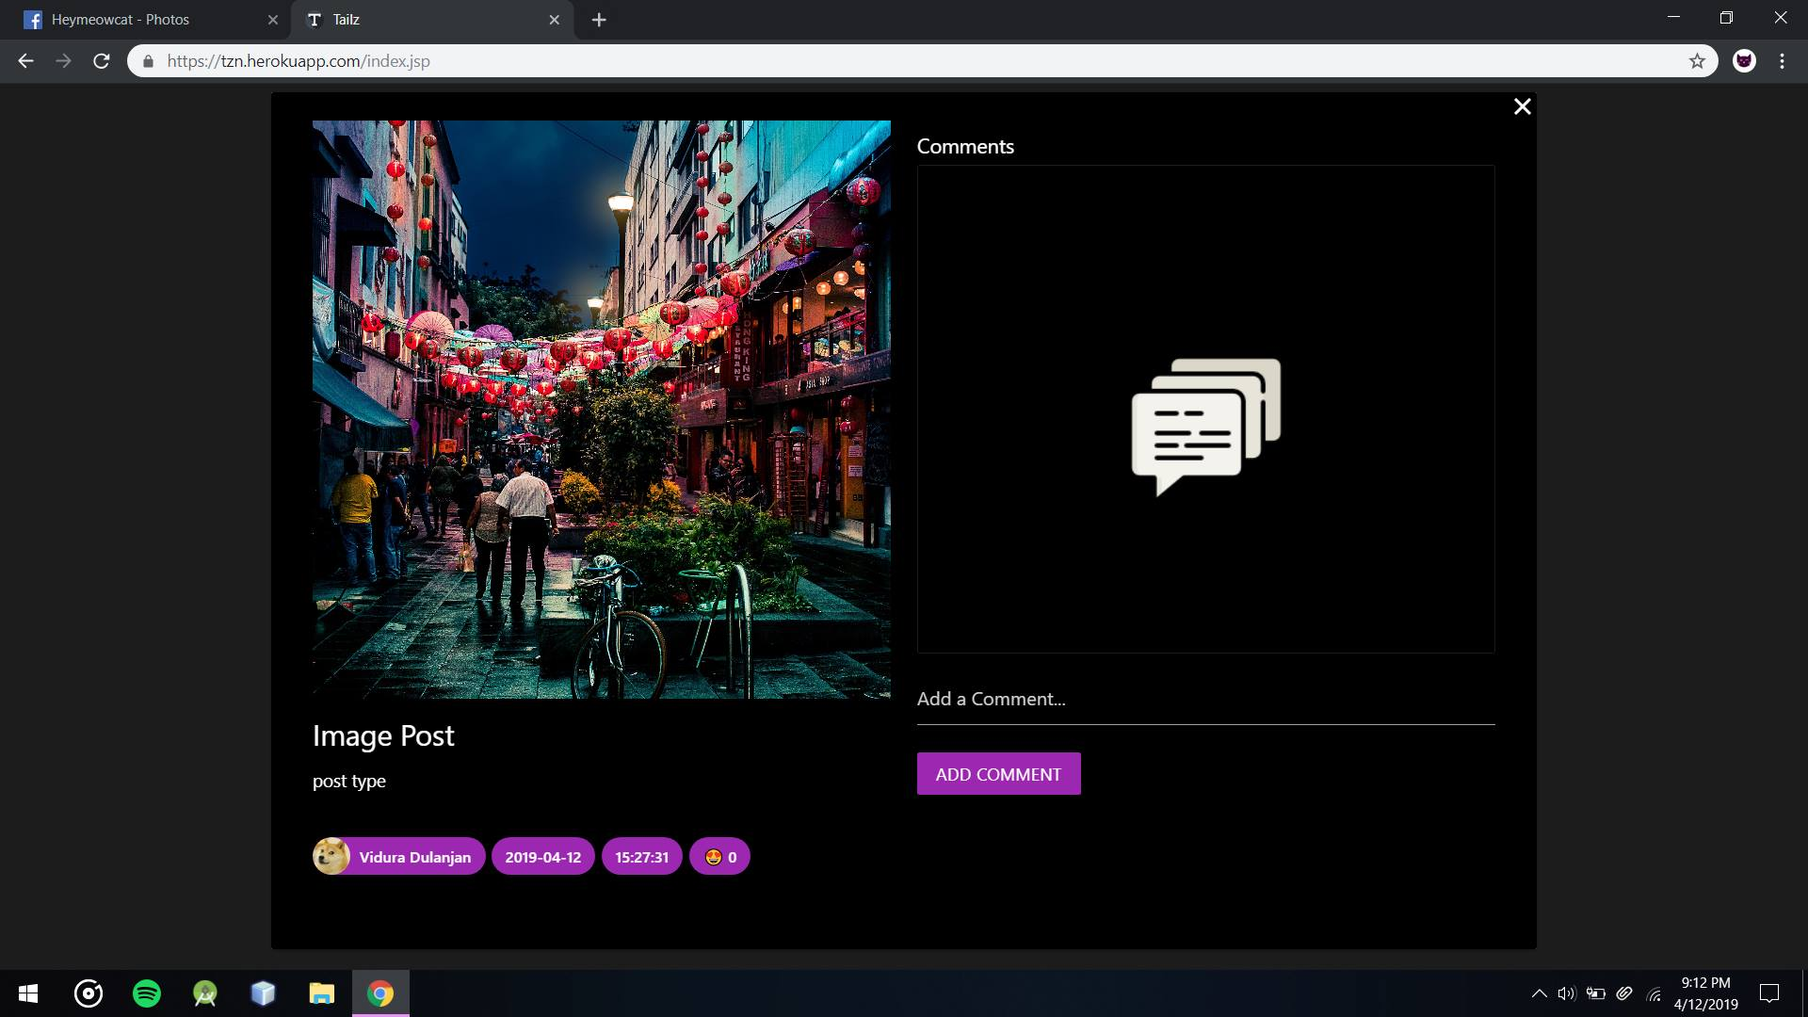

Opened Image post

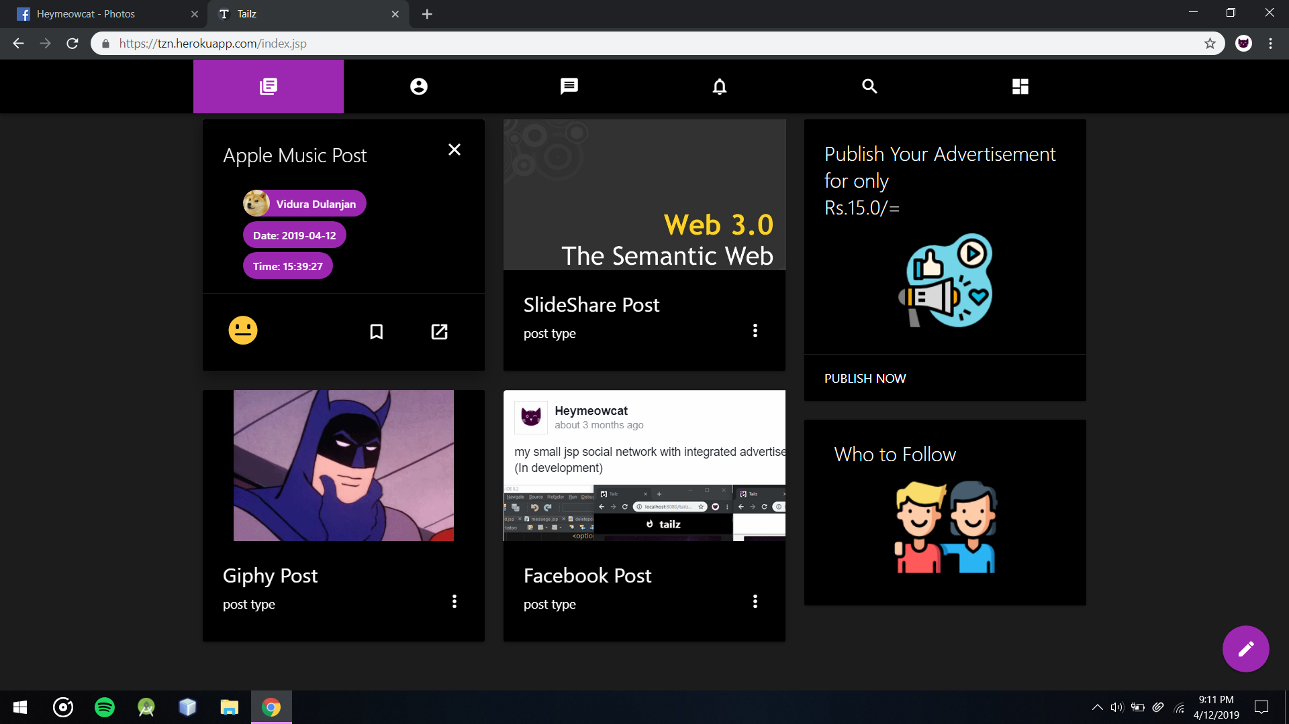

Post Before Reacting and Bookmarking

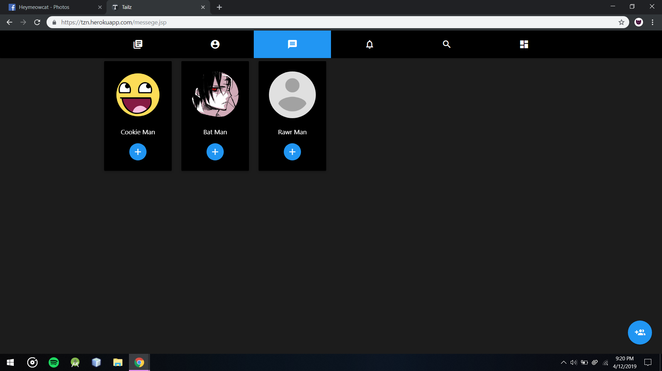

Dark Mode on Messages Contact list

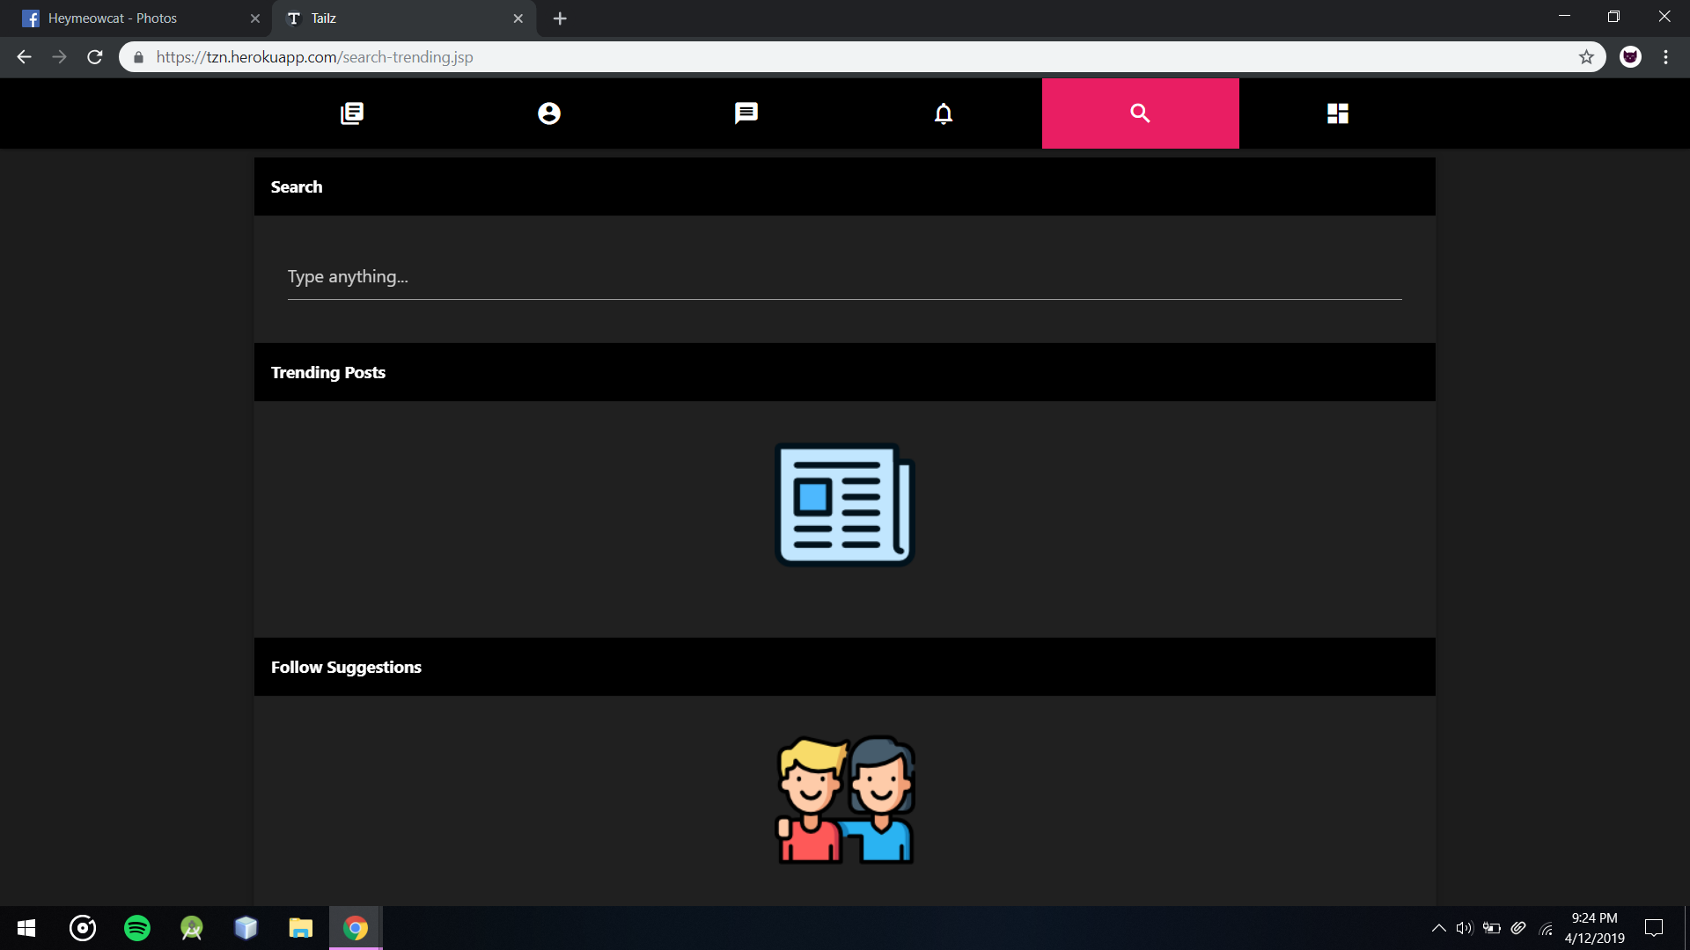

Search and Trending page without any Trending Posts

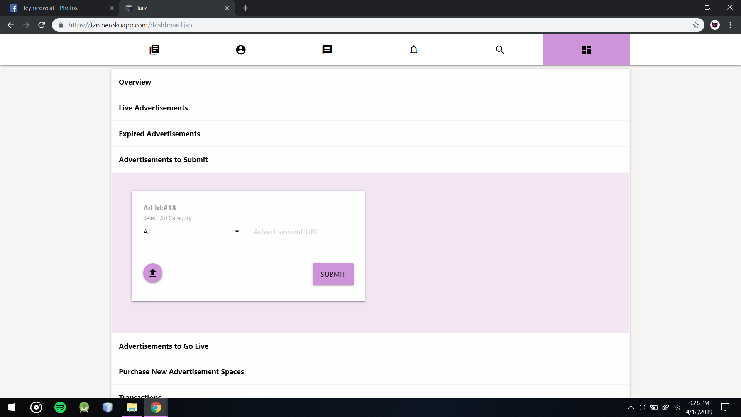

Customers Dashboard’s Advertisements to Submit Section with Advertisement to fill details

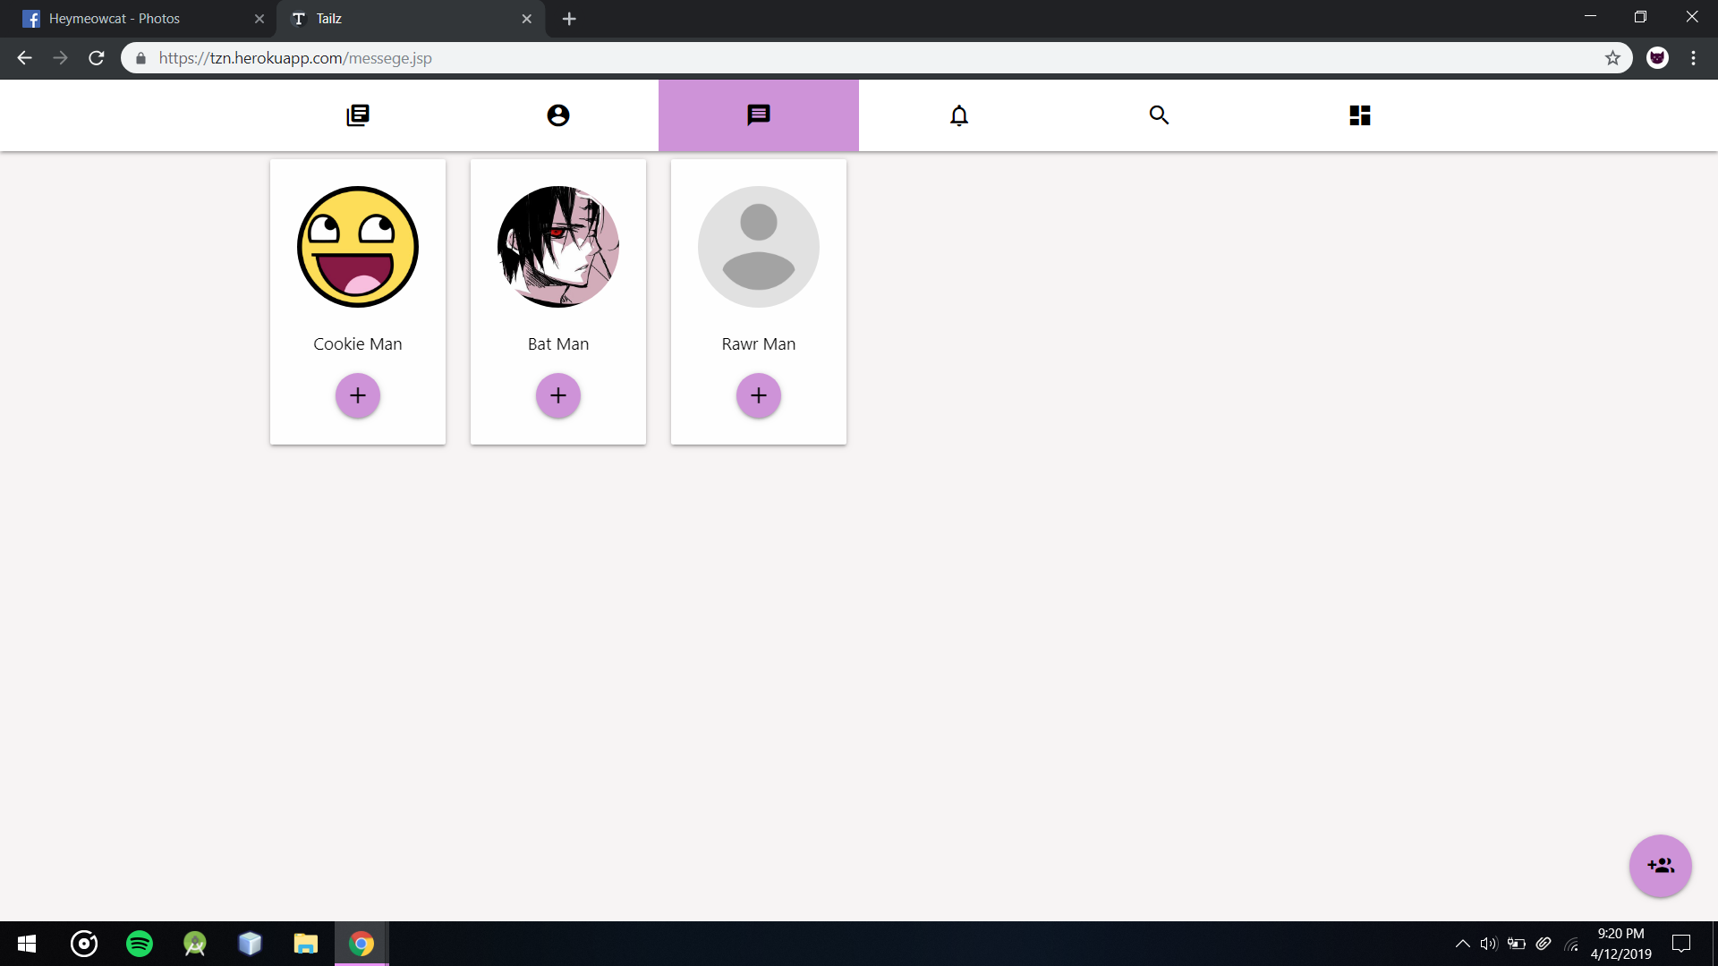

Users Contact List for Chat “+” marks will replace when unread messages from that user are available

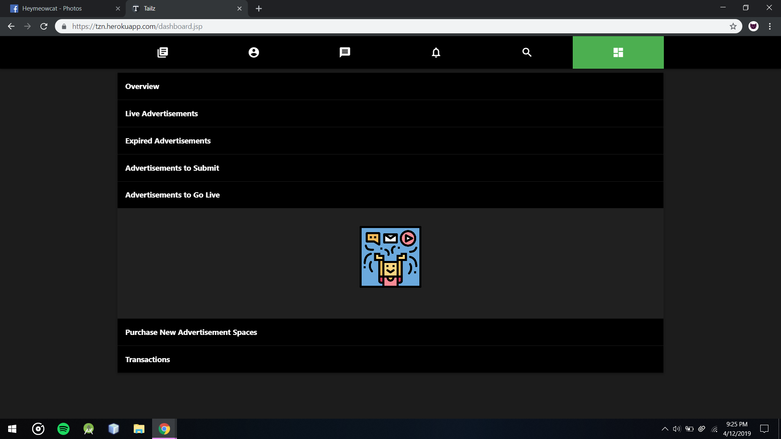

Customers Dashboard’s Advertisements to Go Live Section without and advertisements to Go Live

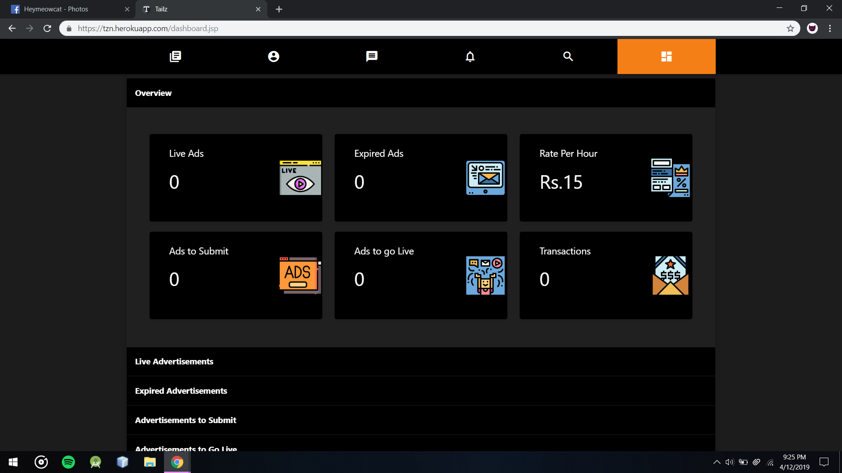

Dark Orange theme Dashboard Page

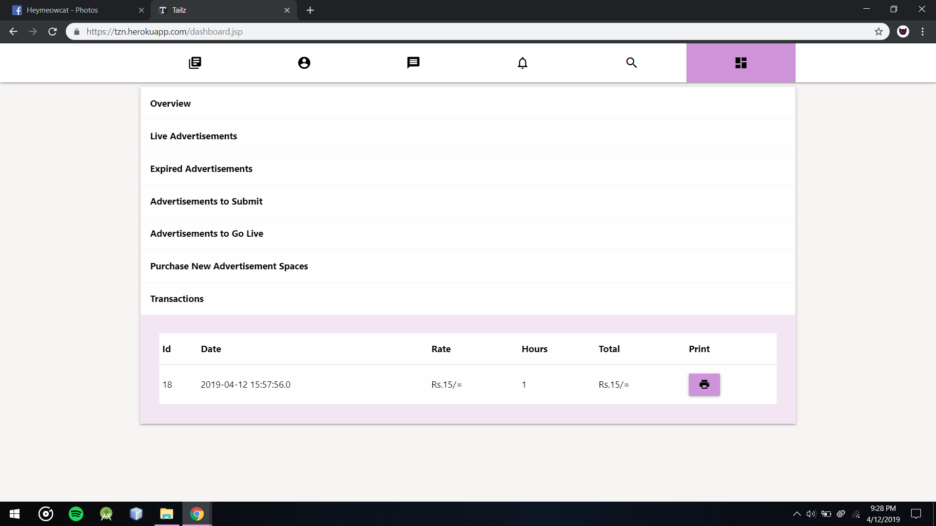

Customers Dashboard’s Transaction Section after purchased Advertisement Area

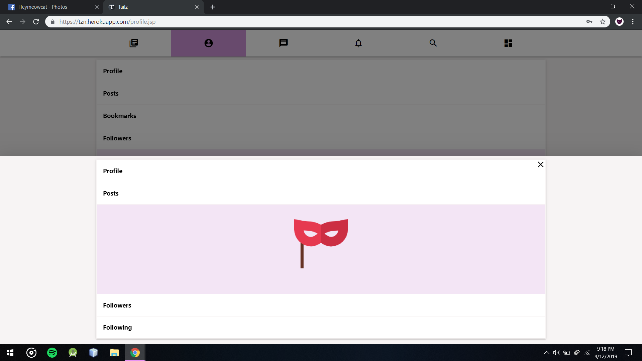

Users can’t view Posts from Users that their privacy setting set to private

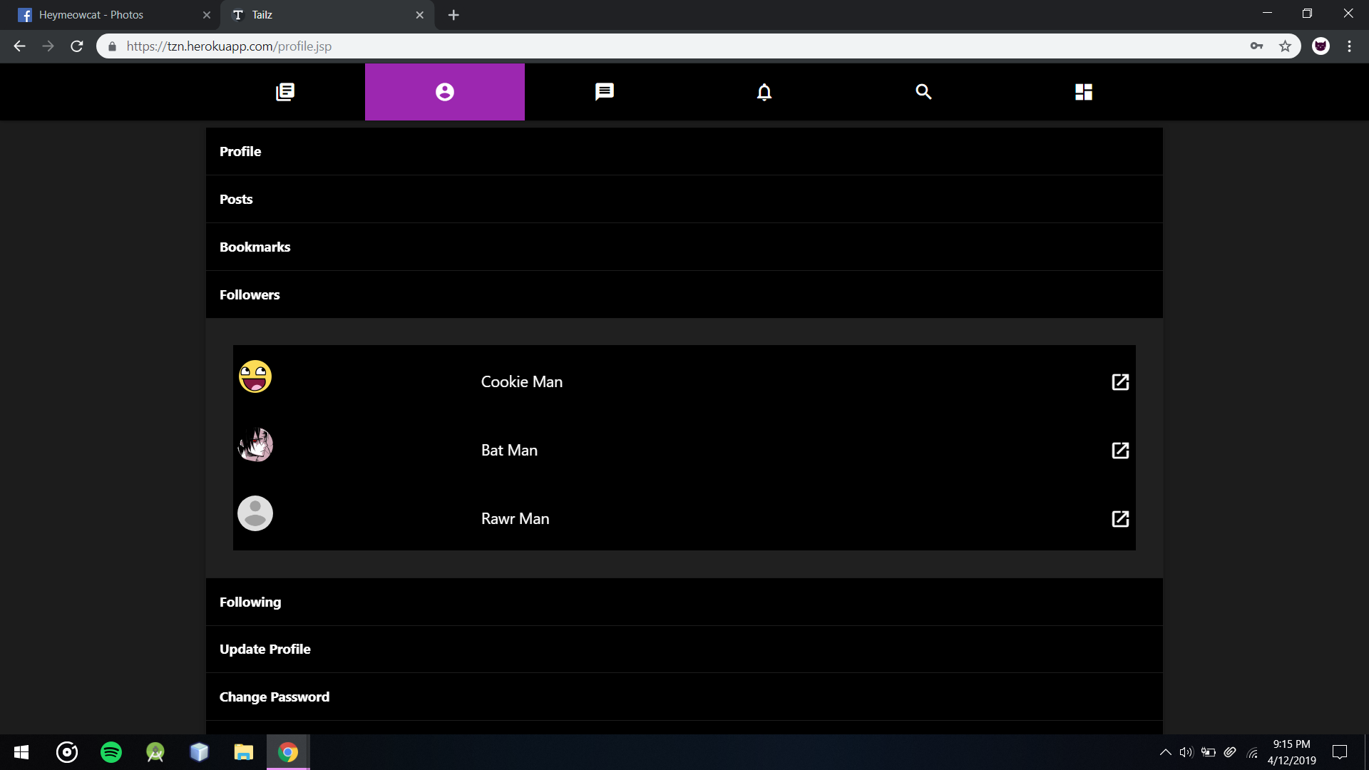

Users Profile’s Followers Section

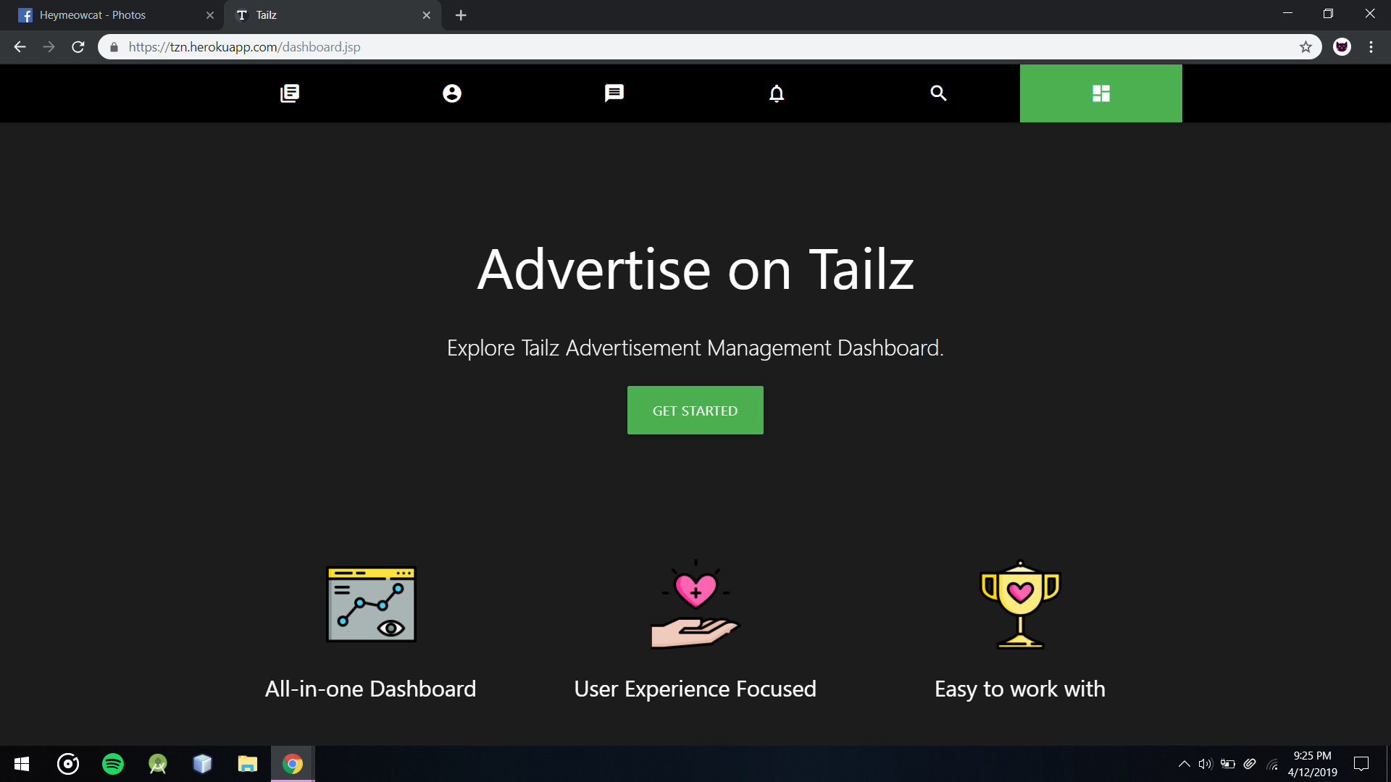

Get Started Page that replaces Dashboard page if user don’t want to use Advertisements Managing Dashboard

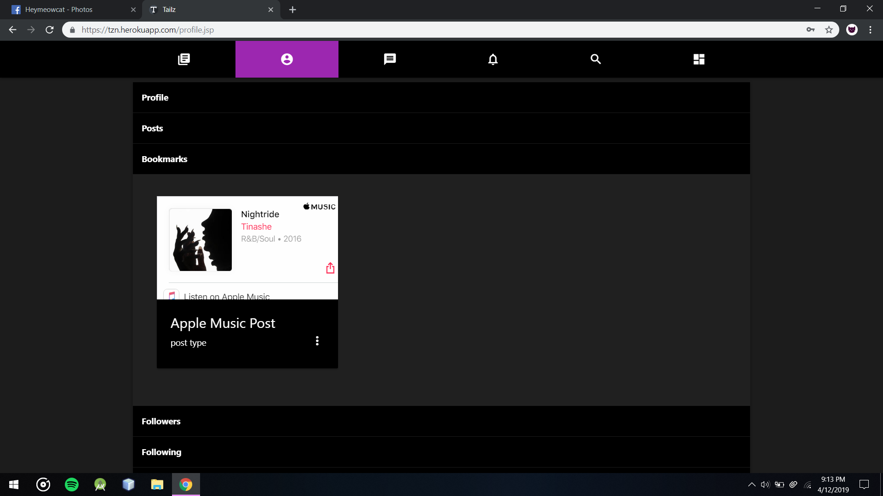

Users Bookmark Section after bookmarking a post

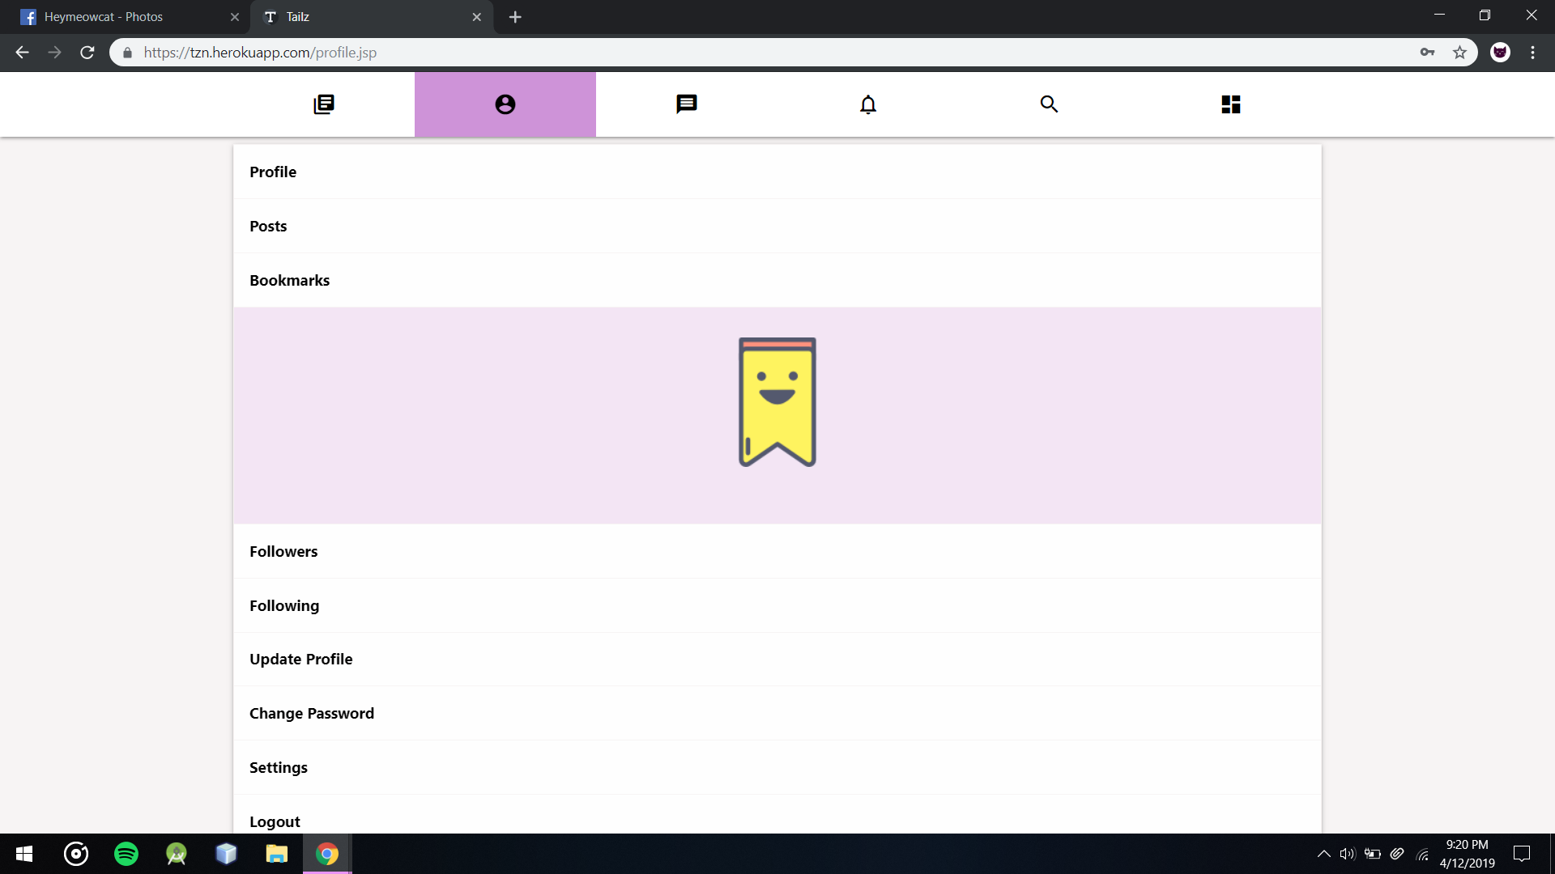

Users Bookmark Section without any bookmarks

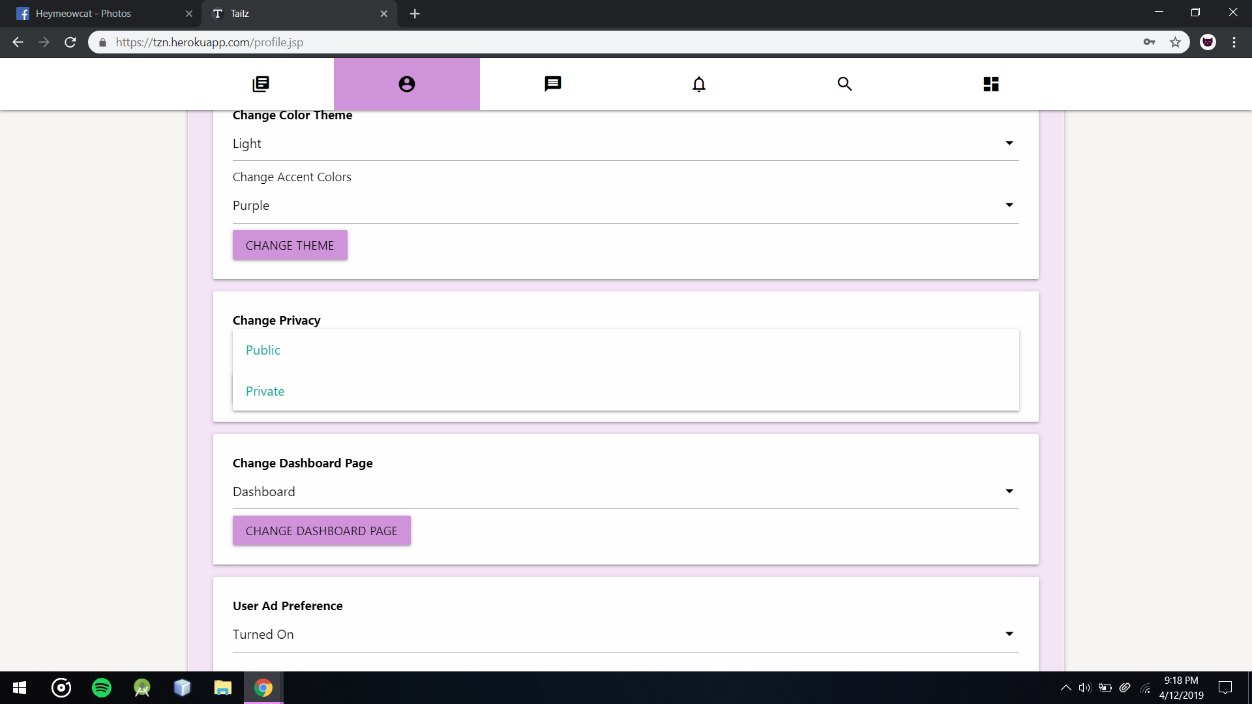

Users Can Change their privacy options to Public or Private

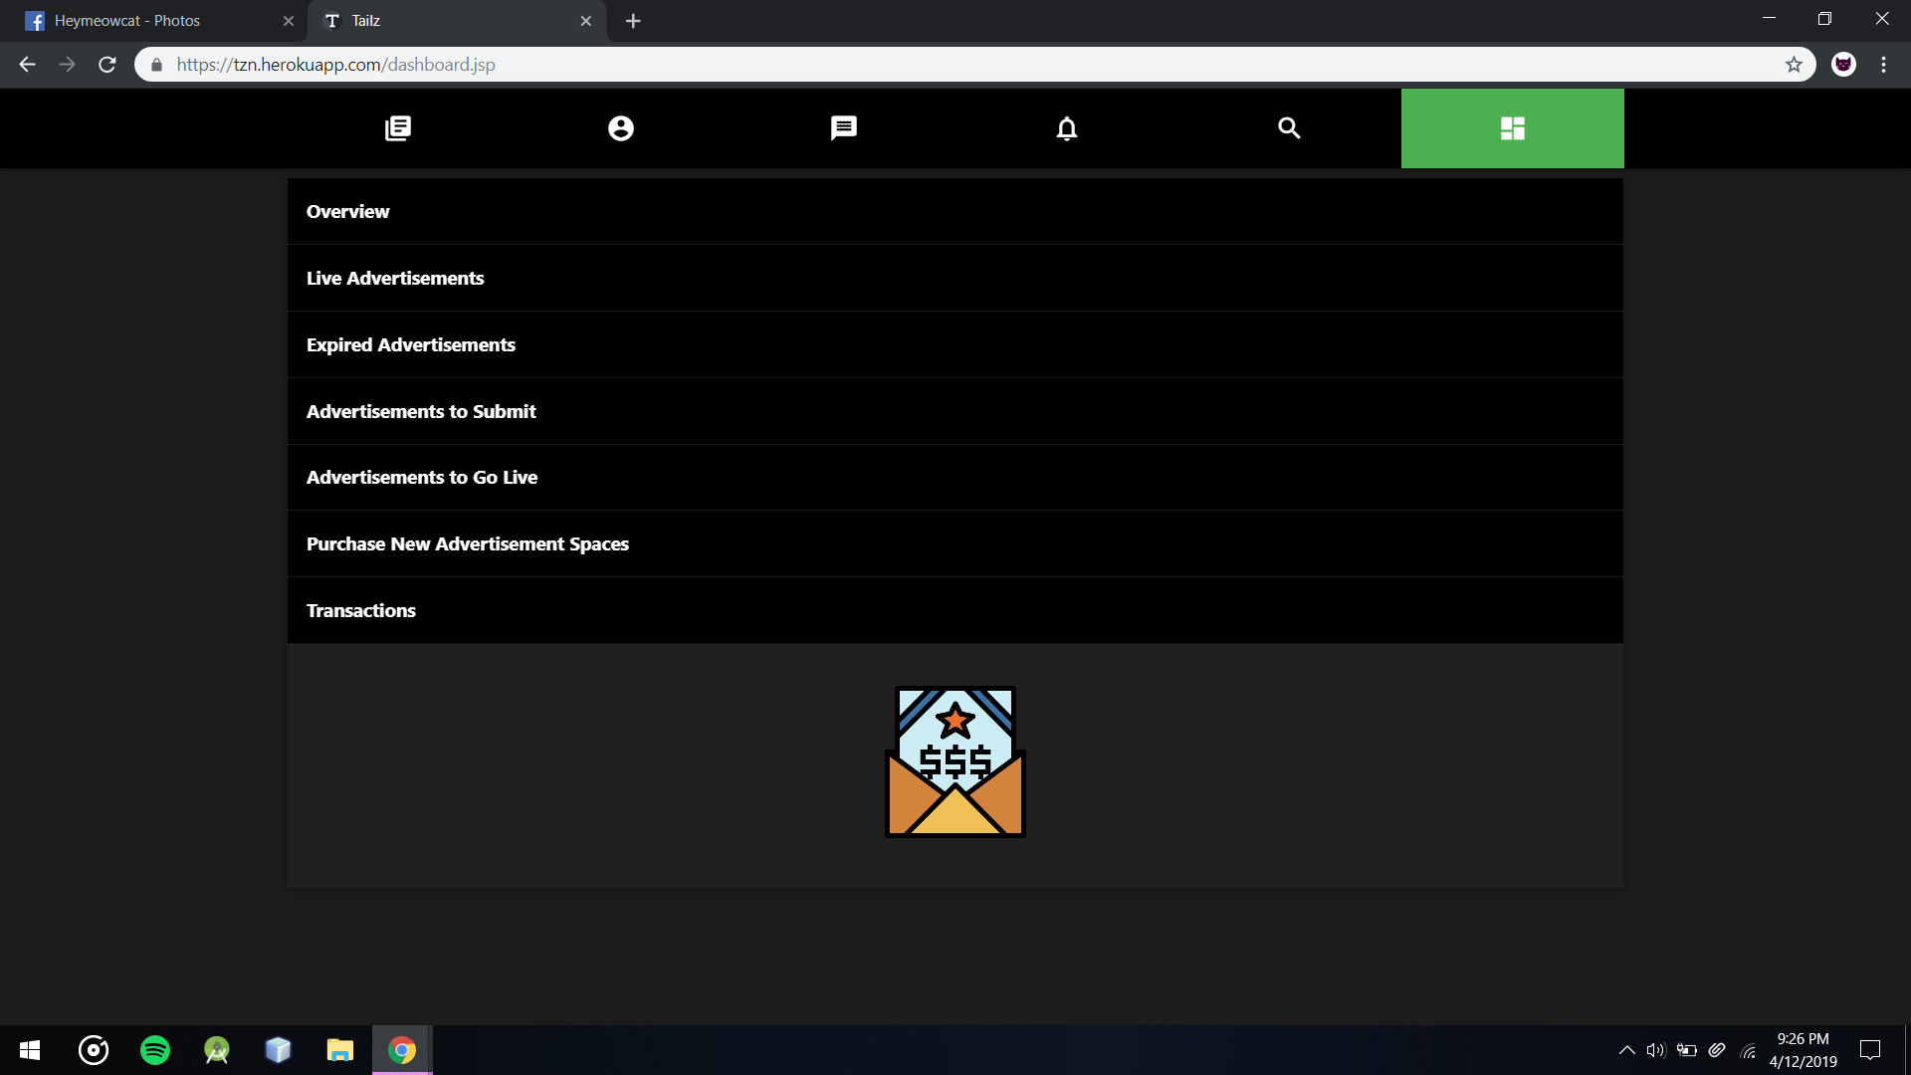

Customers Dashboard’s Transaction Section without any Transactions

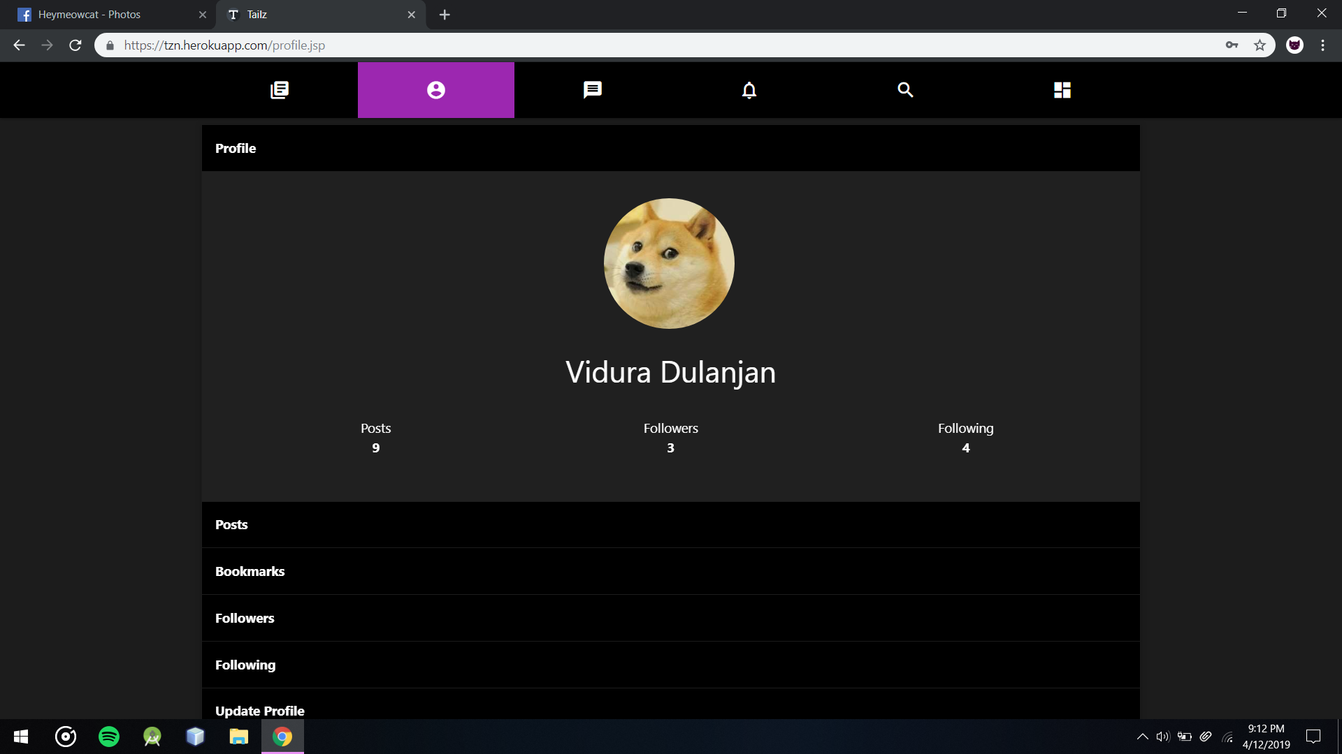

Users Profile Section